King Fahd University of Petroleum and Minerals
College of Computer Science and Engineering
Computer Engineering Department

COE 202: Digital Logic Design (3-0-3)
Term 142 (Spring 2015)
Major Exam II
Saturday April 18, 2015

Time: 150 minutes, Total Pages: 11

Name:_KEY__________________________ ID:______________ Section: _______

Notes:
- Do not open the exam book until instructed
- Calculators are not allowed (basic, advanced, cell phones, etc.)
- Answer all questions
- All steps must be shown
- Any assumptions made must be clearly stated

Question | Maximum Points | Your Points
1 | 12
2 | 12
3 | 12
4 | 12
5 | 10
6 | 10
Total | 68

Question 1. (12 Points)
Assuming the availability of all variables and their complements, simplify the following two Boolean functions F and G subject to the given don’t care conditions d1 and d2 using the K-Map method:

Implement F using only NOR gates:
 |  | C D
 |  | 00 | 01 | 11 | 10
A B | 00 |  |  | X
 | 01 | 1 | 1 | X | 1
 | 11 | 1 | 1
 | 10 |  | X |  | 1

F(A, B, C, D) = ∑(4, 5, 6, 10, 12, 13)
d1(A, B, C, D) = ∑(3, 7, 9)

To get a 2-Level NOR-NOR implementation, we use the simplified POS expression (Groups of 0’s) given by:

F= (A+B) . (B+C). (A’+B’+C’).{(C’+D’) or (B+D’)}

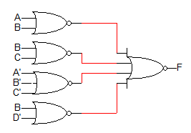

 |  | C D
 |  | 00 | 01 | 11 | 10
A B | 00 | 1 |  | X | 1
 | 01 |  |  | X | X
 | 11 | X | 1 | 1
 | 10 | 1 | X | 1

Implement G using only NAND gates:
G(A, B, C, D) = ∑(0, 2, 8, 11, 13, 15)
d2(A, B, C, D) = ∑(3, 6, 7, 9, 12)

Simplified SOP expression directly maps into a 2-Level NAND-NAND implementation.

G = A D + A' B' D' + A C' OR G = A D + B' C' D' + A' C

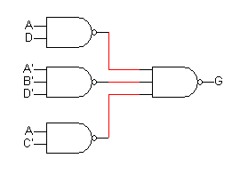

Question 2. (12 Points)

Design a combinational logic circuit which receives a 4-bit unsigned number X (x₃ x₂ x₁ x₀) as input and produces an output Z which equals the result of integer division of X by 3 (e.g., if X=7, Z=2).

How many bits does the output Z have? Why? (2 Points)
Max output value = 15/3 = 5 3-bits

Derive the truth table of this circuit. (4 Points)
 |  | x₁ x₀
 |  | 00 | 01 | 11 | 10
x₃ x₂ | 00 |  |  | 1
 | 01 | 1 | 1
 | 11 |  |  | 1
 | 10 |  | 1 | 1 | 1
Z₀= $\overline{x_{3}}x_{2}\overline{x_{1}}$ + $x_{1}x_{0}(x_{3}+\overline{x_{2}})$+
$x_{3}\overline{x_{2}}(x_{1}{+x}_{0})$
x₃ x₂ x₁ x₀ | Z₂ Z₁ Z₀
0 0 0 0 | 0 0 0
0 0 0 1 | 0 0 0
0 0 1 0 | 0 0 0
0 0 1 1 | 0 0 1
0 1 0 0 | 0 0 1
0 1 0 1 | 0 0 1
0 1 1 0 | 0 1 0
0 1 1 1 | 0 1 0
1 0 0 0 | 0 1 0
1 0 0 1 | 0 1 1
1 0 1 0 | 0 1 1
1 0 1 1 | 0 1 1
1 1 0 0 | 1 0 0
1 1 0 1 | 1 0 0
1 1 1 0 | 1 0 0
1 1 1 1 | 1 0 1

Using K-maps, derive minimized sum-of-products expression(s) for the circuit output(s).

(6 points)
Z₀= $\overline{x_{3}}x_{2}\overline{x_{1}}$ + $x_{1}x_{0}(x_{3}+\overline{x_{2}})$+ $x_{3}\overline{x_{2}}(x_{1}{+x}_{0})$

Z₁= $x_{3}\overline{x_{2}}$ + $\overline{x_{3}}x_{2}x_{1}$

Z₂= $x_{3}x_{2}$

Question 3. (12 points)

Fill the following table with the appropriate signed number representation. Under the columns labeled “O” put “T” if there is an overflow, otherwise put “F”. If the value cannot be represented correctly using the specified number of bits, put “NA”. (6 points)

# Bits | Sign-Magnitude | O | 1’s Complement | O | 2’s Complement | O | Decimal Value
5 | NA | T | NA | T | 10000 | F | -16
7 | 011 1111 | F | 0111111 | F | 0111111 | F | 63
8 | 10001100 | F | 1111 0011 | F | 1111 0100 | F | -12
6 | 11 0001 | F | 10 1110 | F | 10 1111 | F | -17

Perform the following signed-2’s complement arithmetic operations in binary using 5 bits. All numbers given are represented in the signed-2’s complement notation. Indicate clearly the carry values from the last two stages. For each of the three operations, check and indicate whether overflow occurred or not. (6 points)

11000  -10010  11  11000  +01110  00110 | 01001  -11001  01  01001  +00111  10000 | 11011  +10011  10  11011  +10011  01110
Overflow? (No) | Overflow? (Yes) | Overflow? (Yes)

Question 4. (12 Points)
In the following questions, you must clearly label all inputs/outputs of all MSI components, and clearly indicate both the MSB and LSB.

Implement a 3-to-8 decoder with enable, using two 2-to-4 decoders with enable and other logic gates as needed. (5 points)

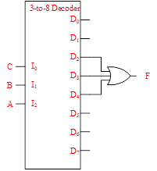
Impalement F(A,B,C)=M₀.M₁.M₅.M₆.M₇ using a decoder and a single gate with minimum number of inputs. (3 points)
F(A,B,C)=m₂+m₃+m₄

 |  | BC
 |  | 00 | 01 | 11 | 10
A | 0 | 0 | 0 | 0 | 1
 | 1 | 0 | 1 | 1 | 1

Implement F(A,B,C)= m₂+m₅+m₆+m₇, using the smallest possible multiplexer and inverters as needed. (4 points)
OR using k-map F=C’B+CA

Question 5. (10 Points)

Given two 8-bit signed numbers, X and Y in 2's complement representation, and assuming overflow does not occur:

Using a single adder of any size and basic logic gates, design a circuit that generates a signal LT which equals 1 if X < Y, otherwise it is 0. (2 Points)

Using a single adder of any size and basic logic gates, design a circuit that receives an 8-bit signed number M and produces an output value which equals 3*M. (2 Points)

Given two 8-bit signed numbers X and Y in 2's complement representation, use only adders of any size, multiplexers and basic logic gates, to compute the output Z defined as follows: (6 Points)

IF (X ≥ Y) Then Z = 3*(X - Y)
Else Z = 2*(Y - X)

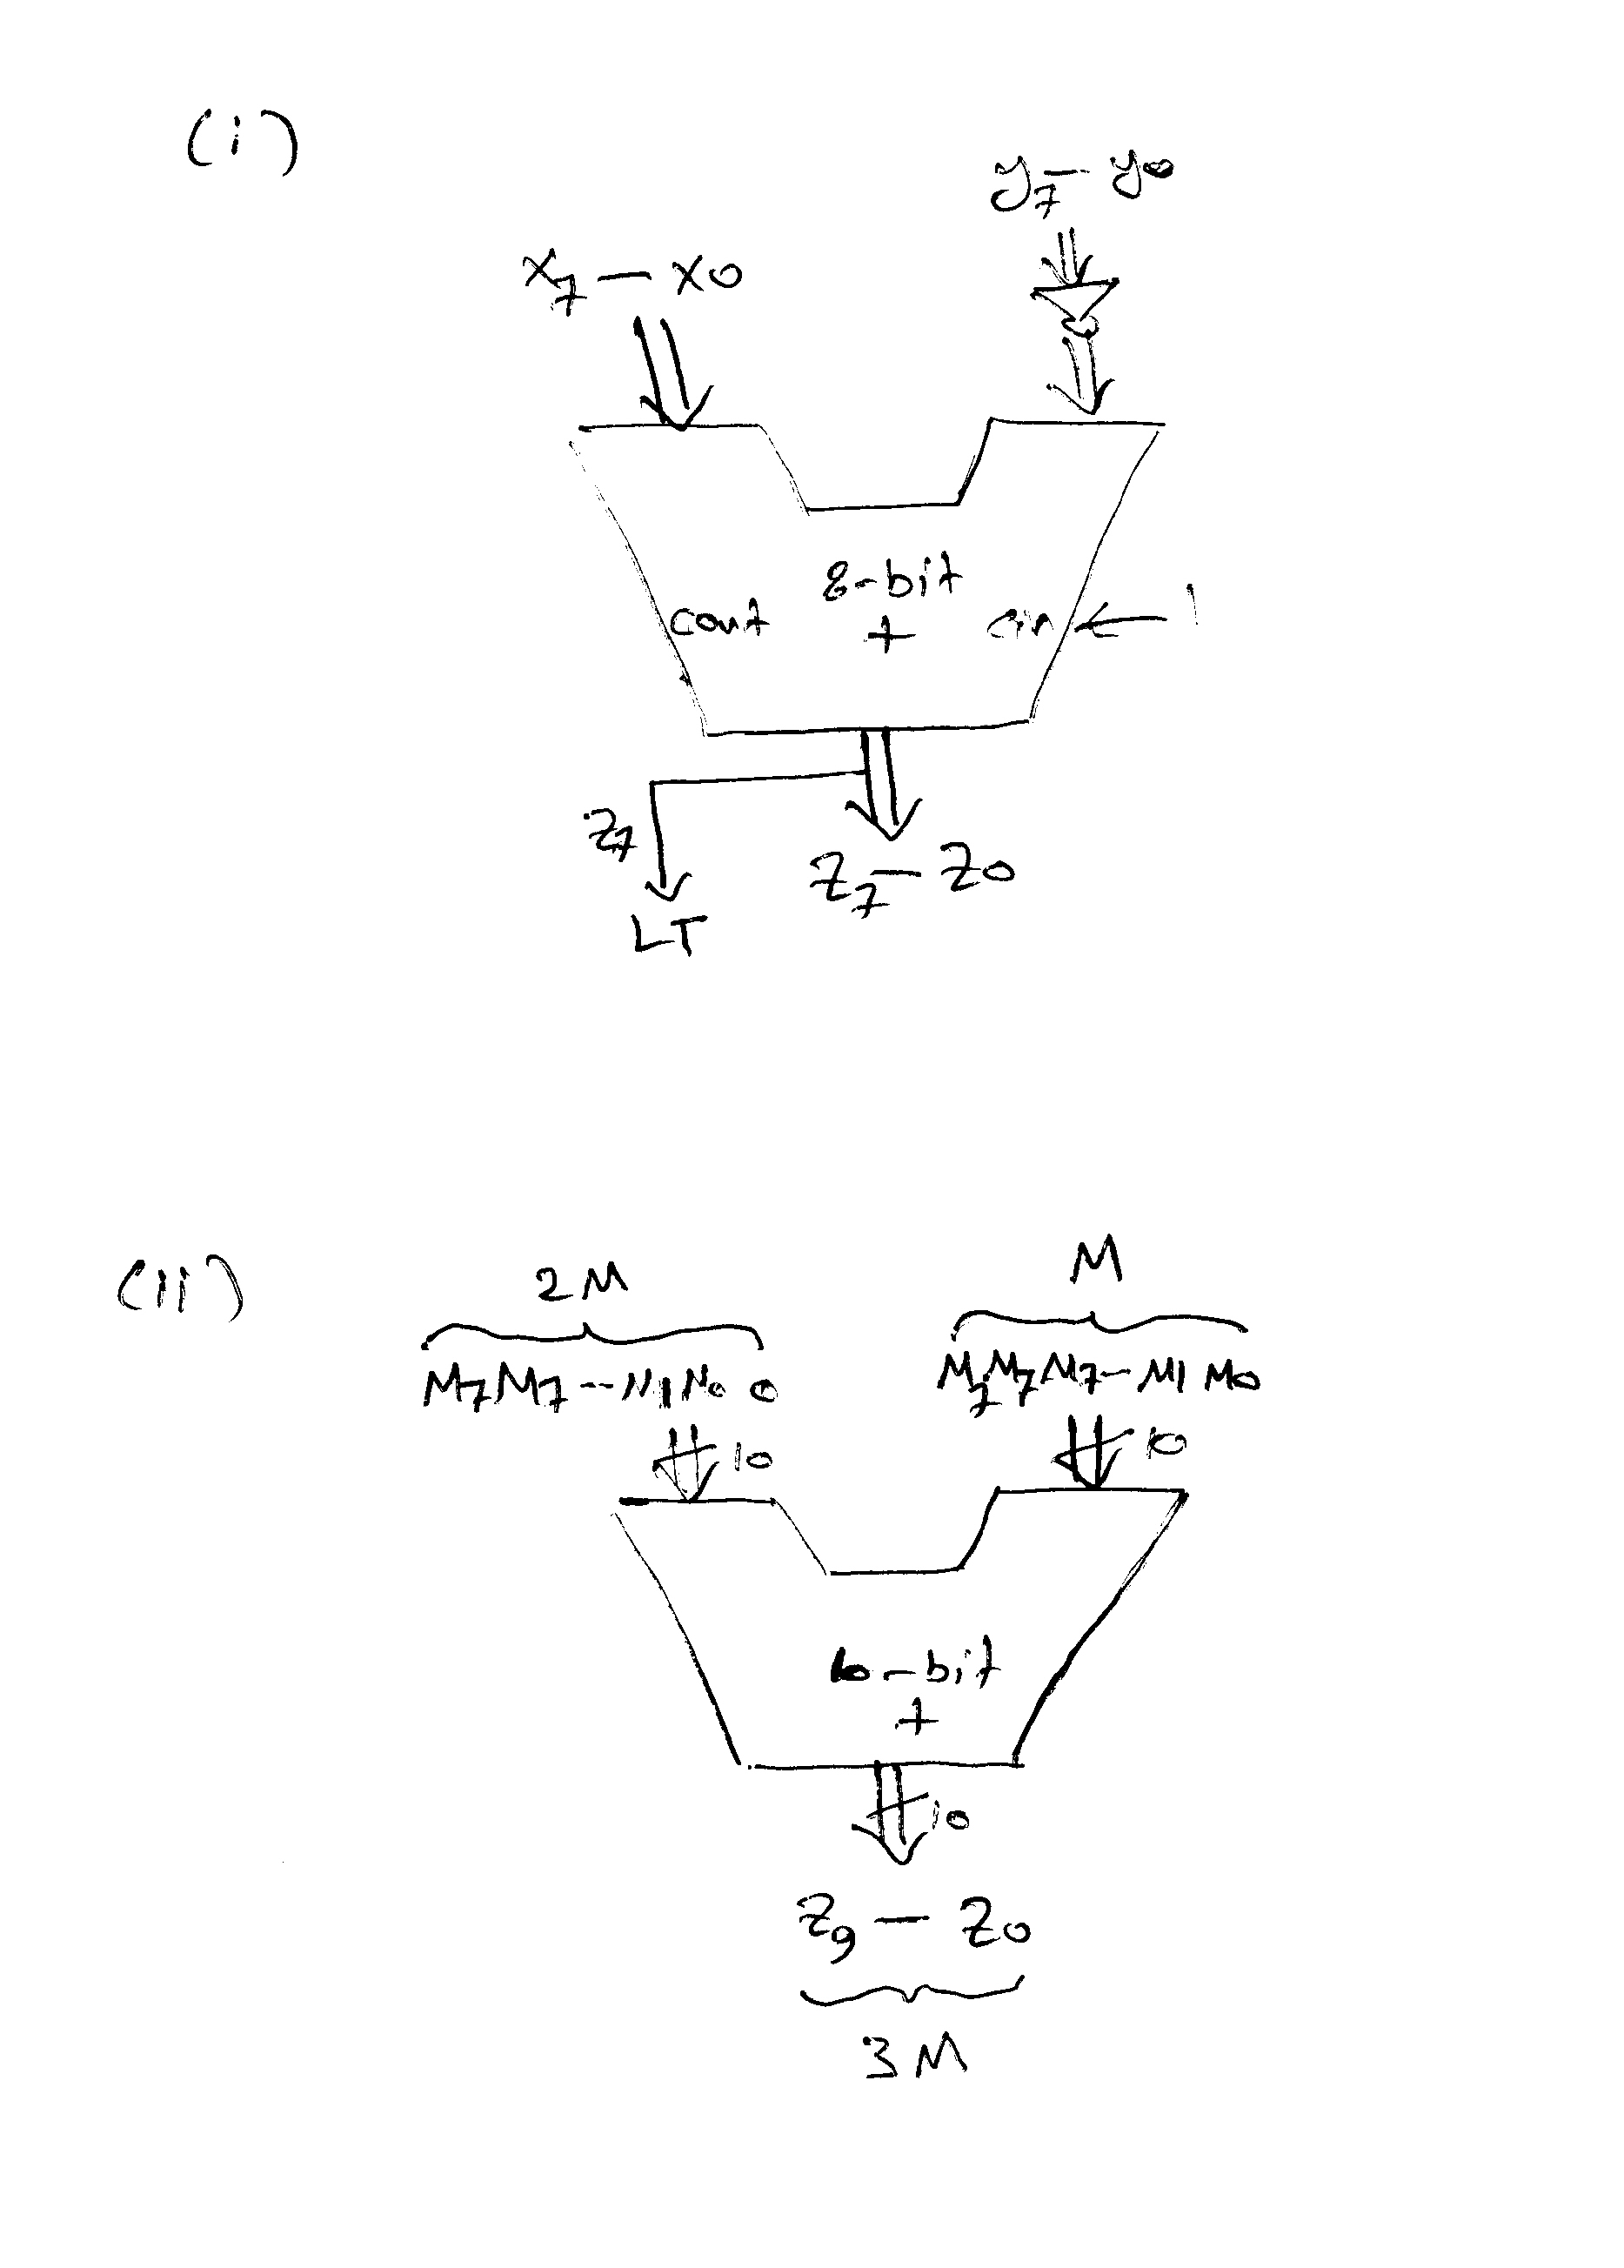
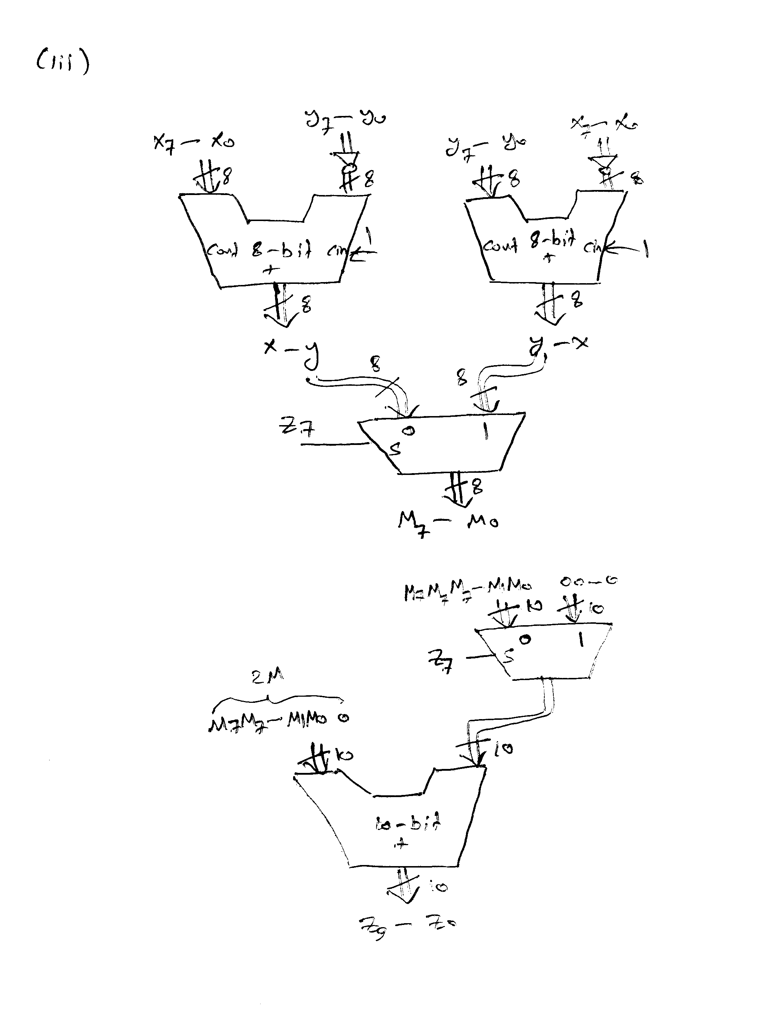

Question 6. (10 Points)

Given below the design of an n-bit magnitude comparator. The circuit receives two n-bit unsigned numbers A and B and produces two outputs GT and EQ as given in the table to the right.
 | GT EQ
IF A > B | 1 0
IF A = B | 0 1
IF A < B | 0 0

The input operands are processed in a bitwise manner starting with the most significant bit (MSB). The comparator circuit is constructed using n identical copies of the basic 1-bit cell shown to the right.
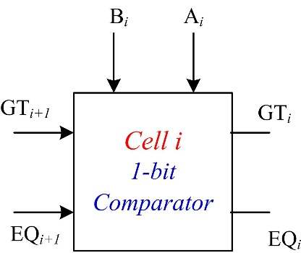

The Figure below shows the n-bit comparator circuit implemented using n copies of the basic 1-bit cell.

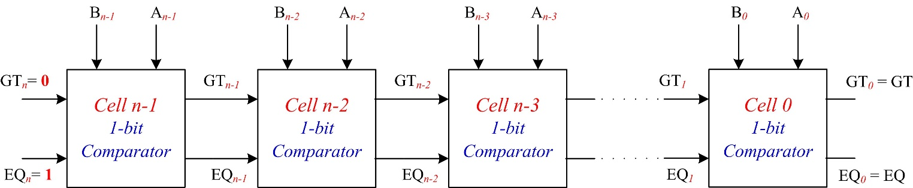

Boolean expressions of the outputs of cell i and its gate-level implementation are given below:

${GT}_{i}={GT}_{i+1}+A_{i} {\overline{B}}_{i}{ EQ}_{i+1}$
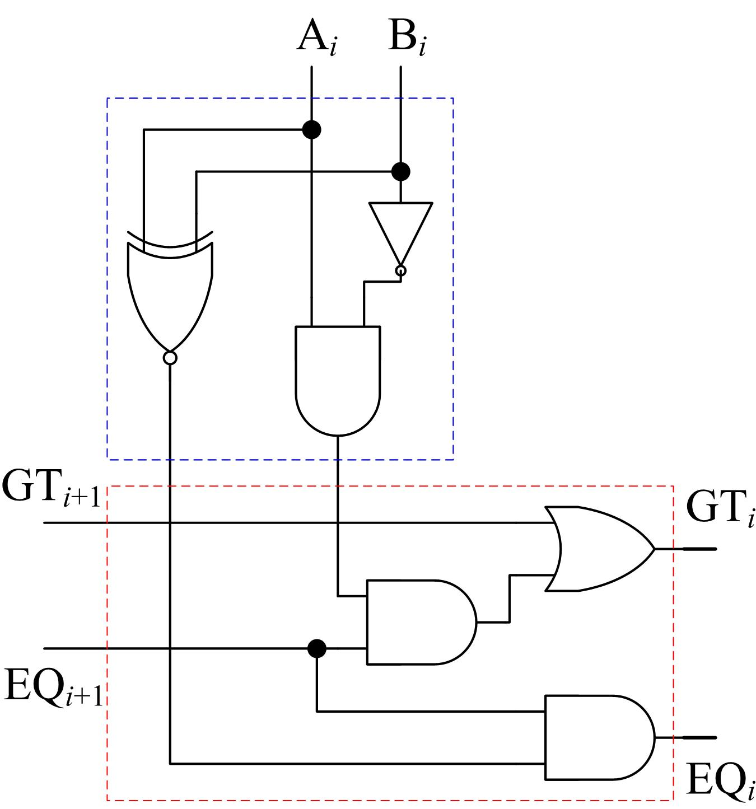
Cell i Gate Level Implementation
EQ_{i} = (A_{i} B_{i}). EQ_{i+1}

Write a Verilog model Comp1Bit to model the 1-bit comparator circuit using either a structural model of basic logic gates or a behavioral model using the assign statement.

(4 Points)

The declaration of the Comp1Bit module is as follows:

module Comp1Bit (output GT_out, EQ_out ,
input GT_in , EQ_in, Ai, Bi);

module Comp1Bit (output GT_out, EQ_out, input GT_in, EQ_in, Ai, Bi);

assign GT_out = GT_in || Ai && !Bi && EQ_in;
assign EQ_out = (Ai ~^ Bi) && EQ_in;

endmodule

OR
module Comp1Bit (output GT_out, EQ_out, input GT_in, EQ_in, Ai, Bi);

not (g1, Bi);
and (g2, g1, Ai);
xnor(g3, Ai, Bi);
and (g4, g2, EQ_in);
or (GT_out, GT_in, g4);
and (EQ_out, EQ_in, g3);

endmodule

Complete the following Verilog model Comp3Bit which models a 3-bit comparator circuit.

(2 Points)

module Comp3Bit (output Greater, Equal,
input [2:0] A , B) ;

wire [2:1] GT, EQ ; // internal wires connecting cells

/* First instance “M1” of the cell Comp1Bit with its inputs GT_in and EQ_in connected to fixed values of 0 and 1 respectively */
//
Comp1Bit M1 (GT[2] , EQ [2], 1'b0, 1'b1, A[2], B[2]);
Comp1Bit M2 (GT[1], EQ[1], GT[2], EQ[2], A[1], B[1]);
Comp1Bit M3 (Greater, Equal, GT[1], EQ[1], A[0], B[0]);

endmodule

Write a Verilog test bench to test the 3-bit comparator Comp3Bit by applying the following input patterns consecutively with a delay of 20ps: (4 Points)

{A=100, B=011},

{A=101, B=101},

{A=011, B=111}.

module t_Comp3Bit();

wire Greater, Equal;
reg [2:0] A, B;

Comp3Bit M1 (Greater, Equal, A, B) ;

initial begin
A=3'b100; B=3'b011;
#20 A=3'b101; B=3'b101;
#20 A=3'b011; B=3'b111;
end
endmodule

