King Fahd University of Petroleum and Minerals
College of Computer Science and Engineering
Computer Engineering Department

COE 202: Digital Logic Design (3-0-3)
Term 142 (Spring 2014-2015)
Major Exam 1
Saturday February 28, 2015

Time: 90 minutes, Total Pages: 7

Name:______________________________________ ID:__________________ Section: _______

Notes:
- Do not open the exam book until instructed
- No Calculators are allowed (basic, advanced, cell phones, etc.)
- Answer all questions
- All steps must be shown
- Any assumptions made must be clearly stated

Question | Maximum Points | Your Points
1 | 25
2 | 20
3 | 10
Total | 55

Question 1. (25 points)
- Convert the following numbers from the given base to the other uncrossed bases listed in the table (if needed, express fractions up to 3 digits only). (12 points)
Decimal | Binary | Octal | HEX | EXCESS-3 BCD
109.39
 | 10101101.101
 |  |  | E7.48

- Perform the following arithmetic operations in the specified number system. (8 points)

Octal Subtraction  4 5 1 2  - 2 5 3 7  _______________ | Hexadecimal Addition  F E A 3  + A F 9 D  __________________ | Binary Subtraction  1 1 1 0 0 0 1 0  - 1 0 1 1 1 1 1 1  _________________ | Binary Addition  11011011  +01110111  ___________________

- Two number system with radixes $r_{1}$ and $r_{2}$, have the following two relations:
  - ${(69)}_{r_{2}}= {(100)}_{r_{1}}$, and
  - ${(17)}_{r_{2}}= {(21)}_{r_{1}}$

What are the values of $r_{1}$ and $r_{2}$ ? (5 points)

Question 2. (20 points)

Use Boolean algebra to solve the following questions. Show clearly all your steps.
- Simplify each of the following Boolean functions to the specified number of literals in sum-of-products (SOP) representation:

- $F1=x +\overline{x} y$ (2 literals) (1 point)

- $F2=x y + \overline{x} z+y \overline{z}$ (3 literals) (4 points)

- $F3=x \overline{w} \overline{z}+ x \overline{w} \overline{y}+x w+x y z$ (1 literal) (4 points)

- $F4=\overline{\left(x+\overline{y}\right)} \overline{\left(x y+\overline{x} z\right)}$ (3 literals) (4 points)

- Given the Boolean function $F\left(X,Y,Z\right)=\left(Y+\overline{Z}\right)\left(\overline{X}+Y\right)$: (5 points)
- Express F as a product-of-maxterms, $F=\prod{M}$.
- Find the algebraic sum-of-minterms expression for F.

- Given the following Boolean function expressed using sum-of-products representation. $F\left(X,Y,Z\right)=X Y+ \overline{X} Z$, express F as a product-of-sums (NOT as product-of-maxterms) representation. (2 points)

Question 3. (10 points)
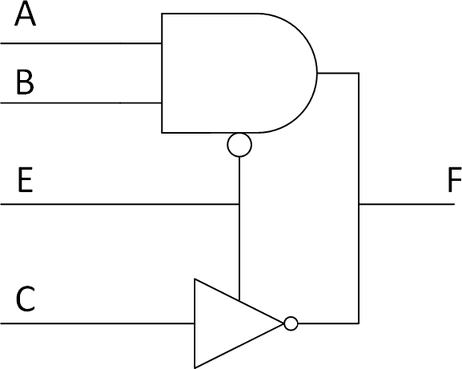
- Without simplification, write the Boolean algebra equation that represents F: (2 points)

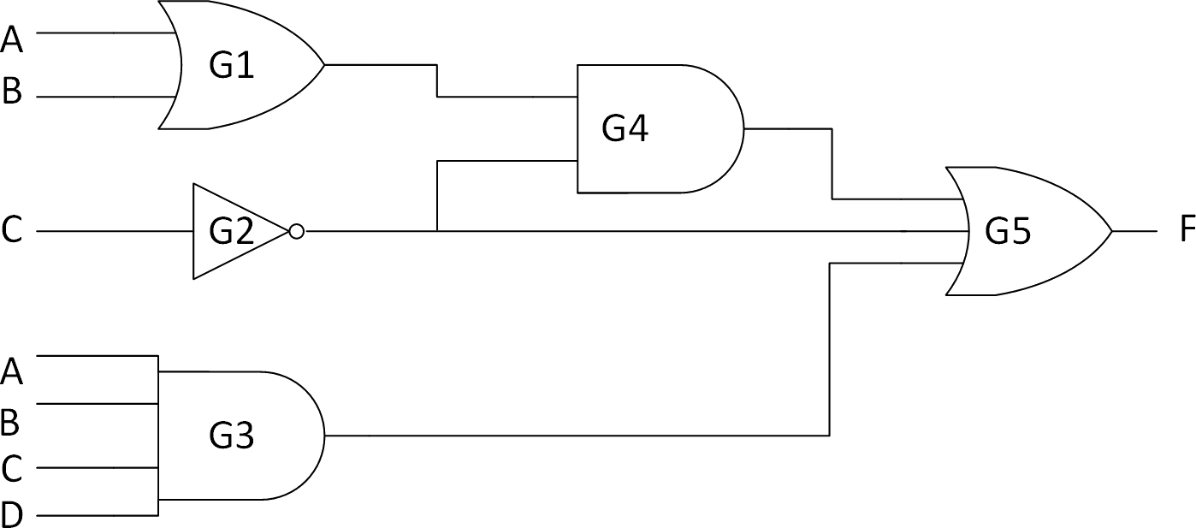
- Fill the table based on the Logic diagram (3 points)
Gate | Delay (ns) | Fan_{in} | Driving Load
G1 | 2
G2 | 1
G3 | 3
G4 | 2
G5 | 2

- What is the worst-case delay? (1 point)

- What is the worst-case delay path? (1 point)

  - You are required to mark the V_{IL}, V_{IH}, V_{OL}, V_{OH} parameters on the following diagram given that the values of these parameters are selected from the set {0.5v , 1.0v , 3.5v , 4.2v}*. (2 points)
*(Voltage values are given in ascending order, i.e. not necessarily in the same order of the V_{IL}, V_{IH}, V_{OL}, V_{OH} parameters)
Input voltages |  | Output voltages
 | 4v
 | 3v
 | 2v
 | 1v
 | 0v

  - Calculate the Noise Margin for logic 1 (NM₁)? (1 point)

Blank Page

