Question 3. (12 points)

  - Express the Boolean function Y of the following given circuit as a Boolean expression without simplification: (3 points)

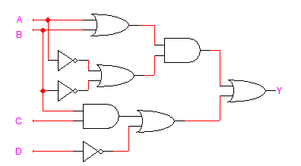

  - Given the Boolean function $F\left(X,Y,Z\right)=\left(X+Y\right)\left(\overline{X}+Z\right)(\overline{Y}+\overline{Z})$: (6 points)
- Express F as a product-of-maxterms, $F=\prod{M}$.
- Find the algebraic sum-of-minterms expression for F.

  - Given that $F(A,B,C)=\sum{m}\left(0,2,5,6\right)$ and $G\left(A,B,C\right)=\prod{M}\left(1,2,5,7\right),$ express the function $F.\overline{G}$ as a sum-of-minterms. (3 points)

