Question 1. (12 points)

- Given the following Boolean function:
$$F\left(X,Y,Z\right)=\left(X+Y\right)\left(X+Z\right)(\overline{X}+\overline{Z})$$
  - (2 points) Express F as a sum-of-minterms, $F=\sum{m}$.
  - (2 points) Find the algebraic product-of-Maxterms expression for F.

- (4 points) Given that $F(A,B,C)=\sum{m}\left(0,3,5,7\right)$ and $G\left(A,B,C\right)=\prod{M}\left(1,2,4,7\right).$ Express the function $F+\overline{G}$ as a sum of minterms.

- (4 points) Given the following two circuits representing the functions F and G. Determine whether the two functions F and G are equivalent or not. Justify your answer.

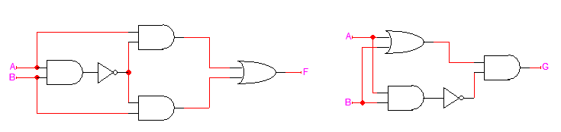

Question 2. (10 points)

- Consider the circuit shown below. Assume that the propagation delay of a gate is related to its number of inputs, i.e. the propagation delays through an Inverter, through a 2-input AND, through a 3-input AND, and through a 2-input OR gates are 1 ns, 2 ns, 3 ns and 2 ns, respectively.
- (2 point) What is the longest propagation delay from an input to the output?
- (3 points) Assuming that the values at the following inputs are stable having the values A=0, B=1, C=1, D=1, and F=0, draw the signals that can be observed at the points G, H, and Y due to a change in signal E by completing the timing diagram given below.

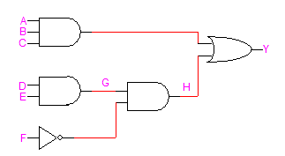

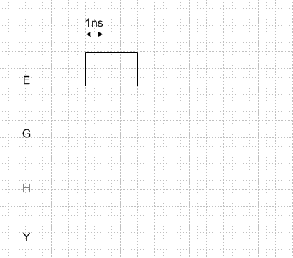

- (2 points) Given an inverter with the following parameters V_{OH}=5v V_{OL}=0v, V_{IH}=2.8v, V_{IL}=1.6, the noise margins NM_{H}=___________________________ and NM_{L}= __________________________.

- (3 points) The Boolean function implemented by the circuit given below expressed as a sum-of products is F = ______________________________________________________________________________.

