***King Fahd University of Petroleum and Minerals***

***College of Computer Science and Engineering***

***Computer Engineering Department***

**COE 202: Digital Logic Design (3-0-3)**

**Term 131 (FALL 2013)**

**Major Exam 1**

**Saturday October 5, 2013**

**Time: 90 minutes, Total Pages: 8**

**Name:________________________________ ID:______________ Section: _______**

**Notes:**

* Do not open the exam book until instructed
* **No Calculators are allowed** (*basic, advanced, cell phones, etc*.)
* Answer all questions
* All steps must be shown
* Any assumptions made must be clearly stated

|  |  |  |
| --- | --- | --- |
| **Question** | **Maximum Points** | **Your Points** |
| **1** | **20** |  |
| **2** | **15** |  |
| **3** | **15** |  |
| **4** | **12** |  |
| **5** | **8** |  |
| **Total** | **70** |  |

**Question 1. (20 points)**

# **Fill the blank in each of the following questions:**

# 1. The decimal value of the binary number (11110000.101)2 is (________________)10.

# 2. The decimal value of the hexadecimal number (3F.4)16 is (________________)10.

# 3. The decimal number (240.75)10 is represented in binary as (________________)2.

# 4. The octal number (57.33)8 is represented in hexadecimal as (________________)16.

# 5. The result of (01011111)2 + (00101111)2 is (________________)2.

# 6. The result of (F0)16 - (CA)16 is (________________)16.

# 7. The result of (32)16 * (9A)16 is (________________)16.

# 8. The number 62 is represented in BCD as _____________________________.

# 9. Given that the base R number (123)R is equal to (83)10. Then the base R = ______.

10. In binary system, the largest decimal value that can be expressed using 4 integer bits and 4 fractional bits is ___________________________.

**Question 2. (15 points)**

* 1. Given that 72 students have registered in the COE 202 course, and that each of these students should be assigned a unique *n-*bit binary code. Find the following: **(6 Points)**

1. The minimum value of *n* is _________
2. The number of additional students that the code can accommodate is __________
3. If out of this *n-*bit , *m* bits are dedicated to indicate the student section
   1. With four equal size sections, *m = ______ , and*  each section can have_______ additional students register per section
   2. With five sections, *m = ____ , and*  each section can have up to ____ students.

II. An 8-bit binary bit pattern consists of an ASCII character code in the 7 least significant bits, together with a parity bit in the MSB. If the HEX value of this pattern is ~~of~~ (E4)16, answer the following: **(3 Points)**

1. The parity used is _________ (Even / Odd)
2. The character code is ___________ representing the character __________

{*Hint: Alphabet characters are given* ***sequential ASCII codes*** *starting* with *A =* (41)16*,* (Upper Case) *or* with *a =* (61)16 (LowerCase)}

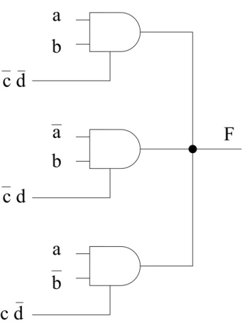**III.**

|  |  |
| --- | --- |
| a b c d | F |
| 0 0 0 0 |  |
| 0 0 0 1 |  |
| 0 0 1 0 |  |
| 0 0 1 1 |  |
| 0 1 0 0 |  |
| 0 1 0 1 |  |
| 0 1 1 0 |  |
| 0 1 1 1 |  |
| 1 0 0 0 |  |
| 1 0 0 1 |  |
| 1 0 1 0 |  |
| 1 0 1 1 |  |
| 1 1 0 0 |  |
| 1 1 0 1 |  |
| 1 1 1 0 |  |
| 1 1 1 1 |  |

The shown circuit uses three 2-Input Tri-state AND gates. Fill-in the Truth Table for this shown circuit indicating the value of the output signal **F** either as 0, 1, or Hi-Z.

**(6 Points)**

**Question 3. (15 points)**

Use Boolean algebra to solve the following questions. Show clearly all your steps.

|  |
| --- |
| (5 points) |
| (5 Points) |
| (4 Points) |
| d. Express F in the logic diagram shown as a function of the input variables. (1 Point)  Do not do any logic manipulations. |

**Question 4. (12 points)**

1. Given the following Boolean function:
 $$F\left(X,Y,Z\right)=(X+YZ)(\overline{XY\overline{Z}})$$

  1. **(4 points)** Find the truth table represented by *F*.
   2. **(2 points)** Find the **sum-of-minterms** expression, $\sum{m}$, for *F*.
   3. **(2 points)** Find the ***algebraic* product-of-Maxterms** expression for the **complement** of *F*.
2. **(4 points)** By distributing the OR operation over the AND operation, find the **product-of-Maxterms** expression, $\prod{M}$, for the following Boolean function:

$$G(A,B,C,D,E)=AB+\overline{CD}+E$$

**Question 5. (8 points)**

Consider the circuit shown below. The propagation delays through the NOT, AND, and OR gates are 1 ns, 2 ns, and 3 ns, respectively.

1. What is the longest path connecting an input to the output? (1 pt)
2. What is the delay along this path? (1 pt)
3. Draw the signals that can be observed at the points H, I, G, and F. (6 pts)

