***King Fahd University of Petroleum and Minerals***

***College of Computer Science and Engineering***

***Computer Engineering Department***

**COE 202: Digital Logic Design (3-0-3)**

**Term 112 (Spring 2013)**

**Major Exam 1**

**Thursday February 28, 2013**

**Time: 90 minutes, Total Pages: 8**

**Name:________________________________ ID:______________ Section: _______**

**Notes:**

* Do not open the exam book until instructed
* **Calculators are not allowed** (*basic, advanced, cell phones, etc*.)
* Answer all questions
* All steps must be shown
* Any assumptions made must be clearly stated

|  |  |  |
| --- | --- | --- |
| **Question** | **Maximum Points** | **Your Points** |
| **1** | **25** |  |
| **2** | **15** |  |
| **3** | **10** |  |
| **4** | **10** |  |
| **Total** | **60** |  |

**Question 1. (25 points)**

1. Perform the following arithmetic operations in the specified number system. **(8 points)**

|  |  |  |  |
| --- | --- | --- | --- |
| **Binary**  **Subtraction**  **1 0 0 0 . 1 0**  **+ 0 1 1 1 . 0 1**  **_________________** | **Hexadecimal**  **Addition**  **2 F 3 A**  **+ 4 B C 2**  **__________________** | **Binary**  **Addition**  **1 0 0 1 . 1 1**  **+ 0 1 1 0 . 0 1**  **_________________** | **Octal**  **Multiplication**  **1 2 7 1**  **× 1 2**  **___________________** |

1. Give the binary, octal, and hexadecimal representations of the decimal value **130. (4 points)**
2. Suppose that we want to represent the decimal fraction 0.6.  **(7 points)**
   1. Find the 4-bit binary fraction that gives the closest value.
   2. Find the 2-Digit Hexadecimal fraction that gives the closest value.
   3. What do you observe?
   4. Without calculations, give the 4-digit Octal representation.
3. Write the sequence of hexadecimal numbers from 9F7 to A03.  **(2 points)**
4. There are 26 letters in the English alphabet. Each letter has two possible shapes capital and small. Answer the following.  **(4 points)**
   1. If you are to assign a binary code to represent only these letters, what is the minimum number of bits needed for such encoding
5. Suggest an encoding that makes the conversion process between capital and small letters the easiest. In your suggested encoding, give the binary codes of ‘A’, ‘B’, Z’, ‘a’, ‘b’, and ‘z’.

**Question 2. (15 points)**

*Using* ***Algebraic manipulation***:

1. **(5 points)** Simplify the function $F\left(X, Y, Z\right)= \overline{X} \overline{Y} \overline{Z}+\overline{X} \overline{Y} Z+\overline{X} Y Z+X \overline{Y} Z +X Y Z$ to **three** literals.
2. **(5 points)** Show that the function $F\left(A, B, C\right)= \overline{A} \overline{B}+A C+B \overline{C}$ is equal to the function $G\left(A, B, C\right)= A B+\overline{A} \overline{C}+\overline{B} C$ by starting from F and reaching to G.
3. **(5 points)** Provide a simplified sum-of-product (SOP) expression for the **complement** of the function: $F\left(A, B, C, D\right)=\left(A+\overline{B} C\right)\overline{D}+\left(\overline{A}+\overline{C}\right)\left(B+D\right)$

**Question 3. (10 points)**



a. Give the logic diagram for the function F as given above (without simplifications)

b. Express F(X,Y,Z) as a sum of products



c. Express F as a sum of minterms in the form

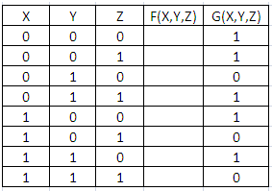

d. Fill in the column for F in the truth table shown

e. For the function G(X,Y,Z) in the truth table above:

* Express G as a product of maxterms in the form
* Express G as an *algebraic* product of Maxterms, G(X,Y,Z) = __________________________



**Question 4. (10 points)**

1. For each of the following four circuits, indicate whether the circuit is valid or not by circling (T) when valid or (F) when Not *where* A, B, E1, and E2 are independent of one another and may assume any possible binary values.
2. For each valid circuit, give the Boolean expression of its output.

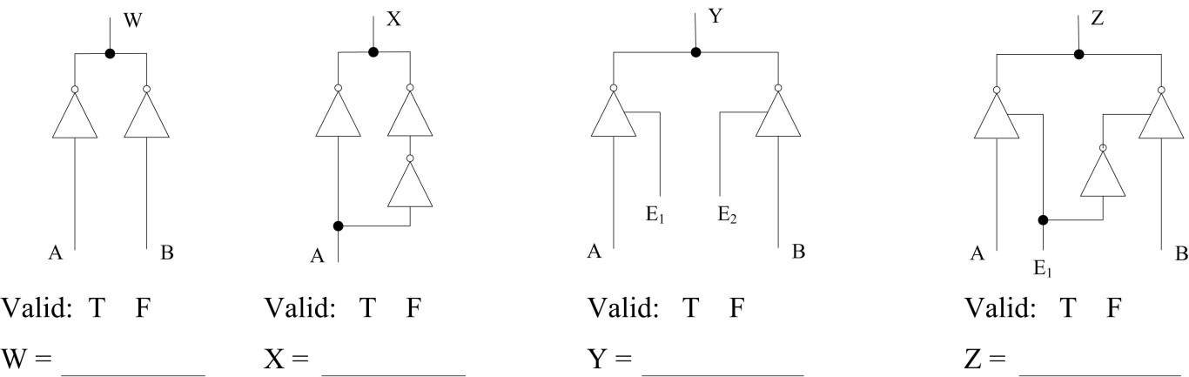

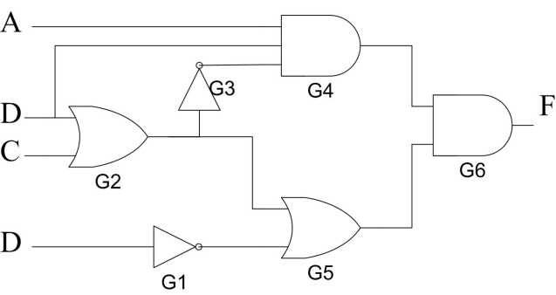

1. Given the propagation delay of the basic gates; INVERTERs 1ns each, AND gates 3ns each and OR gates 5ns each answer the following:
2. What is the critical path delay (longest propagation delay along a path in this circuit)? What is the maximum frequency at which the circuit may be operated?
3. The largest gate fanin is of gate
4. The gate that is driving the largest load is gate