King Fahd University of Petroleum and Minerals
College of Computer Science and Engineering
Computer Engineering Department

COE 202: Digital Logic Design (3-0-3)
Term 201 (Fall 2020)
Major Exam 1
Saturday Oct. 10, 2020

Time: 100 minutes, Total Pages: 8

Name:_________________________________ ID:________________ Section: _______

Notes:
- Do not start the exam until instructed
- No bases conversion Calculators or tools are allowed
- Answer all questions
- Any assumptions made must be clearly stated

Question | Maximum Points | Your Points
Q1 | 6
Q2 | 5
Q3 | 14
Total | 25

Dr. Aiman El-Maleh

Question 1: Answer the following questions by indicating whether the given statement is True or False: (6 points)

- (1 point) Given a function of 3 variables F(a,b,c), the term b c represents minterm m3.
  - True
  - False

- (1 point) Given of a function of 4 variables F(a, b, c, d), the term (a+b+c'+d) represents maxterm M2.
  - True
  - False

- (1 point) The two functions F1(a,b,c,d) = a' c' + b d + a c + a d and F2(a,b,c,d) = (a'+c+d) (a+b+c') (a+c'+d) are equivalent. .
  - True
  - False

- (1 point) A 4-input NAND gate can be implemented using three 2-input NAND gates.
  - True
  - False

- (1 point) The dual and the complement of the function F = a b' + a' b produce equivalent functions.
  - True
  - False

- (1 point) Given that 100 students have enrolled in COE 202. The students are distributed into 5 sections, each having 20 students. Assigning a binary code for each section and then assigning a binary ID code for each student within the section results in the same number of bits as assigning a unique binary code for each of the 100 students.
  - True
  - False

Question 2. Answer the following questions by selecting the correct choice: (6 points)

- (1 point) The Boolean function F(a,b,c,d) = b c' d + a' b d + a b c + b c d' has the following number of minterms:
  - 5
  - 6
  - 7
  - 8

- (1 point) The Boolean function F(a,b,c) = (a+b)(a+c') has the following number of maxterms:
- 1
- 2
- 3
- 4

- (1 point) Given that F(a, b, c) = ∑m(0, 3, 5, 7) and G(a, b, c) = ∏M(0, 1, 2), the function resulting from ANDing F and G' (i.e. F.G') has the following number of maxterms:
- 1
- 3
- 5
- 7

- (1 point) We would like to implement the 3-input AND gate F = A B C. Suppose that we can use any number of 2-input NAND and 2-input NOR gates. The minimum number of 2-input NAND / NOR gates to implement F is:
- 3
- 4
- 5
- 6

- (1 point) Given that the Hexadecimal fraction (0.1XC) is equal to the fraction (0.01123) in base 4, the value of X is:
- 3
- 4
- 5
- 6

Question 3. Answer the following questions by filling the blank: (14 points)

- (1 point) Given the following implementation of function Y. Assume that the delay of each gate is equal to the number of inputs (i.e., the delay of an inverter is 1ns, the delay of a 2-input AND/OR gate is 2ns, the delay of a 3-input AND/OR gate is 3ns). The propagation delay for this circuit is: ____ (write your answer as a number without adding the unit).

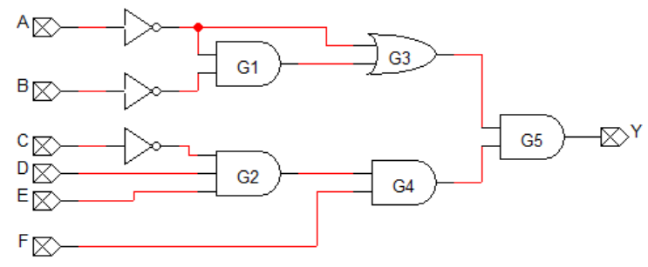

- (1 point) Given the function F(a, b, c) = a b + c', the number of product terms with each one having two literals in the complement of the function F (i.e. F') represented in sum of products is: ____ (put your answer as a single number)

- (1 point) Implementing the given circuit using only 2-input NAND gates, the minimum number of required two-input NAND gates is: ____ (write your answer as a single number)

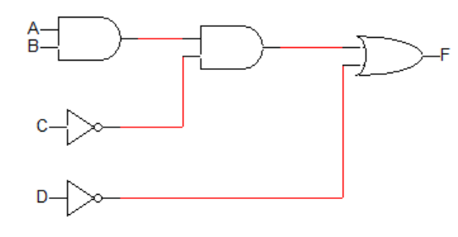

- (1 point) The number of literals in the minimized sum of product function implemented by the following circuit is: ____ (write your answer as a single number)

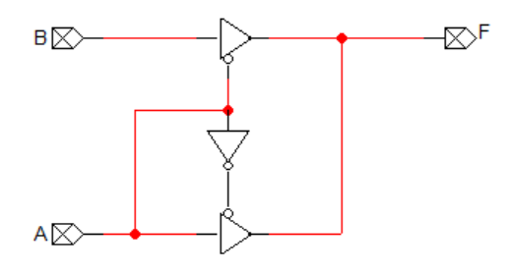

- (1 point) The minimum number of literals resulting from minimizing the function F = a b + a' c' + b' d + c d' into a minimum sum of product expression is: ____ (write your answer as a single number)

- (1 point) The minimum number of literals resulting from minimizing the function F = a b + a b' c + a d' + a c' d into a minimum sum of product expression is: ____ (write your answer as a single number)

- (1 point) The minimum number of literals resulting from minimizing the function F = (a + b)(a +c)(a' + b') into a minimum sum of product expression is: ____ (write your answer as a single number)

- (1 point) The minimum number of literals resulting from minimizing the function F = (a'+b)(b+c')(a+b+d)(b+c+d') into a minimum sum of product expression is: ____ (write your answer as a single number)

- (1 point) Given that the decimal value of the number (2 y 3) represented in base R is equal to 163 and that R=2y. The value of the base R that satisfies this equation is: ____ (write your answer as a single number)

- (1 point) The decimal number 987 is represented in excess-3 code as: _______________ (represent your answer in binary by writing the bits without leaving spaces)

- (1 point) Suppose that a receiver received the 8-bit message represented in hexadecimal as FE without any errors. Assuming that the most significant bit (i.e. bit 7) is the parity bit, the parity used is: ____ (write your answer as either even or odd)

- (1 point) Given that the square of the hexadecimal number (1 x) [i.e. (1 x)^2) ] is equal to the hexadecimal number (1 B 9), the value of the digit x is: ____ (write your answer as a single number)

- (1 point) Assume that an alphabetic character is transmitted and the 8-bit binary code 1100 0110 is received by the receiver. Assuming that no error has occurred during transmission, then the transmitted character is: ____ (Note that bit 7 is the parity bit and the ASCII code for 'a' =0x61 and that for 'A'=0x41) (write your answer as a single character without using quotes)

- (1 point) The value of m that satisfies the equation $\sum_{n=0}^{3}{(7×}8^{n})=2^{m}-1$ is: ____ (write your answer as a single number)

