Herzberg Table I

Number of Vibrations of each species for the point group having non-degenerate vibrations only

Point group | Species | Number of vibrationª
C₂ | a  b | 3m + m₀ - 2  3m + 2m₀ - 4
C_{s} ≡ C_{1h} | a’  a” | 3m + 2m₀ - 3  3m + m₀ - 3
C_{i} ≡ S₂ | a_{g}  a_{u} | 3m - 3  3m + 3m₀ - 3
C_{2v} | a₁  a₂  b₁  b₂ | 3m +2m_{xz} + 2m_{yz} + m₀ - 1  3m + m_{xz} + m_{yz} - 1  3m + 2m_{xz} + m_{yz} + m₀ - 2  3m + m_{xz} + 2m_{yz} + m₀ - 2
C_{2h} | a_{g}  a_{u}  b_{g}  b_{u} | 3m + 2m_{h} + m₂ - 1  3m + m_{h} + m₂ + m₀ - 1  3m + m_{h} + 2m₂ - 2  3m + 2m_{h} + 2m₂ + 2m₀ - 2
D₂ ≡ V | a  b₁  b₂  b₃ | 3m + m_{2z} + m_{2y} + m_{2z}  3m + 2m_{2z} + 2m_{2y} + m_{2z} + m₀ - 2  3m + 2m_{2z} + m_{2y} + 2m_{2z} + m₀ - 2  3m + m_{2z} + 2m_{2y} + 2m_{2z} + m₀ - 2
D_{2h} ≡ V_{h} | a_{g}  a_{u}  b_{1g}  b_{1u}  b_{2g}  b_{2u}  b_{3g}  b_{3u} | 3m + 2m_{xy} + 2m_{xz} + 2m_{yz} + m_{2x} + m_{2y} + m_{2z}  3m + m_{xy} + m_{2y} + m_{2z}  3m + 2m_{xy} + m_{xy} +m_{yz} + m_{2x} + m_{2y} - 1  3m + m_{xy} + 2m_{xz} + 2m_{yz} +m_{2x} + m_{2y} + m_{2z} + m₀ - 1  3m + m_{zy} + 2m_{xz} + m_{yz} + m_{2x} + m_{2z} - 1  3m + 2m_{zy} + m_{xz} + 2m_{yz} + m_{2x} + m_{2y} + m_{2z} + m₀ - 1  3m + m_{zy} + m_{xz} + 2m_{yz} + m_{2y} + m_{2z} -1  3m + 2m_{zy} + 2m_{xz} + m_{yz} + m_{2x} + m_{2y} + m_{2z} + m₀ - 1

m is always the number of sets of equivalent nuclei not on any
element of symmetry;

m₀ is the number of nuclei lying on all symmetry elements present;

m_{xv}, m_{xz} are the number of sets of nuclei lying on the xy, xz, yz plane respectively but not on any axes going through these planes;

m₂ is the number of nuclei on a two-fold axis but not at the point of intersection with another element of symmetry; m_{2s}, m_{2y}, m_{2z} are the numbers of sets of nuclei lying on the x, y, or z axis if they are two-fold axes, but not on all of them;

m_{h} is the number of sets of nuclei on a plane σ_{h} but not on the axis perpendicular to this plane.

Example: water molecule:
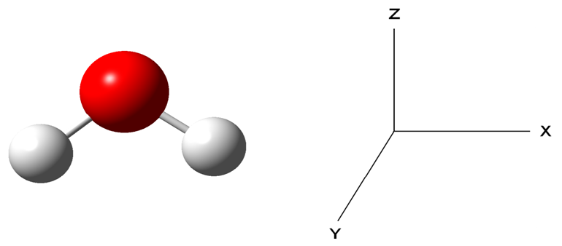
The (XZ) plane is the σ_{v} plane and the (YZ) is the σ_{v}’ plane.
Then:
m = 0 (no sets of equivalent nuclei not on any element of
symmetry; the set of H atoms is lying on the σ_{v} plane)
m₀ = 1 (O atom is lying on all elements of symmetry)
m_{xz} = 1 (one set of H atoms is lying on the σ_{v} plane and on C₂ axis)
m_{yz} = 0 (no set of atoms is lying on σ_{v}’ and on C₂ axis)

Therefore,

A1 = 3m +2m_{xz} + 2m_{yz} + m₀ – 1 = 3x0 + 2x1 + 2x0 + 1x1 -1 = 3-1 = 2
A2 = 3m + m_{xz} + m_{yz}– 1 = 3x0 + 1x1 + 1x0 -1 = 1-1 = 0
B1 = 3m + 2m_{xz} + m_{yz} + m₀ – 2 = 3x0 + 2x1 + 1x0 + 1x1 -2 = 3-2 = 1
B2 = 3m + m_{xz} + 2m_{yz} + m₀ – 2 = 3x0 + 1x1 + 2x0 + 1x1 -2 = 2-2 = 0
∴ Γ_{vib} = 2A1 + 1B1 (for water)

Herzberg Table II
Number of Vibrations of each species for the point group having degenerate vibrations only

Point group | Species | Number of vibrationª
C₃ | a  e | 3m + m₀ - 2  3m + 2m₀ - 2
D₃ | a₁  a₂  e | 3m + m₂ + m₃  3m + 2m₂ + m₃ + m₀ – 2  6m + 3m₂ + 3m₃ + m₀ - 2
C_{3v} | a₁  a₂  e | 3m +2m_{v} + m₀ - 1  3m + m_{v} - 1  6m + 3m_{v} + m₀ - 2
C_{3h} | a’  a”  e’  e” | 3m + 2m_{h} + m₃ - 1  3m + m_{h} + m₃ + m₀ - 1  3m + 2m_{h} + m₃ + m₀ - 1  3m + m_{h} + m₃ - 1
D₃h | a₁’  a₁”  a₂’  a₂”  e’  e” | 3m + 2m_{v} + 2m_{h} + m₂ + m₃  3m + m_{v} + m_{h}  3m + m_{v} + 2m_{h} + m₂ – 1  3m + 2m_{v} + m_{h} + m₂ + m₃ + m₀ – 1  6m + 3m_{v} + 4m_{h} + 2m₂ + m₃ + m₀ – 1  6m + 3m_{v} + 2m_{h} + m₂ + m₃ – 1

m is the number of sets of equivalent nuclei not on any symmetry
element;

m₂, m₃, … are the number of sets of two, three, … axes but not on any other symmetry element which does not wholly coincide with;

m is the number of sets of equivalent nuclei not on any symmetry
element;

m_{v}, m_{h} are the number of sets of σ_{v}, σ_{h} planes respectively but not on any other symmetry element which does not wholly coincide with.

