Chapter 2 Atoms, Molecules and Ions

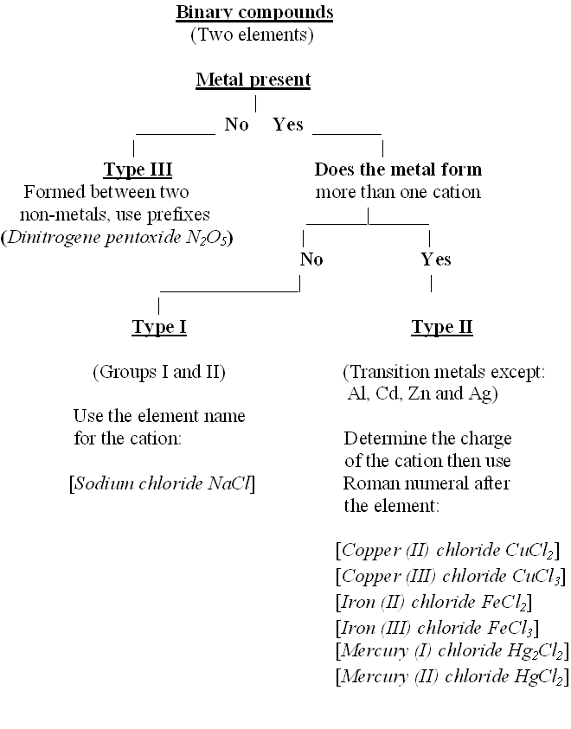

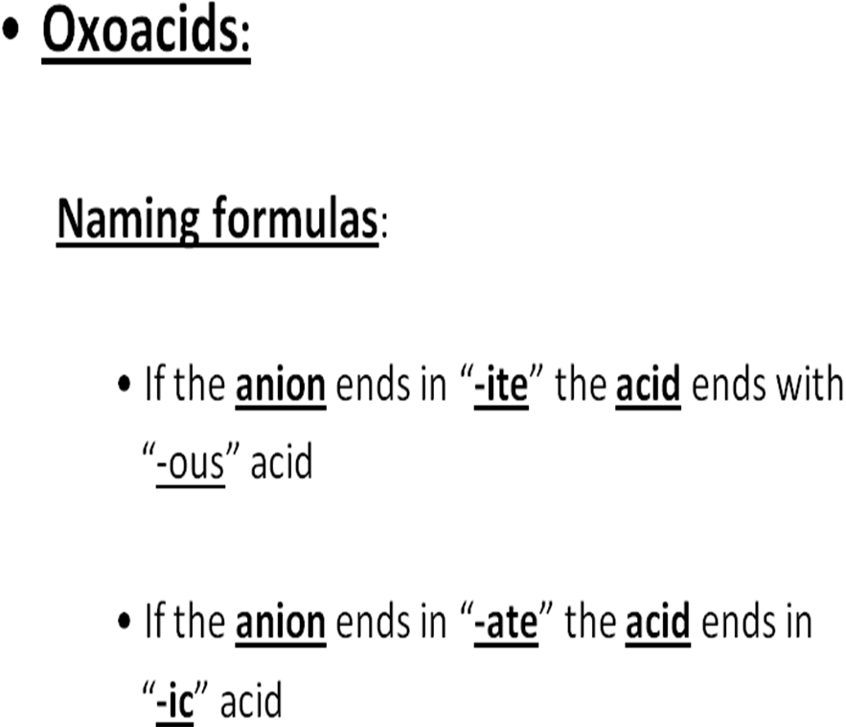

Mineral acids:
Formula Anion Acid

HNO₃ Nitrate Nitric acid
HNO₂ Nitrite Nitrous acid
H₂SO₄ Sulfate Sulfuric acid
H₂SO₃ Sulfite Sulfurous acid

Oxyacids:
Formula Anion Acid

HClO₄ Perchlorate Perchloric acid
HClO₃ Chlorate Chloric acid
HClO₂ Chlorite Chlorous acid
HClO Hypochlorite Hypochlorous acid

Exercise :

For a sample of copper Cu:
Mass of ⁶³Cu = 62.93 amu (69.09 %)
Mass of ⁶⁵Cu = 64.93 amu (30.91 %)
Calculate average mass of Cu

Answer:
Average mass = (0.6909)(62.93) + (0.3091)(64.93)
= 63.55 amu (of Cu)

Chem 101 Chapter 2: Selected Old Exams Questions:
(All correct answers are A):

1. Rutherford's experiment with α particle scattering by a gold foil established
That:

A) atoms do not have a diffuse cloud of positive charge

(yes: the strong scattering of only a few particles indicated a dense,
positive nucleus)

B) electrons have a negative charge

(that is correct, but was from Thomson's cathode ray experiment)

C) electrons have a positive charge

(that is clear nonsense)

D) atoms are made of protons, neutrons, and electrons

(that is correct, but no consequence of Rutherford's experiment with a
gold foil)

E) protons are 1840 times heavier than electrons

(that is also correct, but again not from Rutherford's experiments)

2. What is the formula for the ionic compound formed by aluminum and sulfite
ions?

A) Al₂(SO₃)₃ B) AlSO₃ C) AlSO₄
D) Al₂(SO₄)₃ E) Al₃SO₄

(Al is a representative metallic element and its monoatomic ion is Al³⁺,
main group IIIa. Sulfite is SO₃²⁻ while SO₄²⁻ is sulfate (higher oxygen
content. Charge neutrality requires thus (Al³⁺)₂(SO₃²⁻)₃ = Al₂(SO₃)₃ for
aluminum sulfite giving 6 positive and 6 negative charges)
3. What is the correct name of the formula MnO?

A) Manganese (II) oxide B) Manganese (I) oxide
C) Manganese oxide D) Manganese (III) oxide
E) Manganese monoxide
(O²⁻ (main group VIa, 2 steps to the next larger noble gas): oxide ion Mn
is a transition metal and can form more than 1 cation. It must be Mn²⁺
for charge neutrality of MnO. A type II binary ionic compound must
have the charge number of the cation in roman numerals in brackets
after the cationic element: Manganese (II) oxide)

4. Which of the following statements is FALSE?

A. A chemical compound may not always contain the same elements in the same proportion.

[A compound ALWAYS contains the same elements in the same
proportion (law of definite proportions)]

B. In a chemical reaction, the masses of the reactants equals the masses of the products.

(ALWAYS true)

C. Atoms of different elements have different properties.

(ALWAYS true)

D. All atoms of a given element show the same chemical properties.

(ALWAYS true)

E. In compounds AB₂ and AB₃ the masses of B that combine with 1 g of A are in a ratio of small whole numbers.

(Law of multiple proportions, ALWAYS true)
5. Which of the following is NOT a conclusion of Rutherford's alpha-particle scattering experiment?

A. The nucleus of an atom contains neutrons and protons.
(Rutherford's scattering experiment tells nothing about the particles in a nucleus)
B. Most of the mass of an atom is concentrated in the nucleus.
(That is exactly the result of the experement)
C. The atom is mostly empty space.
(Same as B)
D. The nucleus is positively charged.
(Yes, because the positive alpha-particles are repelled by the
nucleus)
E. The electrons of an atom are outside its nucleus.
(When the nucleus is positive (D) then the negative electrons must be outside)

6. A reaction between 2 L of nitrogen gas (N₂) and 3 L of oxygen gas (O₂) yields 2 L of a gaseous product. All gas volumes are at the same temperature and pressure. What is the formula of the gaseous product?

A. N₂O₃ B. NO C. NO₂
D. NO₃ E. N₂O

(Avogadro's law: at the same temperature and pressure equal volumes of gases contain equal numbers of particles.
Thus 2L N₂ + 3L O₂ → 2L X, or in atoms 4 N + 6 O → 2 X
And X = (N₄O₆)/2 = N₂O₃

7. The ion ⁵⁵Fe²⁺ contains

A. 26 protons, 29 neutrons and 24 electrons
B. 23 protons, 32 neutrons and 21 electrons
C. 23 protons, 32 neutrons and 23 electrons
D. 26 protons, 24 neutrons and 24 electrons
E. 26 protons, 29 neutrons and 28 electrons

(n + p = 55; periodic table: Fe is atomic number 26 and thus p = 26
n = 55 - p = 55 - 26 = 29. The ion is 2+, thus there must be 2
negative electrons less than positive protons: e = 26 - 2 = 24)

8. Which of the following statements is NOT correct:

A) There can only be one compound formed by any pair of elements.

B) All samples of sodium chloride have the same composition, no matter
what the source.

C) In chemical reactions the sum of the masses of the reactants equals the
sum of the masses of the products.

D) The amount of sodium that will combine with one gram of chlorine to
form sodium chloride is a fixed number.

E) In the group of compounds NO, N₂O and NO₂ each one is an example
of the law of definite proportions.

(B - E are certainly correct, while A contradicts E and thus A is
incorrect)

7. Which one of the following is named correctly?

A) aluminum nitride, AlN
B) ammonia, NH₄⁺
C) calcium sulfide, Ca(HS)₂
D) iron(III) oxide, FeO
E) bromic acid, HBrO₂

(A: aluminum nitride, Al³⁺N³⁻, a type I binary ionic compound and thus
correct)

(B: NH₄⁺ is the ammonium cation and not ammonia, NH₃)

(C: Ca(HS)₂ is calcium hydrogensulfide and not calcium sulfide, Ca²⁺S²⁻)

(D: Fe²⁺O²⁻ is iron (II) oxide, and not iron (III) oxide, Fe₂O₃)

(E, HBrO₂ is bromous acid and not bromic acid, HBrO₃)

8. An element has 34 protons, 36 electrons, and 44 neutrons. What isotope is it?

A) ⁷⁸₃₄Se²⁻
B) ⁸⁰₃₆Kr
C) ⁷⁸₃₄Se⁻
D) ⁷⁸₃₄Se
E) ⁴⁴₃₆Kr

(34, the number of protons gives the atomic number. Thus it must be ₃₄Se.
The upper number is the mass number and thus the number of protons +
the number of neutrons = 34 + 44 = 78. The number of electrons is by 2
larger than the number of protons, and thus the isotope must have a double
negative charge, 2-)

9. A reaction of 1 liter N₂ gas with 2 liters of O₂ gas yields 1 liter of a gaseous
product. What is the formula of the product if all volumes are at the same
temperature and pressure?

A) N₂O₄ B) NO₃ C) NO D) N₂O₅ E) N₂O₃

(Avogadro's law says, that at the same T and P equal volumes of gases
contain equal numbers of molecules. Thus, assuming that 1 L N₂ contains
n molecules N₂, then 2 L O₂ must contain 2n O₂ molecules and 1 L
product must contain n product molecules: n N₂ molecules and thus 2n N
atoms + 2n O₂ molecules and thus 4n O atoms → n product molecules
which thus must be n N₂O₄ molecules)

10. The symbol of the element antimony is:

A) Sb
(Correct; the symbol derives from the old latin name of antimony,
Stibium)

B) He
(Helium is from helios, Greek for the sun, because it was first found in
the sun spectroscopically).

C) Na
(Sodium is from the German name Natrium).

D) Ag
(Silver is from the latin name Argentum).

E) Au
(Gold is from the latin name Aurum).

11. Which of the following statements is true?

A) Nonmetals tend to form anions

(It was several times mentioned in class that this is true)

B) The horizontal rows of elements in the periodic table are called groups

(NO: periods)

C) The vertical columns of elements in the periodic table are called periods

(NO: groups)

D) Most of the elements are nonmetals

(NO: metals)

E) Elements of the first vertical column of the periodic table are called
alkaline earth metals

(NO: alkaline metals; alkaline earth metals are in the second column)

12. The systematic name of CaSeO₃ is:

A) Calcium selenite B) Calcium selenate C) Calcium (II) selenate

D) Calcium (II) selenite E) Calcium selenide

(C, D: Calcium, Ca, is representative group II and thus has only Ca²⁺
cations and thus the naming must be according to type I and not to type II.
E: A selenide denotes a monoatomic anion of selenium, which would be
Se²⁻ without any oxygen.
Se is right below S in the periodic table. Thus, since SO₄²⁻ is sulfate,
SeO₄²⁻ is selenate, and since SO₃²⁻ is sulfite, SeO₃²⁻ is selenite and A is the
correct)

13. The chemical symbol of an ion is ⁶⁰Co²⁺. The numbers of neutrons and
electrons for this ion are, respectively:

A) 33 and 25 B) 60 and 27 C) 60 and 25 D) 27 and 60

E) 33 and 29

(The periodic table tells that the atomic number of Co is 27. Thus the
number of protons in a Co nucleus is p = 27. Since the mass number A =
60 = p + n, the number of neutrons in the nucleus is n = 60 - 27 = 33. Since
the ion is 2+, there must be 2 negative electrons less than there are positve
protons and thus the number of electrons e = p - 2 = 27 - 2 = 25 and the
correct choice is A).

14. A cation of element X forms an ionic compound with bromine, having the
formula XBr₂. If the ion of element X has a mass number of 230 and 86
electrons, how many neutrons does the element X have?

A) 142 B) 157 C) 194
D) 189 E) 174

Br: representative group VIIa (halogen), needs 1 step to the next larger noble gas and thus its monoatomic anion is Br⁻.

So the formula XBr₂ contains 2 negative charges from Br, and thus X must have 2 positive charges for charge neutrality: X²⁺

So X²⁺ must have 2 positive protons more than it has negative electrons: p = 86 + 2 = 88

Since mass number 230 = n + p, the number of neutrons is n = 230 - 88 = 142

