CHEM 101 Dr. Al-Saadi Work Sheet # 5
(Thermochemistry)

1) A sample of gas at 15.0 atm and 10.0 L is allowed to expand against a constant external pressure of 2.00 atm at a constant temperature. Calculate the work in the unit of kJ for the gas expansion.
Ans: -13.2 kJ

2) As a system increases in volume, it absorbs 52.5 J of energy in the form of heat from the surrounding. The piston is working against a pressure of 380.0 mm Hg. The final volume of the system is 58.0 L. What was the initial volume of the system if the internal energy of the system has decreased by 102.5 J?
Ans: 54.9 L

3) What is the change in the internal energy for a process where a piston expands against 1.00 atm of pressure from 11.2 L to 29.1 L. In the process, 1037 J of heat is absorbed.
Ans: -770 J

4) The overall reaction in a commercial heat pack can be represented as:

4 Fe (s) + 3 O₂ (g) → 2 Fe₂O₃ (s) ΔH = –1652 kJ

- How much heat is released when 4.00 mol iron is reacted with excess O₂?
Ans: 1650 kJ

- How much heat is released when 1.00 mol Fe₂O₃ is produced?
Ans: 826 kJ

- How much heat is released when 1.00 g iron is reacted with excess O₂?
Ans: 7.39 kJ

- How much heat is released when 10.0 g Fe and 2.00 g O₂ are reacted?
Ans: 34.4 kJ

5) Consider the combustion reaction of propane:

C₃H₈(g) + 5O₂(g) → 3CO₂(g) + 4H₂O(l) ΔH = –2221 kJ

Assuming that you want to produce an amount of heat of 1.3×10⁸ J to inflate a balloon, what mass of propane must be burned to furnish this amount of energy assuming that the heat transfer process is 60.% efficient?
Ans: 4.4×10³ g of propane.

6) For the following reaction:

2H₂ (g) + O₂ (g) → 2H₂O(l) ΔH = –572 kJ

- How much heat is evolved for the production of 1.00 mol of water?
Ans: 286 kJ

- How much heat is evolved when 4.03 g of hydrogen is reacted with excess oxygen?
Ans: 572 kJ
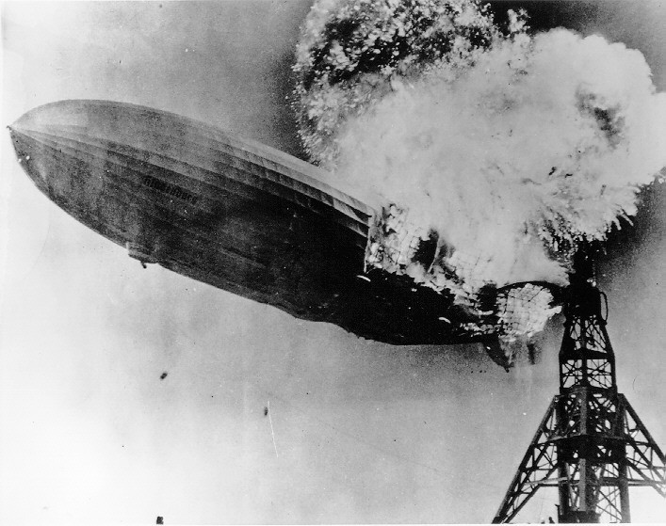
- The total volume of hydrogen gas needed to fill the Hindenburg was 2.0×10⁸ L at 1.0 atm and 25°C. How much heat was evolved in the Hindenburg disaster assuming all the hydrogen gas was burned?
Ans: 2.3×10⁹ kJ

7) Consider the dissolution of CaCl₂:

CaCl₂(s) → Ca²⁺(aq) + 2Cl–(aq) ΔH = –81.5 kJ

In a specific experiment, 11.0 g of calcium chloride was dissolved in 125 g of water at 25.0°C. Calculate the final temperature of the solution assuming no heat lost to the surrounding. The specific heat of the solution is 4.18 J/°C·g.
Ans: 39.2°C

8) When a sample of metal weighing 150.0 g at 75.0°C is added to 150.0 g of water at 15.0°C, the temperature of the water raises to 18.3°C. Assuming all the heat lost by metal is absorbed by the water, what is the specific heat capacity of the metal?
Ans: 0.25 J/°C·g

