CHEM 101 Dr. Al-Saadi Work Sheet # 10 (Gases)
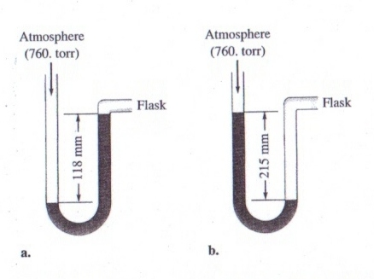

1) For each of the following situations, calculate the pressure
inside the flask in torrs, mm Hg, atmospheres, and pascals.

2) Consider the following chemical equation:

2NO₂(g) → N₂O₄(g)

If 25.0 mL of NO₂ gas is completely converted to N₂O₄ gas under the same conditions, what volume would the N₂O₄ gas occupy?

3) A 2.50 L container is filled with 175 g argon. If the pressure is 10.0 atm, what is the temperature?

4) A compressed gas cylinder contains 1.00×10³ g of argon gas. The pressure inside the cylinder is 2050. psi (pounds per squared inch) at a temperature of 18°C. How much gas remains in the cylinder if the pressure is decreased to 650. psi at a temperature of 26°C.

5) Sulfur trioxide is produced in a two-step reaction according to:

S(s) + O₂(g) → SO₂(g)
2SO₂(g) + O₂(g) → 2SO₃(g)

What volume of O₂(g) at 350.°C and a pressure of 5.25 atm is needed to completely covert 5.00 g of sulfur to sulfur trioxide?

6) An unknown diatomic gas has a density of 3.146 g/L at STP. What is the identity of the gas?

7) A 1.00-L gas sample at 100.°C and 600. torr contains 50.0% helium and 50.0% xenon by mass. What are the partial pressures of the individual gases?

8) Hydrogen azide, HN₃, decomposes on heating by the following unbalanced equation:

HN₃(g) → N₂(g) + H₂(g)

If 3.0 atm of pure HN₃(g) is decomposed initially:
- What is the final total pressure in the reaction container?
- What are the partial pressures of nitrogen and oxygen gases?
Assume that the volume and temperature of the reaction container are constant.

9) Consider two gases A and B, each in a 1.0-L container with both gases at the same temperature and pressure. The mass of gas A in the container is 0.34 g and the mass of gas B in the other container is 0.48 g. Answer the following questions:
a) Which gas sample has the most molecules present?
b) Which gas sample has the largest average kinetic energies?
c) Which gas sample has the fastest average velocity?
d) How can the pressure in the two containers be equal to each other since the larger gas B molecules collide with container walls more forcefully?

10) (a) Do all molecules in a 1-mol sample of CH₄(g) have the same average kinetic energy at 273 K?
(b) Do all molecules in a 1-mol sample of N₂ have the same velocity at 500 K?

11) Calculate the average kinetic energies of CH₄ and N₂ molecules at 273 K and 546 K. Also calculate the root mean square velocities of CH₄ and N₂ molecules at 273 K and 546 K

12) A 100.-L flask contains a mixture of methane and argon at 25°C. The mass of argon present in 228 g and the mole fraction of methane in the mixture is 0.650. Calculate the total kinetic energy of the gaseous mixture?

13) Freon-12 is used as a refrigerant in air conditioners. The rate of effusion of Freon-12 to Freon-11 (molar mass = 137.4 g/mol) is 1.07:1. The formula of Freon-12 is:

- CF₄.
- CF₃Cl.
- CF₂Cl₂.
- CFCl₃.
- CCl₄.

14) It took 4.5 minutes for 1.0 L helium to effuse through a porous barrier. How long will it take for 1.0 L of Cl₂ gas to effuse under the same condition?

15) Calculate the partial pressure of helium in dry air assuming that the total atmospheric pressure is 1.0 atm. The mole fraction of helium in atmosphere is 5.24×10⁻⁶. Assuming the temperature is 25°C, calculate the number of He atoms in one cubic centimeter.

