King Fahd University of Petroleum & Minerals
Chemistry Department

Organic Chemistry II (CHEM 202)

( 052)

First Major Exam

March 17, 2006
Dr. I. Forristal
Dr. A. J. Hamdan

Name----------------------------------------------- ID#........................... Section #----------

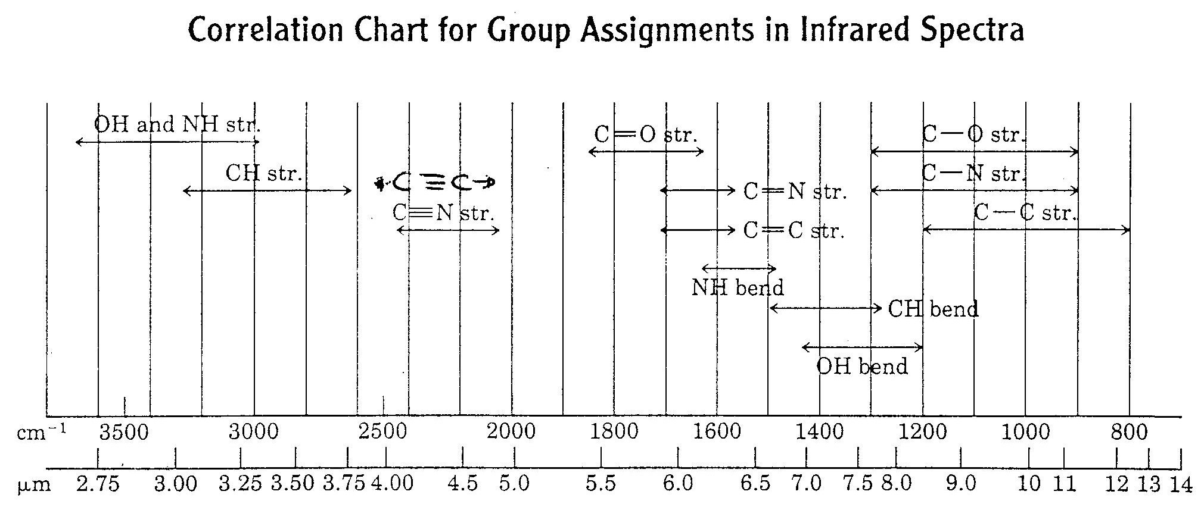

(4 pts)
Q.1 What compounds could be aromatic among the following:

a) I, II, and III
b) II, III, and IV
c) I, II, and IV
d) I, III, and IV
e) I and IV

(14 pts)
Q.2 Give the reaction products for each of the following:

( 6 points)

Q.2 Provide the necessarily reagents needed for the following transformation

Q.3 How would you make the following conversions?
( 4 points)

(6 points)

(6 points)

