King Fahd University of Petroleum & Minerals
Chemistry Department

Organic Chemistry II (CHEM 202)

( 042)

First Major Exam

March 15, 2005
Dr. H. Perzanowski
Dr. A. J. Hamdan

Name----------------------------------------------- ID#........................... Section #----------

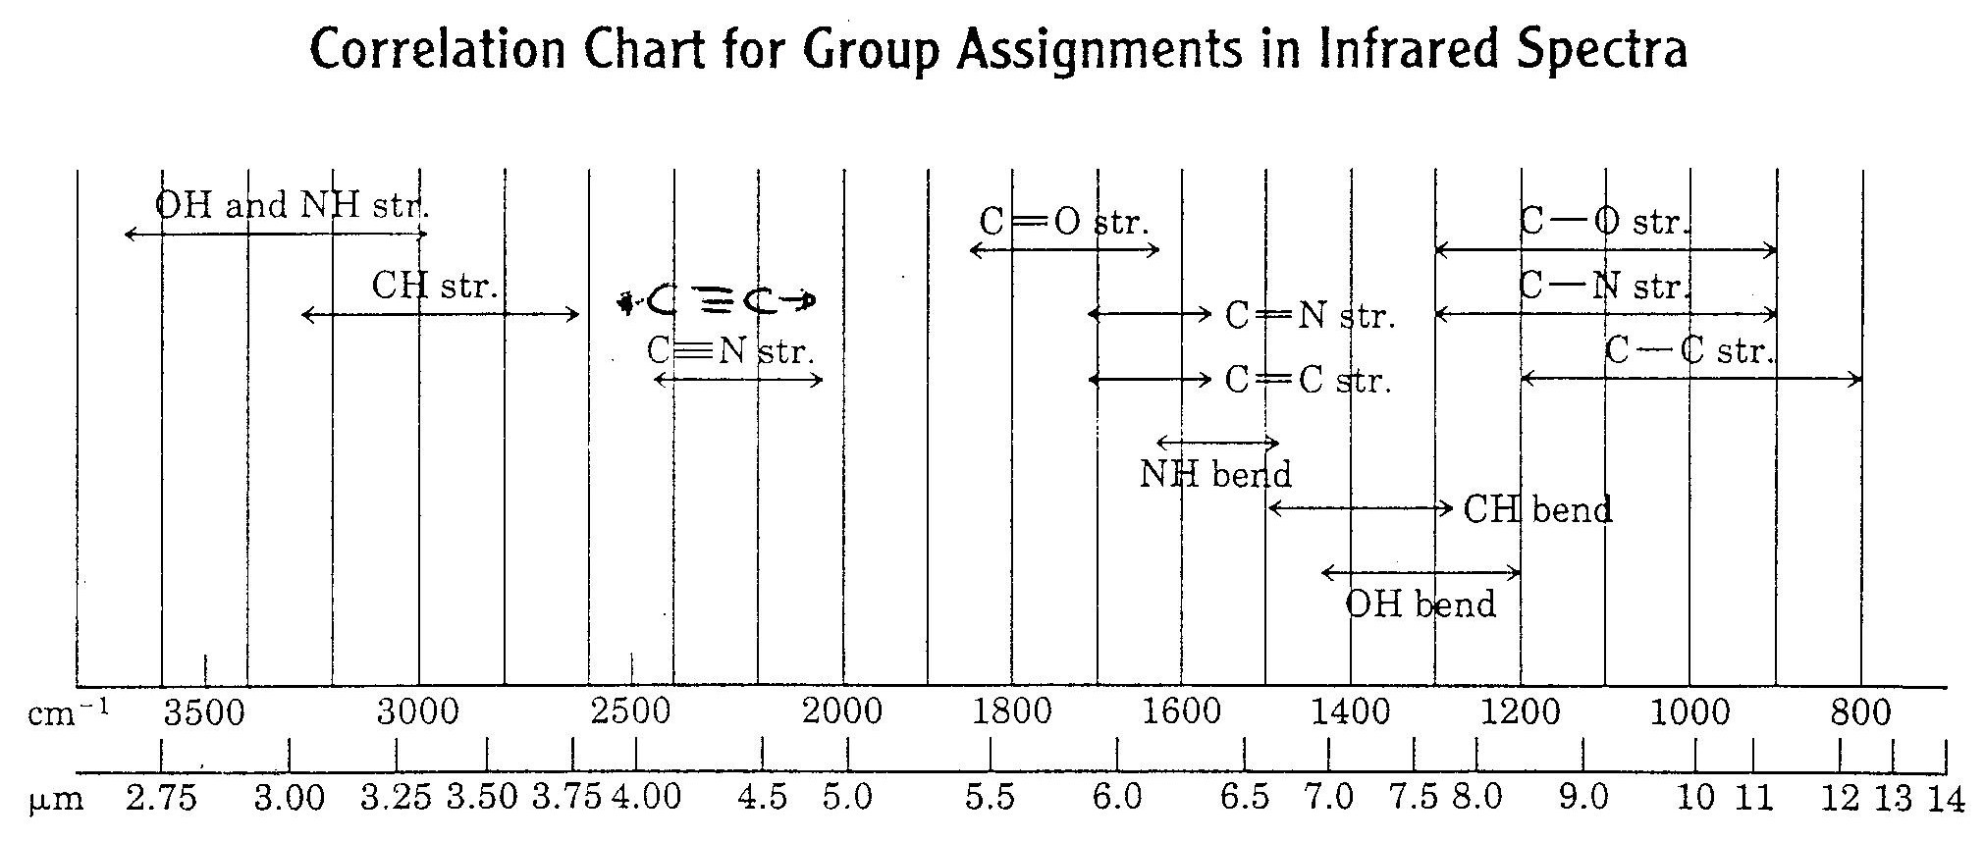

( 14points)
Q.1 Predict the major organic product(s) for each of the following reactions.

( 6 points)
Q.2 Provide the missing reagents in the following transformation.

(4 points)
Q.3 Write a mechanism for the following reaction. Be sure to show the appropriate arrows to indicate the flow of electrons.

Q.3 Show how you would make the following conversions.

( 4 points)

( 6 points)

( 6 points)

