King Fahd University of Petroleum & Minerals

DEPARTMENT OF CHEMICAL ENGINEERING

CHE 495 Integrated Design Course (1-6-3)

TERM 031

Problem Statement

Introduction
Saudi Arabia runs 30 desalination plants that produce more than 3 million cubic meters of desalinated water per day and 5000 megawatts of electricity. This desalination production represents 21% of the world production. The desalination industry in Saudi Arabia was first established in 1928 (1348H). The first plant was built at Al-Kandasa to provide Jeddah with drinking water. The latest plant to be commissioned was Shoiba phase II in 2002 (1423 H). The world largest desalination plant is Al-Jubail II, which produces 945,000 m³/day and generates 1150 megawatts. Deatils of all the desalination plants in Saudi Arabia, year of commission, the process used, its capacity and location are listed in Table 1 below. The locations of these plants are shown in Figure 1.
Saudi Arabia continues to develop its desalination industry through research centers. The need for desalination is growing due to the industrial development of the country and the rapid increase in population. At the moment the Saline Water Conversion Corporation (SWCC) has 22 desalination plants under study. The capacity of these plants ranges from 4,500 to 450,000 cubic meters per day. A full list of these projects is given in Table 2. Many of these projects are planned for the Eastern province. These include Al-Jubail phases 3, 4, 5 and 6 and Al-Khobar-4. SWCC has also 15 pipelines under study, most of them to transport potable water to various parts of the Kingdom.
Large desalination plants are not economical unless they are coupled with electricity generation plants. These are referred to as cogeneration plants, i.e for power and water production. The electrical power is first generated by the high level energy, then the low level energy (low pressure steam) is used for water production.
A typical design data is given in Table 3 for one unit (one steam turbine with four desalination plants) of Al-Jubail II. Figure 2 shows the cycle of water desalination and power generation. However, for the sake of this course (CHE 495), only the design of the desalination units (and not the power generation units) will be considered.
Table 1: SWCC Desalination Plants

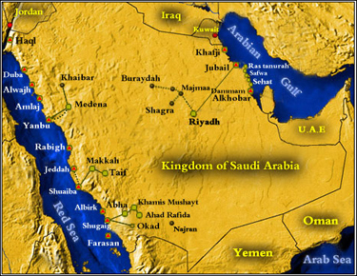
Figure 1: Location of Desalination Plants in Saudi Arabia.
Table 2: Under Study desalination Plants
Table 3: Design data for Al-Jubail Phase II Power and Desalination plant
Figure 2: Al-Jubail Phase II Power/desalination plant
Calculations related to steam and power generation and fuel consumption will be done only if time permits. This table gives a clear idea about the ratio of kg of water produced per 1000 kJ of energy used.
Statement of the Problem
Your assignment is to:
- Synthesize the optimum flow sheet and material balance for a desalination plant (the full details of the generation part of the plant is beyond the scope of this assignment). The conditions are as follows:
Group No. | Product (desalinated water) flowrate (m³/day) | Temperature (of the stream leaving the brine heater)
1 | 350,000 | 115
2 | 300,000 | 115
3 | 250,000 | 115
4 | 200,000 | 115
5 | 350,000 | 95
6 | 300,000 | 95
7 | 250,000 | 95
8 | 2000,000 | 95
- Size and estimate the costs of the major pieces of equipment.
- Estimate the installed equipment capital cost.
- Estimate the manufacturing cost
- Use the net present value (NPV) as the economic indicator estimate the cost of production. Base the estimate on the following: 20 years life, No income tax, 4% inflation rate.

Description of the Desalination Plant
A typical multi stage flash (MSF) desalination plant is shown in Figures 3 and 4. Figure 4 shows the progression from 1 to 2 to 4 stages. The optimum design may be a
Figure 3: A desalination Plant.
Figure 4: Principle of multi-stage flash evaporation.
function of the number of stages. Feed water flows from the gulf in to the plant by gravity. An inclined channel is dug under the sea bed. The total dissolved solids (TDS) in the Arabia Gulf varies according to location. For the area opposite the UAE, the TDS range is between 40,000 to 42,000 ppm. Opposite Oman the TDS level becomes 35000 ppm which is standard level for sea water. Opposite the shores of Saudi Arabia, the TDS levels are much higher due to limited natural circulation. Opposite AL-khobar the TDS concentration range is between 52,000 to 55,000 ppm. Oposite Al-qurrayah it reaches 65,000 ppm.
Chlorine is added at the mouth of the feed channel. A concentration of 0.3 ppm is desirable. The measurement of concentration is done on shore. CO₂ and lime are also injected into the feed water in order to control the pH.
The material of construction is titanium steel for the heat reject section, 90-10 Cu-Ni steel for the heat recovery section and 70-30 Cu-Ni for the brine section.

Process description:

Multi-Stage Flash Desalination Plant

Overview (refer to Figure 5)
The Multistage Flash Evaporator produces distilled water from feedwater by heating it until it is ready to flash. The flashed vapor is drawn to the cooler tube bundle surfaces where it is condensed and collected as distillate.
Flashing occurs when heated brine is turbulated in a chamber which is maintained at a lower vapor pressure than that of the entering heated brine. Heat is given up by the brine and a portion converted into vapor until the temperature of the brine reaches the saturation temperature corresponding to the chamber pressure. In other words, the heated brine is flashed off by a pressure reduction.
Entrained brine droplets are removed from the vapor by entrainment separators and the pure vapor condenses into distillate on the condenser tubes. The distillation process operates from a low vacuum in the first stage to a high vacuum in the last stage, with stage-to-stage pressure differential being the key to the repeated flashing.
Initial vacuum in the stages is created by the high-pressure steam-driven ejector/condenser vacuum system.
The brine recirculation system is designed to operate at a top temperature of about 110°C (230°F) (In your problem this temperature is set at 95 or 115). In order to achieve long run operation of the unit, it is necessary to retard the formation of scale on the heat transfer surfaces. This is accomplished through the chemical treatment systems described later.
The acid-treated brine recirculation system permits operation at higher evaporator temperatures and, at the same time, reduces the amount of feed water chemical treatment required compared with that which would be required for once-through operation at the same temperature.
Brine/Circulating Water Flow
Filtered raw seawater is pumped through the condenser tubes of the heat rejection stages and is discharged. The cool feedwater flowing through the condenser tubes dissipates the heat in these last stages.
A portion of raw seawater is withdrawn as make-up water and the remainder is discharged to the sea. The make-up water is deaerated to remove the non-condensable gases and is treated with sulfuric acid for scale control purposes. The deaerated feedwater is introduced into the brine section of the last stage and mixes with the recirculating brine flow. The mixture of recirculated brine and deaerated feedwater is pumped through the condenser tubes of the heat recovery stages and the brine heater by the brine recirculating pump.
In order to maintain a material balance in the system and control the maximum brine concentration, a portion of the concentrated brine from the last stage is discharged to the ocean as blowdown. The blowdown flow rate is controlled by the brine level in the last stage. As the brine flows through the condenser tubes of the heat recovery stages, it is progressively heated in each stage by flashing brine vapor condensing on the outer tube surfaces. The brine then passes through the tubes of the brine heater for final heating to the design top temperature of about110°C.
The heated recirculating brine is directed to the shell side of the first stage for flashing. The recirculating brine flows into each stage, flashes down, and is discharged from the last stage.
Condensate Flow
Low-pressure steam is used to heat the recirculating brine flowing through the tubes of the brine heater.
The low-pressure steam is piped into the shell side of the brine heater and, by transfer of its heat to the recirculating brine flow, condenses on the outer tube surfaces. Thus, the recirculating brine is heated to its design top temperature. Condensate formed by the condensing steam is piped to the condensate pump and is pumped to the condensate return system.
Distillate Flow
Distillate is formed on the stage condenser tubes by condensation of the flashed brine vapor. The distillate collects in a distillate trough which is common to all the stages and flows from the first stage to the last stage. From there it is pumped into the distillate storage system.
Vacuum System
High pressure steam is used to drive ejectors to create the initial vacuum in the evaporator. Once the plant is in normal operation, the vacuum is maintained by the condensing action in each stage, supported by the ejectors. The ejectors also evacuate non-condensables from the evaporators. The spent high pressure steam and the non-condensables are discharged from the ejectors into condensers where the steam is condensed and the non-condensables are vented to atmosphere.
Acid and Antifoam Injection Systems
A measured amount of sulfuric acid is continuously injected into the make-up flow to neutralize scale-forming elements in the seawater, thereby preventing formation of scale in the stage and brine heater condensing tubes. A measured amount of anti-foam can be injected into the feedwater stream to reduce the foaming characteristics in the evaporator vessel.
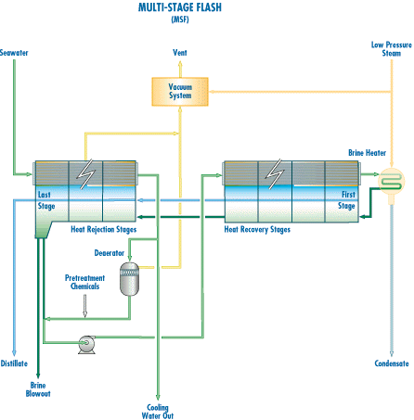

Figure 5: A schematic diagram of a desalination plant
Storage Tanks
Usually a small number of storage tanks are available. The storage capacity is usually enough for about half a day production. The product is usually pumped through the distribution system.
There are fuel oil storage tanks.

Technical data

In a cogeneration plant, the boilers generate steam at 525 C and 80 bars. The steam used for desalination is at a few bars (e.g. 3 bar) and about180 C.

References:
KFUPM Library:
- The USAID Desalination Manual, 1981, TD 479.U82
- Salt Water Purification, K. S> Spiegler, Plenum Press, 1977.
- Desalination Processes and Multistage Flash, Arshad H. Khan, Elsevier, 1986.
- Principles of Desalination, Spiegler and Laird eds. Academic Press, 1980.

N.B. There are books on desalination in KFUPM library written also in Arabic.

Internet:
Use a search engine such as Google or Scirus etc.
See attached examples of these searches.

