EXAMPLE OF MIXTURE PROPORTIONING –
ABSOLUTE VOLUME METHOD

Problem: To proportion a trial mixture that will meet the following conditions and specifications.

Conditions and Specifications: Concrete with a structural design of 40 MPa is required for a bridge that will be exposed to freezing and thawing, deicers, and very severe sulfate soils. A coulomb value not exceeding 1500 is required to minimize permeability to chlorides. Water reducers, air entrainers, and plasticizers are allowed. A shrinkage reducer is requested to keep shrinkage under 300 millionths. Some structural elements exceed a thickness of 1 meter, requiring control on heat development. The concrete producer has a standard deviation of 2 MPa for similar mixes to that required here. For difficult placement areas, a slump of 200 mm to 250 mm is required. The following materials are available:
Cement: Type HS, silica fume modified Portland cement with relative density of 3.14. Silica fume content of 5 %.
Fly ash: Class F, ASTM C 618. Relative density of 2.60.
Slag: Grade 120, ASTM C 989. Relative density of 2.90.
Coarse aggregate: Well graded, 19-mm nominal maximum-size crushed rock with ovendry relative density of 2.68, absorption of 0.5% and ovendry density of 1600Kg/m³. The laboratory sample has a moisture content of 2.0%. This aggregate has a history of alkali-silica reactivity in the field.
Fine aggregate: Natural sand with some crushed particles with an ovendry relative density of 2.64 and absorption of 0.7%. The laboratory sample moisture content is 6%. The fineness modulus is 2.80.
Air-Entraining Admixtures: Synthetic, ASTM C 260. For 8% air content, the air entraining admixture manufacturer recommends a dosage of 0.5 g per Kg of cement.
Retarding Water reducer: Type D ,ASTM C 494. Dosage rate of 3 g per Kg of cement. Plasticizer: Type 1, ASTM C 1017. Dosage of 30 g per Kg of cementing materials.
Assume density of water as 997.75 Kg/m³
The water reducer and plasticizer would also result in a reduction of 15% in total needed water.

SOLUTION:

Strength.
The required compressive strength for proportioning f'_{cr} is given by larger of : f'_{c} + 1.34 S or 0.90f'_{c} + 2.33 S , where S is the Std. deviation.
i.e. f'_{cr} = 40 + 1.34*(2) = 42.7 MPa
or . f'_{cr} = 0.9*40 + 2.33*(2) = 40.7 MPa.
Therefore, f'_{cr} = 42.7 MPa.

w/c ratio: According to Table 9-1, the maximum w/c ratio for concrete in the given condition is 0.40 and a strength of atleast 35 MPa.. However , the recommended w/c ratio on basis of compressive strength of 42.7 MPa is 0.35.

Table 9-1. Maximum Water-Cementitious Material Ratios and Minimum Design Strengths for Various Exposure Conditions

Exposure Condition | Maximum water-cementitious material ratio by mass for concrete | Minimum design compressive strength, f' c , MPa (psi)
Concrete protected from exposure to freezing and thawing, application of deicing chemicals, or aggressive substances. | Select water-cementitious material ratio on basis of strength, workabilty, and finishing needs | Select strength based on structural requirements
Concrete intended to have low permeability when exposed to water | 0.50 | 28 (4000)
Concrete exposed to freezing and thawing in a moist condition or deicers | 0.45 | 31 (4500)
For corrosion protection for reinforced concrete exposed to chlorides from deicing salts, salt water, brackish water, seawater, or spray from these sources | 0.40 | 35 (5000)

Air Content: According to Table 9-5, for severe conditions, a target air content of 6.0% is recommended for aggregate of size 19-mm.Therefore, we can design the mix for 5%-8% air and use 8% for batch proportions. The trail batch air content must be within ±0.5 % of the maximum allowable air content.

Table 9-5 (Metric). Approximate Mixing Water and Target Air Content Requirements for Different Slumps and Nominal Maximum Sizes of Aggregate

Slump, mm | Water, Kilograms per cubic meter of concrete, for indicated sizes of aggregate
Slump, mm | 9.5 mm | 12.5 mm | 19 mm | 25 mm | 37.5 mm | 50 mm | 75 mm | 150 mm
 | Non-air-entrained concrete
25 to 50 | 207 | 199 | 190 | 179 | 166 | 154 | 130 | 113
75 to 100 | 228 | 216 | 205 | 193 | 181 | 169 | 145 | 124
150 to 175 | 243 | 228 | 216 | 202 | 190 | 178 | 160 | -
Appropriate amount of entrapped air in non-air-entrained concrete, percent | 3.0 | 2.5 | 2.0 | 1.5 | 1.0 | 0.5 | 0.3 | 0.2
 | Air-entrained concrete
25 to 50 | 181 | 175 | 168 | 160 | 150 | 142 | 122 | 107
75 to 100 | 202 | 193 | 184 | 175 | 165 | 157 | 133 | 119
150 to 175 | 216 | 205 | 197 | 184 | 174 | 166 | 154 | -
Recommended average total air content, percent, for level of exposure:
Mild exposure | 4.5 | 4.0 | 3.5 | 3.0 | 2.5 | 2.0 | 1.5 | 1.0
Moderate exposure | 6.0 | 5.5 | 5.0 | 4.5 | 4.5 | 4.0 | 3.5 | 3.0
Severe exposure | 7.5 | 7.0 | 6.0 | 6.0 | 5.5 | 5.0 | 4.5 | 4.0

Slump: We assume a slump of 50 mm without the plasticizer and a maximum of 200 mm to 250 mm with plasticizer. However, for proportioning purpose, we shall use 250mm ±20mm.

Water content: In accordance with Table 9-5 or Fig 9-5, the required water content for a 50-mm slump, air-entrained concrete with 19-mm aggregate size is about 168 Kg/m3. However, the water reducer and plasticizer would also result in reduction of 15%. Thus the final water content would be:
168 – (15% of 168) = 142.8 Kg/m³. Say 143 Kg/m³.

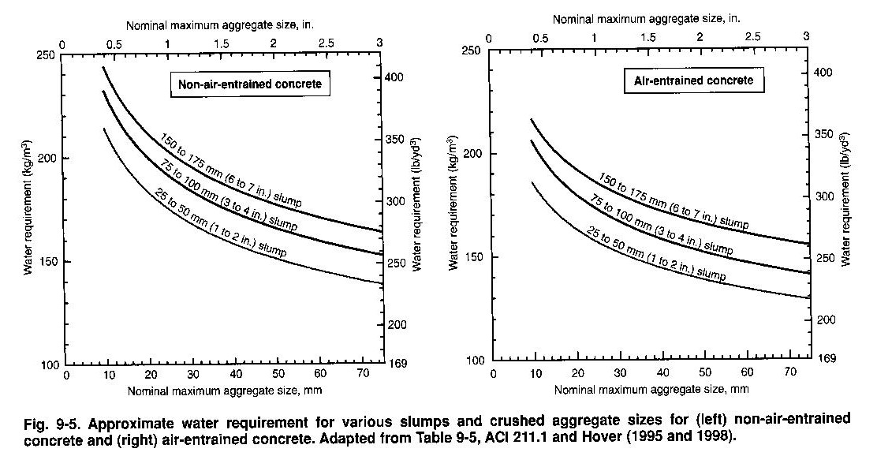

Cement Content: On basis of w/c ratio of 0.35 and water content of 143 Kg/m³,
The cement content required will be:
143/0.35 = 408.57 Kg/m³. Say 409 Kg/m³.
The fly ash and slag addition would control the alkali silica reactivity and also control the temperature rise.
A dosage of 15 % and 30 % is advisable for fly ash and Slag respectively.
Thus , now the cementitious material are:
Cement: 55% of 409 = 225 Kg.
Fly ash: 15% of 409= 61 Kg.
Slag: 30% of 409 = 123 Kg.

These dosages meet the requirements as per Table 9-8.
(2.8% silica fume + 15% fly ash + 30% slag = 47.8 % which is less than the 50% maximum allowed)

Table 9-8. Cementitious Materials Requirements for Concrete Exposed to Deicing Chemicals.

Cementitious Materials | Maximum percent of total cementitious materials by mass
Fly ash and natural pozzolans | 25
Slag | 50
Silica Fume | 10
Total of Fly ash, Silica fume, and natural Pozzolans | 50
Total of natural pozzolans and silica fume | 35

Coarse aggregate content: The bulk volume of CA (of 19-mm size) recommended when using sand with fineness 2.80 is 0.62. (Table 9-4 or Fig 9-3).
Therefore the ovendry mass of CA for a cubic meter of concrete will be density times the volume.
i.e. 1600 * 0.62 = 992 Kg.

Table 9-4. Bulk Volume of Coarse Aggregate Per Unit Volume of Concrete

Nominal maximum size of aggregate, mm (in.) | Bulk volume of dry-rodded coarse aggregate per unit volume of concrete for different fineness moduli of fine aggregate
Nominal maximum size of aggregate, mm (in.) | 2.40 | 2.60 | 2.80 | 3.00
9.5 (3/8) | 0.5 | 0.48 | 0.46 | 0.44
12.5 (1/2) | 0.59 | 0.57 | 0.55 | 0.53
19 (3/4) | 0.66 | 0.64 | 0.62 | 0.6
25 (1) | 0.71 | 0.69 | 0.67 | 0.65
37.5 (11/2) | 0.75 | 0.73 | 0.71 | 0.69
50 (2) | 0.78 | 0.76 | 0.74 | 0.72
75 (3) | 0.82 | 0.8 | 0.78 | 0.76
150 (6) | 0.87 | 0.85 | 0.83 | 0.81

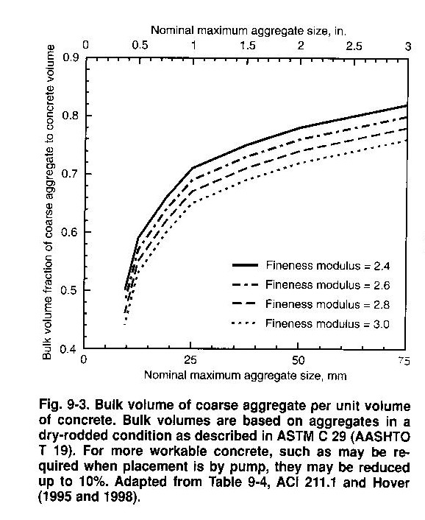

Admixture Content: For 8% air content, the air entraining admixture manufacturer recommends a dosage of 0.5 g per Kg of cement. Hence, the amount of air-entraining admixture per cubic meter of concrete is:
0.5 * 409 = 205 g or 0.205 Kg.
The amount of water reducer per cubic meter of concrete is: 3 * 409 = 1227 g or 1.227 Kg.
The amount of plasticizer per cubic meter of concrete is: 30 * 409 = 12,270 g or 12.270 Kg.
The amount of shrinkage reducer per cubic meter of concrete is: 15 * 409 = 6135 g or 6.135 Kg.

Total Admixture = (0.205 + 1.227 + 12.270 + 6.135) = 19.837 Kg.

Fine Aggregate content:
At this point, we have calculated the amount required of all the ingredients except fine aggregate.
By the Absolute volume method, FA content can be obtained by subtracting the absolute volumes of the known ingredients from 1 cubic meter.

Absolute volume is calculated by dividing the mass of ingredient by the product of its relative density and the density of water. Assume density of water as 997.75 Kg/m³.
Water = = 0.143 m³.
Cement = = 0.072 m³.
Fly ash = = 0.024 m³.
Slag = = 0.043 m³.
Air = = 0.080 m³.
Coarse aggregate = = 0.371 m³.
---------------
Total Volume of known ingredients = 0.733 m³.
Hence, absolute volume of FA is: 1 – 0.733 = 0.267m³.
The mass of dry FA is: 0.267*2.64*997.75 = 703 Kg.

The admixture volumes are:

Air entrainer = = 0.0002 m³.
Water reducer = = 0.0012 m³.
Plasticizer = = 0.0123 m³.
Shrinkage reducer = = 0.0062 m³.
-----------------
Total Volume 0.0199 m³.

Considering the admixture part of mixing water
Mixing water minus admixture = 143 – 19.84 = 123.16 Kg. Say 123 Kg.

Thus, the proportions before trial mixing per cubic meter of concrete are:
Water 123 Kg
Cement 225 Kg
Fly ash 61 Kg
Slag 123 Kg
Coarse aggregate (dry) 992 Kg
Fine aggregate (dry) 703 Kg
Air entraining admixture 0.205 Kg
Water reducer 1.227 Kg
Plasticizer 12.27 Kg
Shrinkage reducer 6.135 Kg
--------------
Total mass 2247 Kg
Slump 250 mm (±20 mm for trial batch)
Air content 8% (±0.5% for trial batch)

Estimated concrete density (using SSD aggregate) =
123 + 225 + 61 + 123 + (992*1.005) + (703*1.007) + 19.84
= 2257 Kg/m³.

Note: (0.5% absorption / 100) + 1 = 1.005
(0.7% absorption / 100) + 1 = 1.007

Correction for moisture:
Test indicates that for this example, CA moisture content is 2 % and FA moisture content is 6 %.
Now the trial batch aggregate proportions become:
CA = 992*1.02 = 1012 Kg.
FA = 703*1.06 = 745 Kg.
Note that water absorbed by the aggregate does not become part of mixing water and hence must be excluded from water adjustment.
Surface moisture contributed by CA = 2 % - 0.5 % = 1.5 %. = 0.015
FA= 6 % - 0.7 % = 5.3 %. = 0.053
Thus, the estimated requirement for added water becomes:
123 – (992*0.015)-(703*.053) = 71 Kg.

Now the revised proportions of batch taking moisture into consideration are:
Water (to be added) 71 Kg
Cement 225 Kg
Fly ash 61 Kg
Slag 123 Kg
Coarse aggregate (2% MC, wet) 1012 Kg
Fine aggregate (6% MC, wet) 745 Kg
Air entraining admixture 0.205 Kg
Water reducer 1.227 Kg
Plasticizer 12.27 Kg
Shrinkage reducer 6.135 Kg
--------------
Total mass 2257 Kg

