King Fahd University of Petroleum & Minerals

CIVIL ENGINEERING DEPARTMENT

CE 203 STRUCTURAL MECHANICS I
First Semester 2012 / 2013 (121)

HOMEWORK NO. 7 (Key Solution)

- Textbook Sections Covered: 5.1 & 5.3 , Torsion of circular shafts

Problem # 1:-

Given Data:

- The shown figure.
- Smooth bearings at D and E (induce zero resistance torque).
- Motor delivers 20 KW of Power to the shaft.
- Turning at 60 rev/sec.
- Gears A, B, and C remove 5 kw, 7 kw, and 8 kw respectively

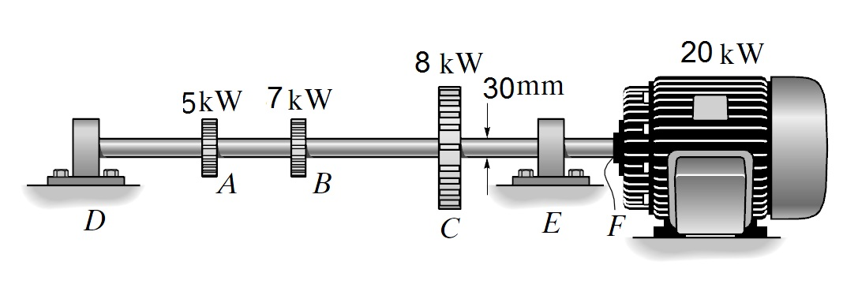
Required:

- The maximum shear stress developed in the shaft within regions CF and BC.

Solution:
As it is shown in the following free body diagram and torque diagram,

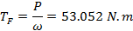
A
B
C
F
T_{A}
T_{B}
T_{C}

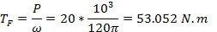
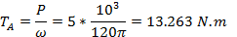
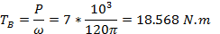
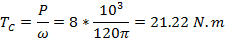

Problem # 2:-

Given Data:

- The shown figure.
- Solid rod AB (d=12 mm).
- Rigid disk at B.
- Tube DC outer diameter is 40 mm and a thickness of 6 mm.
- The max allowable stress is 50 MPa.

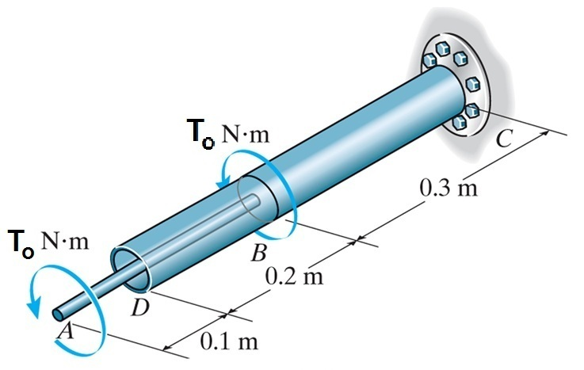

Required:

- The largest value of torque T₀ that can be safely applied.

Solution:
As it is shown in the following free body diagram and torque diagram,

A
B
C
T₀
T₀
T_{C} =2T0

T₀
2T₀
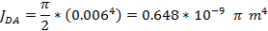

Problem # 3:-
Given Data:

- The shown figure (hollow circular shaft).
- Outer radius = 50 mm ,
- Inner radius = 30 mm

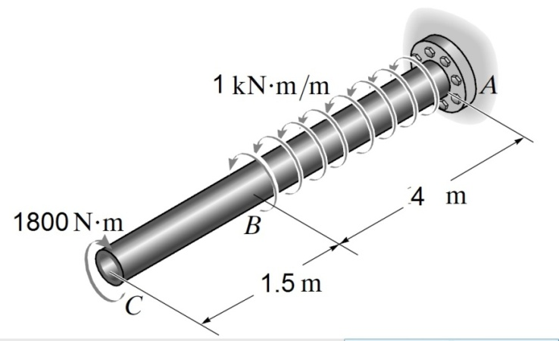
Required:

- The absolute maximum shear stresses in BC
- The absolute maximum shear stresses in BA.
- A diagram sketch for the value of the internal torque T_{R} along axis CA

Solution:
C
B
A
1800N.m
T_{A}

T_{BA}(x) =1kN.m/m

; and
- The diagram sketch for the value of the internal torque T_{R} along axis CA is as follows:-
1800 N.m
1800 N.m
2200 N.m
C
B
A
1.5 m
1.8 m
2.2 m
Ans
(-)
(+)

