بسم الله الرحمن الرحيم
PR-1434
Session-2 Interactions
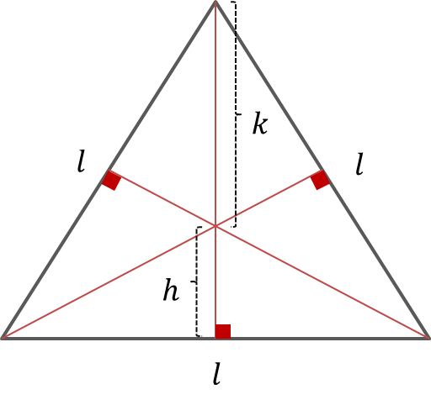
Quiz #1:
In the equilateral triangle shown in figure, find the ratio of $h$to $k$, noting that $h+k=$ height of the triangle.

Quiz#2:
A uniform rigid rod of length $L$ and mass $M$ makes an angle $θ$ with the $z$-axis as shown in figure. Calculate its moment of inertia about the z-axis.
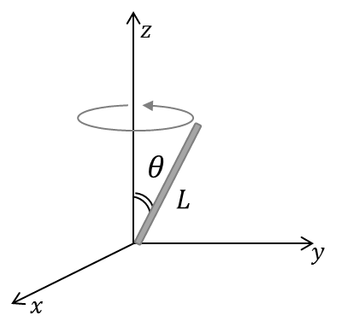

Quiz#3:
What mathematics is important for physicists?

