KING FAHD UNIVERSITY OF PETROLEUM AND MINERALS_________________

DEPARTMENT OF PHYSICS

PHYS 203
Electrical and Magnetic Properties of Materials
( Physics of Semiconductor Devices )

Instructor Dr. Mohammed M. Faiz

Office: Bldg.6 / Room 232 Phone: 860-2284

Res. Lab: Bldg.6 / Room 252 Phone: 860-4105

E-mail: mmfaiz@kfupm.edu.sa

Website: http://faculty.kfupm.edu.sa/PHYS/mmfaiz

COURSE

OBJECTIVE:
Physics (working principle, limitations and performance) of various devices.
This is a minimum requirement for innovation !

TOPICS COVERED:
Concepts of Modern Physics (Chapters-1,2&3) 3 Weeks
Semiconductors (Chapter-4) 2 Weeks
Drift and Diffusion (Chapters-5&6) 2 Weeks
PN-Junction Diode (Chapters-7&8) 3 Weeks
Bipolar Junction Transistor (Chapter-10) 2 Weeks
Field Effect Transistors (Chapter-13) 1 Week
Optoelectronic Devices (Chapter-14) 2 Weeks

Textbook:
D.A. Neamen, “Semiconductor Physics and Devices”, McGraw-Hill, 2003

Additional references:
G. Parker, "Introductory Semiconductor Device Physics", Prentice Hall, 1994
Ben G. Streetman, "Solid State Electronic Devices", Prentice Hall, 1995
Kanaan Kano, "Semiconductor Devices", Prentice Hall, 1998

Pre-requisite: PHYS 102
policy

grading:
Quizzes: 20% ( Based on Homework and Classwork )
1st Major Exam: 20% ( Covers Chapters 1 – 4 )
2nd Major Exam: 20% ( Covers Chapters 5 – 8 )
Final Exam: 40% ( Comprehensive )

ATTENDANCE:
Attendance record will be considered for boarder line cases.
DN grade will be reported for more than 9 absences.

HOMEWORK:
Homework will not be collected. However, you are urged to solve all problems before seeing the solutions.
Solutions and other announcements will be posted on the course WebCT-page:
https://webcourses.kfupm.edu.sa/webct

QUIZ:
There will be a Quiz in each Chapter.
All Quizzes are important.
There is no make up for the quizzes.

MAKE-UP EXAM:
Make-up exams will be given only for students who have officially documented excuses.

Office Hours
Saturday Monday Wednesday 9:00 – 11:00 am
or by appointment.

PHYS-203 Lecture Schedule (Term 121)

Week # |  |  | Topics |  | Chapter |  |  |  | Sections |  |  | HW Problems
1  01−05 Sep. |  |  | The Crystal Structure of Solids |  | 1 |  |  |  | 1−5 |  |  | 1,2,3,4,5,8,17
2  08−12 Sep. |  |  | Introduction to Modern Physics, Energy levels in atoms |  | 2 |  |  |  | 1, 4 |  |  | 5,7,9,11,12,38
3  15-19 Sep. |  |  | Introduction to the Quantum Theory of Solids: Energy bands in solids, conductors, semiconductors, insulators |  | 3 |  |  |  | 1−5 |  |  | 16,17,18,30,31,  35,39,42
4−5  22 Sep.−03 Oct. |  |  | The Semiconductor in Equilibrium |  | 4 |  |  |  | 1−3,5−6 |  |  | 18,22,29,33,48,  51,56
6  06−10 Oct. |  |  | Carrier Transport Phenomena |  | 5 |  |  |  | 1−2,4 |  |  | 1,2,5,23,27,40,42
Sunday – 07 Oct. 2012 – First Major Exam (Chapters 1– 4)
7  13−17 Oct. |  | Non equilibrium excess carriers in Semiconductors |  |  |  | 6 |  | 1−2 |  |  | 2,4,6,18
Eid Holidays 18 Oct.−02 Nov. 2012
8-9  03−14 Nov. |  | PN Junction |  |  |  | 7 |  | 1−3 |  |  | 2,5,7,17,22,25
10  17-21 Nov. | PN Junction Diode |  |  | 8 |  |  | 1−2,4 |  |  | 2,8,10,14,22,26,  40
11−12  24 Nov.−05 Dec. | Bipolar Junction Transistor (BJT) |  |  | 10 |  |  | 1−4 |  |  | 3,5,9,18,21,34,45

Sunday – 25 Nov. 2012 – Second Major Exam (Chapters 5– 8)
13  08−12 Dec. | The Junction Field Effect Transsitor (JFET) |  |  | 13 |  |  | 1−2 |  |  | 3,5,7,10,13
14−15  15-26 Dec.. | Optoelectronic devices: Solar cells, Photodetectors, LED, Laser Diodes. |  |  | 14 |  |  | 1−3,5-6 |  |  | 2,3,4,10,14,17,2023

Thursday - 03 Jan. 2013 - 7:30 am. - Final Exam
Wish you a successful semester

HISTORY OF ELECTRONICS

1897 (Thomson) Discovery of Electron

1904 (Fleming) 1st Vacuum Tube

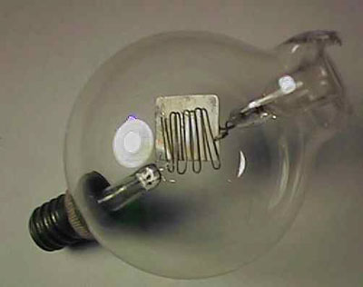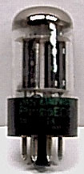

1947 (Bell Labs) 1st Transistor (Ge) (Dim. 15 cm)

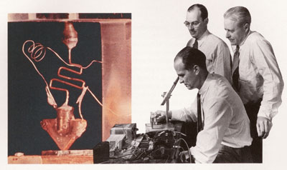
Shockley, Bardeen & Brattein (all Physicists) received Nobel Prize in 1956 for this innovation.
1956 (Tx.I) Si-based Transistor (T_{max}: 200 ⁰C)

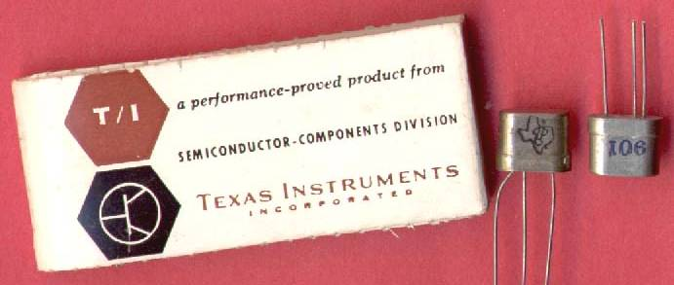

1959 (Tx.I) 1st Integrated Circuit

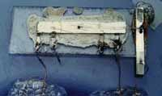

1971 (Intel) Microprocessor

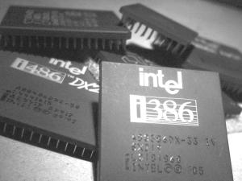

1986 10⁶ Transistors in a chip (miniaturization)

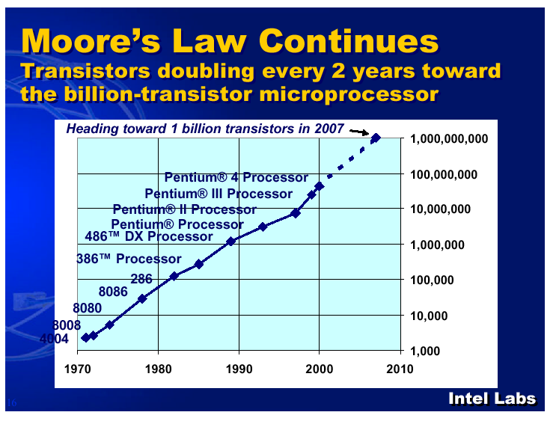
1981 (IBM) Scanning Tunneling Microscope

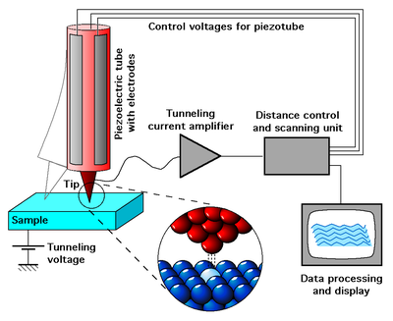

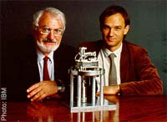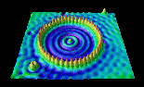

Rohrer & Binnig Fe / Cu(111)

received Nobel Prize in 1986 for this innovation.

INTRODUCTION

Material Type Resistivity (ρ) Use in IC’s

Conductor < 10⁻³ Ω.cm Connectors

Semiconductor 10⁻³ – 10⁵ Ω.cm Devices

Insulator > 10⁵ Ω.cm Isolators

Semiconductor is interesting because their properties are influenced by:
- Temperature
- Doping
- Light

CRYSTAL STRUCTURE
(Chapter 1)

Lattice Periodic arrangement of atoms in a solid

Crystalline Regular arrangement

Amorphous Random arrangement

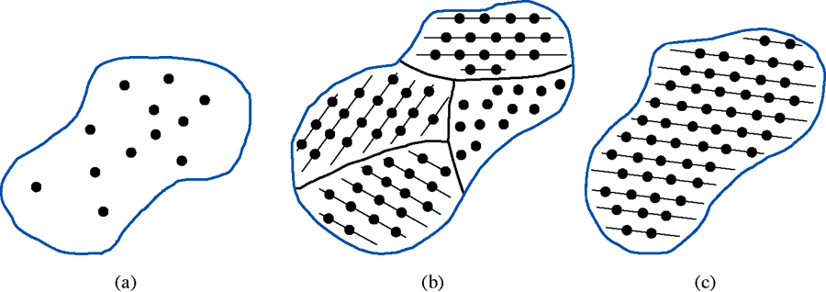
e.g. Rubber Quartz Si

Unit cell Smallest unit that reproduces the lattice

Lattice constant Length of a side of the unit cell

Grain Single crystal portion of a poly crystal

Grain boundary boundary between two grains

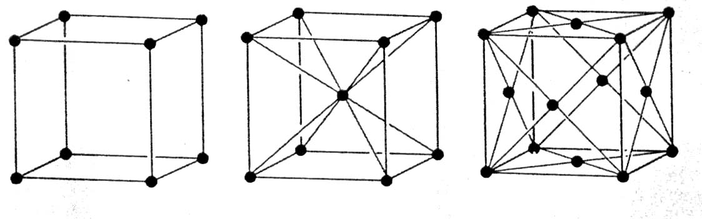
SC BCC FCC

Speed of e, performance, and cost of a device made of
Single X’l > Poly X’l > Amorphous

Properties of a solid depend on its crystal structure.
e.g. graphite vs diamond vs C-60 buckyball

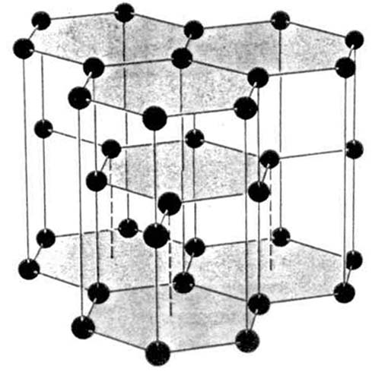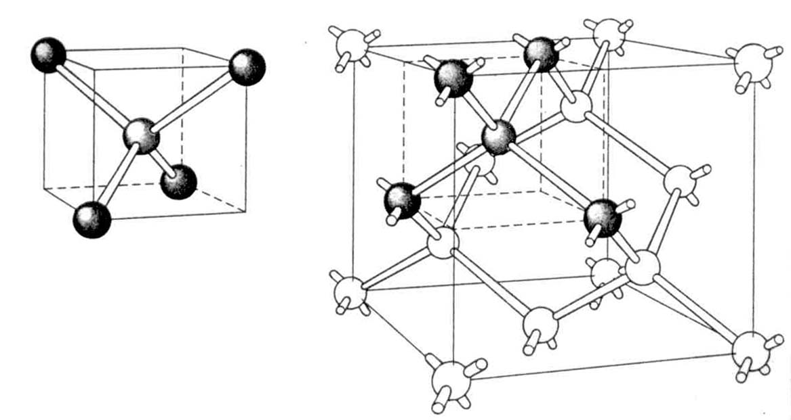
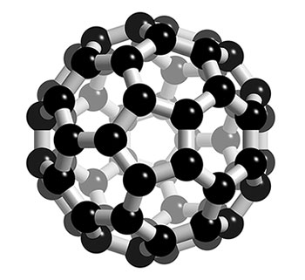
Periodic Table
I | II | III | IV | V | VI | VII | VIII
H |  |  |  |  |  |  | He
Li | Be | B | C | N | O | F | Ne
Na | Mg | Al | Si | P | S | Cl | Ar
K | Ca | Ga | Ge | As | Se | Br | Kr

Chemical bonding between neighboring atoms also affects the properties.

Ionic bond I + VII elements (Na⁺Cl⁻) Insulators

Covalent bond IV elements (C, Si, Ge) Semiconductor

Metallic bond Group-I elements (Na) Conductors

Elemental S.C (Si, Ge) Diamond structure
Compound S.C (GaAs) Zincblend structure

Unit cell of the diamond structure has 8 corner atoms, 6 face-centered atoms and 4 inside atoms.

Note that each face-centered atom is shared by 2 cells and each corner atom is shared by 8 cells.

Each atom has 4 neighbors→Tetrahedral coordination

Example
- Determine the number of atoms per unit cell of the diamond lattice.
- Determine the density of atoms in silicon, given the lattice constant a = 5.43 Å. (5x10²² atoms/cm³)
- Determine the density of silicon, given Avogadro’s number is 6.023x10²³ atoms/mole and the atomic weight of Si is 28.09 g/mole. (2.33 g/cm³)
- Determine the density of valence (outer shell) electrons. (2x10²³ electrons/cm³)

Defects in solids (see Figures 1.17 and 1.19)
Vacancy
Intertitial
Substitutional impurity
Intertitial impurity

