King Fahd University of Petroleum and Minerals

Department of physics

Course Code: PHYS 503
Course Title: Graduate Laboratory
Experimental Supervisor: Dr.Akhtar Abbas Naqvi
Course Coordinator: Dr.Akhtar Abbas Naqvi

Prepared By:
Redhwan Moqbel
(g201302630)

Experimental Report on:
ENERGY RESOLUTION MEASUREMENT OF CeBr3 DETECTOR USING
ACTIVATION SPECTRUM

  - 25-Feb-2016

Contents
Abstract………………………………………………………………………………………………………………….2
1.0 Introduction…………………………………………………………………………………………………….3
  - Energy resolution……………………………………………………………………………………….….3
  - Prompt Gamma Ray Production Through Thermal Neutrons Capture Reaction………………………………………………………………………………………………..….…4
  - Cerium bromide (CeBr3) Detector and its Intrinsic Spectrum.........................4
  - Aim of Experiment……………………………………………………………………………….………5
- Experimental Setup……………………………………………………………………………………..…..5
  - Electronic Diagram …………………………………………………………………………………......6
  - Experimental Procedure…………………………………………………………………………..…..7
- Results and Discussion………………………………………………………………………………….....7
  - Energy Resolution of CeBr3 Detector for Radioisotope sources……………..…….7
3.1.1 Energy Calibration of CeBr3 Detector………………………………………….…..10
  - Activation Spectrum of CeBr3 Detector………………………………………………..…...10
- Prompt Gamma Ray Measurement From B-Sample……………………………………….11
- Energy Resolution of the CeBr₃ detector……………………………………………………....13
- Conclusion………………………………………………………………………………………………….….14
References…………………………………………………………………………………………………….…14

Abstract
Energy resolution was measured for a large (76mm x 76mm)(diameter x height) cylindrical Cerium bromide CeBr₃ detector using the MP320 portable neutron generator-based Prompt Neutron Activation Analysis (PGNAA) setup. Low energy capture gamma rays were produced using thermal neutron capture reaction in CeBr3 detector materials. The energy resolution was then computed for the prompt gamma ray peaks of Br(512),Br(828)and H(2223) peaks present in CeBr₃ detector activation spectrum. Bismuth peaks at (570), (1046) and (1770) keV energies, also (1137) and (1333) keV peaks of cobalt were analyzed. Also prompt gamma ray spectrum was recorded from boron to measure the detector energy resolution for (478) keV boron peak. For (570), (1064) and (1770) keV bismuth peaks energy resolution of (4.959%), (3.89%), and (2.984%) was measured respectively. For (1173) and (1333) keV peaks of ⁶⁰Co, an energy resolution of 3.6% and (3.55%) was determined respectively. The energy resolution of the detector for (478) keV peak from boron was determined to be (6.5%). The energy resolution of the detector for Br (195), Br (271) and Br (367) were measured. The detector percentage energy resolution data was fitted as a function of gamma ray energy using a second degree polynomial.

1.0 Introduction
  - Energy resolution
Energy resolution of a detector defines conventionally as full width at half maximum FWHM ( the distribution width at a level which is just half the maximum ordinate of the peak ) divided by the location of the peak pulse height Hₒ (depicted in Fig. 1a). The ranges of the energy resolution of scintillation detectors are between 5-10 %. The detector will be better, if the energy resolution is smaller and it will be able to differentiate between two radiations whose energies are very close to each other. When the width of the spectrum be smaller and smaller (depicted in Fig. 1b) the possibility to resolve fine detail of a given measurement in the incident energy of the radiation is clearly improved. The curve named “Good resolution” represent one with sharp distribution around an average pulse height Hₒ and The curve labeled “poor resolution” represents the response of a detector with inferior performance. The potential sources of poor energy resolution in the response of a given detector contain electronic noise, drift in operating parameter during the course of the measurements and statistical noise arising from discrete nature of the measured signal itself.
We need a monoenergetic gamma ray source to measure energy resolution of a detector. monoenergetic gamma rays sources that are possible are radioisotope gamma ray sources with their corresponding gamma ray energies listed in Table 1.
Table 1: Energy of Radioisotope Sources
Sample | Energy (KeV)
Cs- 139 | 661
Bi | 661
 | 570
 | 1064
Co | 1170
 | 1333
Also, there is another way of generating gamma rays which is nuclear reactions. For example, the rising of gamma ray photon of 4.44MeV can be given from 14 MeV neutrons inelastic scattering from carbon.
Prompt gamma ray production through thermal neutron capture reaction or through inelastic scattering of 14 MeV neutrons are nuclear reaction studied at KFUPM.

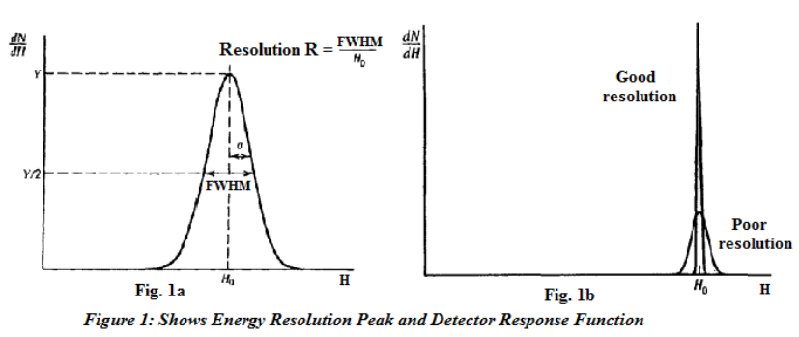

  - Prompt Gamma Ray Production Through Thermal Neutrons Capture Reaction.
Neutron capture of Radioactive is defined as the process in which neutron incident on a target nucleus to form an excited compound nucleus. The nucleus of compound de-excites return to the ground state by emitting prompt and delayed gamma-rays. The relation between the intensity of the prompt gamma-ray and the number of atoms and the energy values of the gamma –rays identify the nuclide is proportional. In Prompt Gamma Neutron Activation Analysis (PGNAA), neutrons bombard sample material. When each element returns to a stable state, it emits a distinctive gamma-ray signature. To be measured, the element, within the energy window being analyzed, must emit a gamma-ray and it must have a high capture cross section of thermal neutron. To produce measurable intensity of gamma rays, the amount of atoms of an element present in the sample must be enough. With a high resolution gamma-ray detector, these gamma-rays are collected and measured. The capability of the detector, to distinguish between two gamma rays with very close energy, is determined by the energy resolution of the detector.
  - Cerium bromide (CeBr3) Detector and its Intrinsic Spectrum
A low intrinsic activity is the asset of CeBr₃. Currently we can only supply data on CeBr₃ energy resolution below 3 MeV. At that energies, which is above 3 MeV, experience with LaBr₃:5%Ce shows that the energy resolution gradually worsens from a pure 1/√E dependence. If such behavior applies to CeBr₃ as well, this may tend to equalize CeBr₃ and LaBr₃:5%Ce energy resolutions above 3 MeV. Below 3 MeV and due to its much reduced intrinsic activity, CeBr₃ detection sensitivity is, on average, about 5 times higher compared to LaBr₃:5%Ce. Nonetheless, recent investigations have identiﬁed the speciﬁc raw materials batches responsible for such a contamination and, through raw material screening, crystal growers are now able to produce CeBr₃ with none or very low ²²⁷Ac contamination. For applications such as remote gamma-ray spectroscopy of planetary surfaces, CeBr₃ ability to detect gamma ray with high sensitivity is an extremely important asset because of the low ﬂux emissions expected from the planets. Furthermore, higher sensitivity leads to much faster acquisition times allowing to gain ﬁner spatial resolution of the planet's gamma-ray map, with substantial beneﬁt for the scientiﬁc goals. Similar beneﬁts apply to other gamma-ray spectroscopy applications, as environmental radiation monitoring and homeland security, making of CeBr₃ an alternative to existing instruments.
  - Aim of Experiment
The objective of this project is to measure the energy resolution of the CeBr₃ detector for 196-2223 keV gamma-ray energies.
2.0 Experimental Setup
The experimental study was executed using KFUPM portable neutron generator based PGNAA setup using 76 mm x 76 mm (diameter x height) cerium bromide (CeBr3) detector for gamma-ray detection. In this experimental exercise, the detector (CeBr3) itself uses as a main sample. The prompt gamma emitted due to thermal neutron capture in bromine, and cerium in the detector and hydrogen in the moderator that was measured by detector energy resolution. Bromine has very high thermal neutron capture cross sections and it emits several gamma rays over 196 keV, 271 keV, 367 keV , 512 keV . Further the detector energy resolution was measured also for the gamma rays emitted from Bismuth, Cobalt and Cesium radioisotope sources.
The PGNAA setup consist of cylindrical high density moderator which is made of polyethylene, MP320 model portable neutron generator which provides a pulsed beam of 2.5Mev neutron was produced through D(d, n) reaction. 2.5 MeV neutrons were produced using 70µA beam of 70keV deuteron. The gamma rays were detected using a cerium bromide (CeBr3) detector. The detector was shielded with 3mm thick lead and 50mm thick paraffin to prevent undesired gamma-rays and neutrons from reaching the detector. A 90 mm diameter cavity in the moderator allow to irradiate a cylindrical bottle with a size of 90 mm x 140 mm (diameter x height) to be in the moderator. The figure 2 below shows the schematic representation of PGNAA setup.

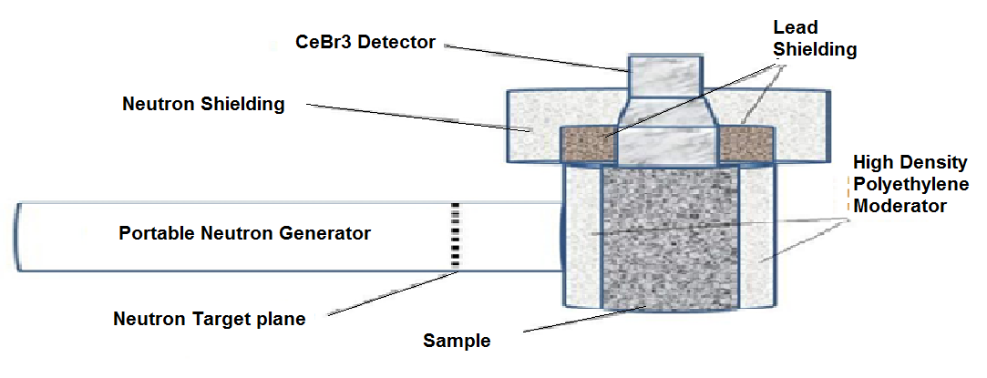
Figure 2: schematic diagram of the MP320 portable neutron generator.
  - Electronic Diagram
To minimize the source of noise transmitted with the signal and to convert the photon to electrical signal for further processing, the preamplifier and photomultiplier are connected to the detector. The voltage of the signal is increased by amplifier and these signals are converted from analogue to digital by using the analogue digital converter (ADC). The converted digital signals represent the quantity’s amplitude and linear gate stretcher which was used to stretch a gated fast pulse to slow pulse by using a shaping time of one micro sec. Figure 3 shows the electronic configuration diagram.
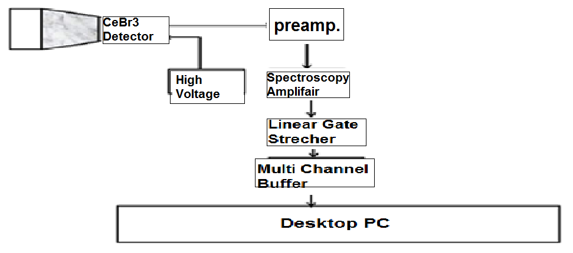
Figure 3: Electronic configuration diagram

  - Experimental Procedure
During the experimental run, 700V bias voltage was applied to CeBr3 detector. Then the neutron beam generator was put ON without placing any sample in the moderator cavity. Then for background measurement run, the neutron beam generator was put on without any sample in the moderator cavity. Meanwhile the Radiation laboratory was always closed for appropriate safety before putting ON neutron beam generator. The Moderated thermal neutron were incident on the detector and then the detector activation spectrum was recorded the prompt gamma ray spectrum. The system was run for nearly 10 minutes and in the created file the data was stored. The peaks in the spectrum appeared from cerium bromide and hydrogen measure in the detector in the moderator. For each peak corresponding channel number location, real time and full width at half maximum (FWHM) were recorded. The experiment was carried out for low energy run using different setting of the coarse gain of the detector pulse height amplifier. For each energy run, different energy calibration curve of the detector has been used, due to detection of capture gamma ray with varying energies.
The generator of neutron was switch off and in the moderator cavity gamma ray radioactive sources were placed to measure detector energy resolution of the gamma rays from the radioisotope source. The peaks rise up again and channel number, real time and FWHM were recorded and data was saved in the folder of the hard drive (disk). These steps were repeated during the experiment for radioisotope source spectra. Over period varying from 7-15 minutes, the data of radioisotope source was taken.

3.0 Results and Discussion.
3. 1 Energy Resolution of CeBr3 Detector for Radioisotope sources
Figure 4 shows intrinsic activity spectrum of CeBr₃ spectrum. The pulse height spectrum of the cerium bromide (CeBr3) detector taken with Cesium- 137, Cobalt-60 and Bismuth-207 samples that are shown in figure 5,6 and 7 below. The Cesium-137 spectrum shows distinguished peak with gamma ray energy of 661 keV.
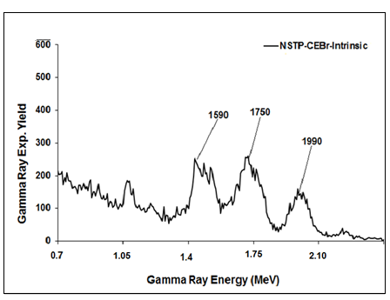

Figure 4: Intrinsic pulse height spectrum of (CeBr3) detector.
To calculate the energy resolution the fitting peak to the selected area on the computer display screen was used. The marker on either side of the peak was used to select the area. The FWHM and centroid of the peak were calculated by computer. The FWHM of the peak divide by the peak centroid to calculate the energy resolution for Cesium-137 source.
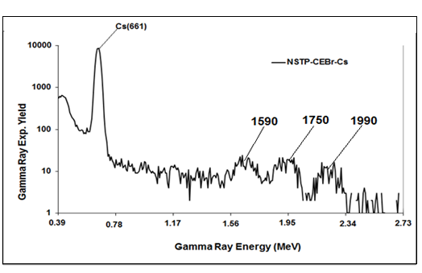
Figure 5 : CeBr3 detector pulse height spectrum taken with cesium-137 peak.
The energy resolution of the detector was calculated to be 4.3 %. The gamma ray analysis of Cobalt-60 and Bismuth-209 sources presents double peaks with different irradiation times and different gamma ray energies. With gamma ray energies of 570 keV, 1064 keV, and 1770 keV, the Bismuth- 209 gave three peaks. For bismuth source, the energy resolutions of the detector were calculated as 4.9%, 3.6%, and 2.8% respectively. Also, Cobalt-60 produced two peaks with energy (1173) keV and (1333) keV.

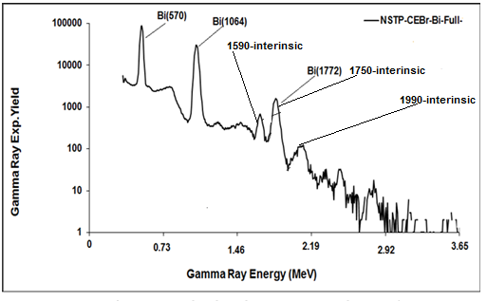
Figure 6: CeBr3 detector pulse high spectrum taken with bismuth- 209 peaks

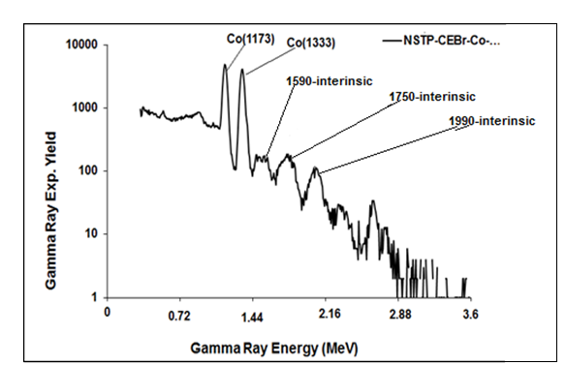

Figure 7: CeBr₃ detector pulse height spectrum taken with cobalt-60 peaks

3.1.1 Energy Calibration of CeBr3 Detector
Using radioisotope gamma ray source Bi(570 keV), Bi(1064 keV), Co(1173 keV), Co(1333 keV) and Bi(1770 keV), low energy calibration has been done. We obtained the curve of energy calibration for CeBr3 detector ,by plotting these gamma ray source energies versus the corresponding channel number.
Table 2: Energy and channel number for radioisotopes sources.
Source | Energy | Ch#
Bi | 570 | 72
Bi | 1064 | 143
Co | 1173 | 163
Co | 1333 | 185
Bi | 1770 | 251

FFF

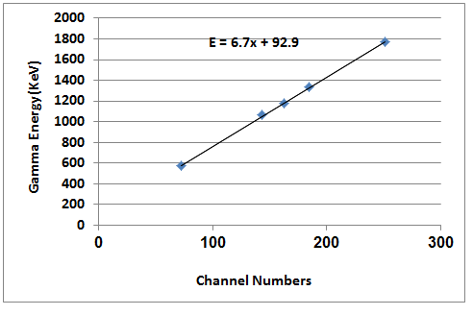

Figure 8: Low energy calibration curve of CeBr3 detector
Figure 8 shows low energy calibration curve of detector with a slope of 6.7 (keV/channel).
  - Activation Spectrum of CeBr3 Detector
To measure activation spectrum of CeBr3 detector, the portable KFUPM neutron generator based PGNAA setup has been used and data was recorded with two amplifier setting. Figure 9 shows activation spectrum with low amplifier gain. Fig 10 shows , In the low energy activation spectrums of CeBr3 detector, well resolved prompt ray peaks due to thermal neutron capture in cerium, bromine and Hydrogen (moderator) are observed at Ce(737 keV), Br(196 keV),Br(271 keV), Br(367 keV),Br(512 KeV) and H(2223 keV) . For 71 minutes run,the CeBr3 detector low energy activation spectrum was registered. Energy resolution of the detector was calculated, from the low energy activation spectrum, for Ce(737 keV), Br(196 keV), and H(2223 keV) peaks and are listed in Table 1.
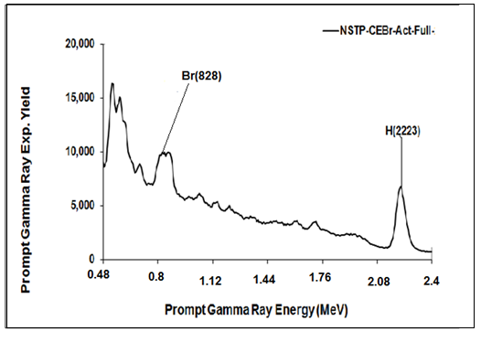

Figure 9: prompt gamma ray spectrum due to activation full of CeBr3 detector caused by capture of thermal neutron in Ce, Br elements present in CeBr3 detector.
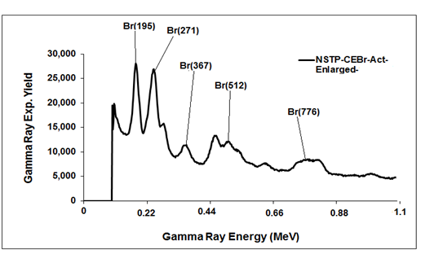
Figure 10: Low energy prompt gamma ray spectrum due to activation of CeBr₃ detector caused by capture of thermal neutron in Ce, Br elements present in CeBr3 detector.
- Prompt Gamma Ray Measurement From Boron-Sample.
Using portable Neutron generator based PGNAA set up described in section 2. Water sample contained with 0.5 wt% B concentration was used to measure B(478)gamma ray. Thermal neutrons were produce from 2.8 MeV reactions via the moderator shown and describe in section 2. Fig11 shown gamma ray spectrum Boron sample with 0.5 wt% that superimposed upon background spectrum taken without sample. Fig 12 shows boron beak in boron sample difference spectrum after background subtraction. This peak was used in energy resolution calculation of the CeBr3 detector.
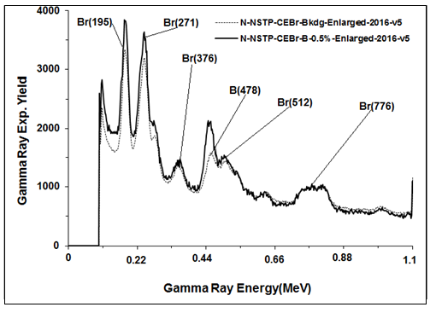

Figure 11: prompt gamma ray spectrum of CeBr3-Bkgd-Enlarged and CeBr₃-B-0.5%-_{Enlarged.}

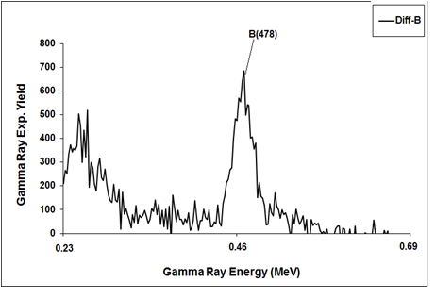

Figure 12: Enlarged prompt Gamma Ray difference pulse height spectra after background subtraction from 0.5 wt% boron-contaminated water sample.

5.0 Energy Resolution of the CeBr₃ detector.
For prompt gamma rays from cerium, bromine and hydrogen capture in the moderator, the CeBr3 detector energy resolution has been measured. Also, for Bismuth (570 keV), Cesium (661 keV), Bismuth(1064 keV), Cobalt (1333 keV) and Bismuth(1770 keV) radioisotope source, the energy resolution of CeBr3 detector was also determined. The data of the energy resolutions of the detector at twelve different energies was fitted with a least square fit of type ∆E/E (%) = aE^-b (KeV). The data along with the fitted curve is shown in Fig.10.
Table 3 : Energy Resolution of CeBr3 Detector
Elements |  | Energy (KeV) | Cent' | FWHM | FWHM/Cent ( %)
Br |  | 196 | 82 | 9.23 | 10.49
Br |  | 271 | 109 | 11.53 | 10.577
Br |  | 367 | 162 | 13.4 | 8.27
Br |  | 512 | 207 | 11.9 | 5.748
B |  | 478 | 205 | 13.38 | 6.5
Bi |  | 570 | 246 | 12.2 | 4.959
Cs |  | 661 | 290 | 13.2 | 4.55
Ce |  | 698 | 288 | 14.4 | 5
Bi |  | 1064 | 145 | 5.65 | 3.89
Co |  | 1173 | 162 | 5.9 | 3.6
Co |  | 1333 | 186 | 6.6 | 3.55
Bi |  | 1770 | 252 | 7.52 | 2.984
H | 2223 |  | 321 | 9.51 | 2.96

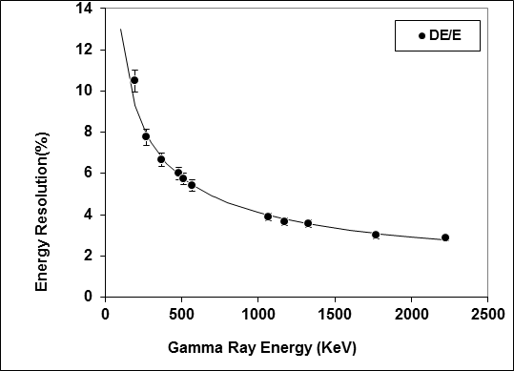

Figure 13: Energy Resolution Curve of CeBr₃ detector for 196-2223 KeV gamma rays.

6.0 Conclusion
In this experiment, PGNAA approach was carried out to test the energy resolution of the CeBr₃ detector using low energy prompt gamma-rays from Cesium, bismuth, cobalt and boron sample. One peak was observed in the Boron sample spectrum corresponding to B-(478) with 6.5% resolution. Three peaks were observed in the bismuth sample spectrum corresponding to Bi-(570), Bi-(1064) and Bi-(1770) with corresponding energy resolutions of 4.959%, 3.89% and 2.984% respectively. Two peaks were observed in the Cobalt sample spectrum corresponding to Co-(1173) and Co-(1333) with corresponding energy resolutions of 3.6% and 3.55% respectively. One peak was observed in the Cesium sample spectrum corresponding to Ce-(661) with 4.55% resolution. In spite the activation during sample irradiation, the resulting energy resolution curve shows that the detector has a very good energy resolution to resolve prompt gamma rays from low energy gamma-ray- emitting radioactive metals from background prompt gamma-rays. We therefore, conclude by saying that the CeBr3 detector has a good energy resolution for high energy prompt gamma-rays.

References
[1] Naqvi, A.A. , Al-Matouq, F.A., Khiari, F.Z., Isab, A.A., Raashid, M., Khateeb-ur-Rehman. "Hydrogen, carbon and oxygen determination in proxy material samples using a LaBr:Ce detector". Applied Radiation and Isotopes , Volume 78, August 2013, Pages 145-150.
[2] Grupen, C. (June 28-July 10, 1999). "Physics of Particle Detection". AIP Conference Proceedings, Instrumentation in Elementary Particle Physics, VIII 536. Istanbul: Dordrecht, D. Reidel Publishing Co. pp. 3–34.
[3] Naqvi A. A., Zameer Kalakada,, M.S. Al-Anezi, M. Raashid, Khateeb-ur-Rehman, M. Maslehuddin and M. A. Garwan , F.Z. Khiari, A. A. Isab and O.S. B. Al-Amoudi. "Detection Efficiency of Low Levels of Boron and Cadmium with a LaBr3:Ce Scintillation Detector". Nuclear Inst. and Methods in Physics Research, A 665 (2011) 74–79
[4] A. A. Naqvi, M. S. Al-Anezi, Zammeer Kalakada, A. H. Isab, M. Raashid, Khateeb-ur-Rehman, F. Z Khiari, M. A. Garwan and M. Maslehuddin. " Response of LaBr:Ce Detector for Low Energy Prompt Gamma-Rays"

[5] G.F. Knoll," Radiation Detection and Measurement". Wiley (1989).

[6] K. S. Shah, J. Glodo, M. Klugerman, W. M. Higgins, T. Gupta, and P. Wong. "High Energy Resolution Scintillation Spectrometers". IEEE Transactions on Nuclear Science, vol. 51, no. 5, October 2004

