**HW#2-GK-Ch-4-GK. T172**

**Prob# 4.5 A scintillation counter operated at a given voltage produces a differential pulse height spectrum as sketched below:**



**(a) Draw the corresponding integral pulse height spectrum.**

**(b) Sketch the expected counting curve obtained by varying the voltage to the detector while counting above a fixed threshold.**



**Prob# 4.7 A gamma-ray spectrometer records peaks corresponding to two different gamma-ray energies of 435 and 490 ke V. What must be the energy resolution of the system (expressed as a percentage) in order just to distinguish these two peaks?**



**Prob# 4.8 In a detector with a Fano factor of 0.1 what should be the minimum number of charge carriers per pulse to achieve a statistical energy resolution limit of 0.5%?**

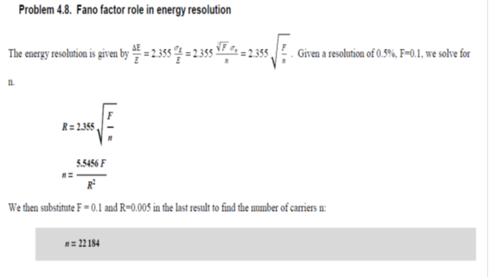

**4.9 A pulse-processing system operated over a long period of time shows a typical drift that broadens single- amplitude pulses into a distribution with pulse height resolution of 2%. If this system is used with a detector with an intrinsic pulse height resolution of 4%, what will be the expected overall pulse height resolution?**

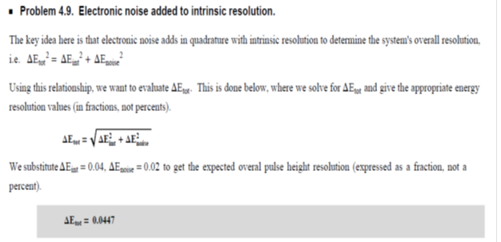

**4.14 Counters A and B are nonparalyzable with dead time of 30 and 100 μs, respectively. At what true event rate will dead time losses in counter B be twice as great as those for counter A?**



**4.16 A paralyzable detector system has a dead time of 1.5 μs. If a counting rate of 105 per second is recorded, find the two possible values for the true interaction rate.**

