**HW GK-Ch-3-Probability**

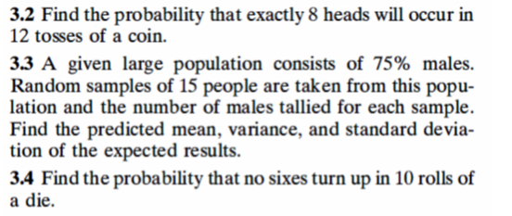

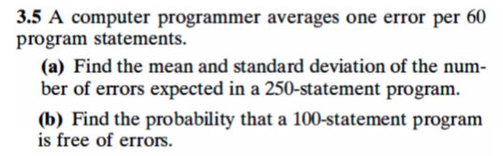

**HW NT-Ch-2-Probability**



