**HW-4-Ch-17-GK-T172**

**17.3** A step voltage of 1 V amplitude is applied to the input of a CR-RC differentiator-integrator network with equal time constants. What is the amplitude of the shaped pulse?

Problem 17.3 CR-RC network. Maximum amplitude of shaped pulse.

The pulse shape is shown below, where we measure time in units of τ:





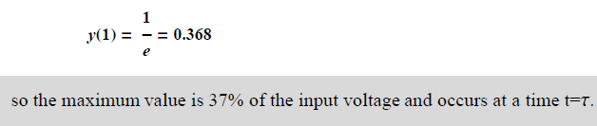

**17.10** A given application involves processing pulses at a low average rate from a high-resolution detector. If the objective is to preserve the pulse height resolution as much as possible, indicate which of the options given below is the better choice:

(a) Short or long shaping times

(b) Monopolar or bipolar shaping

(c) With or without active baseline restoration



**17.11** Pulses corresponding to a particular full-energy peak occur at a rate of 8000/s in a system in which the total pulse rate is 25,000/s. Estimate the fraction of the full-energy events that are lost due to pile-up, if the effective pulse width is 4 μs.



**Problems on χ2 Test**

Suppose we throw 3 dices 100 times and measure the number of sixes showing up simultaneously. The observed data is given in the following table :

|  |  |
| --- | --- |
| **Number of sixes** | **Observed frequency of**  **Sixes** |
| **0** | **53** |
| **1** | **39** |
| **2** | **5** |
| **3** | **3** |

Calculate the expected frequency of occurrence of sixes and χ2 of the data to **decide whether any of the dices is loaded?**

**fcalc(x) = N * P(x)**

**Dice throwing governed by Binomial Distribution**

**P(x) = n!*px*qn-x/[x!*(n-x)!] ; p=1/6; q=5/6**

|  |  |  |  |
| --- | --- | --- | --- |
| **Number**  **of sixes** | **Observed**  **frequency fO** | **Calculated frequency fc**  **≈ N * P(x)** | **χ2=(fo-fc)2/ fc**  **\*\*σ2= fc** |
| **0** | **53** | **56** | **0.161** |
| **1** | **39** | **34** | **0.735** |
| **2** | **5** | **6** | **0.166** |
| **3** | **3** | **4** | **0.250** |

Σχ2= 1.312

**χν2=Σχ2/ν= 1.312/4=0.328 closer to 0.5**

**Dices are not loaded**