Energy Resolution Measurement of NaI Detector

Purpose

To measure the energy of unknown gamma rays using ⁶⁰Co source and study 1/√E behavior of energy resolution ( FWHM/E) of a NaI detector for the gamma rays of energy E.

Procedure

1. Place the ⁶⁰Co source at a distance of ~2 cm in front of the NaI(Tl) detector.
2. Adjust the coarse and fine gain controls of the amplifier so that the 1.33 and 1.17 MeV photopeaks for ⁶⁰Co falls at approximately channel 650.
3. Accumulate the ⁶⁰Co spectrum for a time period long enough to determine the peak position. Fig. 3.2 shows a typical ⁶⁰Co spectrum that has been plotted. Although these spectra are usually plotted on semi log graph paper, the figures shown in this experiment are plotted on linear paper to point out some of the features of the spectra.

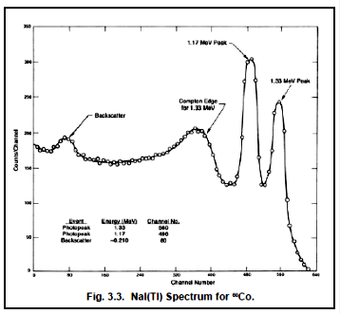

4. Read out the MCA.
5. Enter the ⁶⁰Co peaks positions and corresponding energy resolutions (FWHM) in channels in the data Table 1.
6 . Remove ⁶⁰Co source and place Ba source in front of the NaI detector.
7. Accumulate the Ba source spectrum for a time period long enough to determine the peak position.
8. Enter the Ba peaks position and corresponding energy resolutions (FWHM) in channels in the data Table 1.
9. From items 1, 2 and 3 in Table 1, make a plot of energy of the Peak Energy vs. channel number. Fig. 3.4 shows this calibration for the data taken from Fig. 3.3.
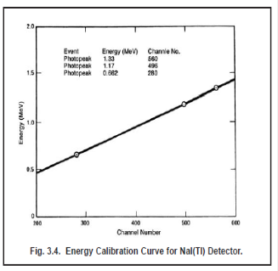
10. Make a linear regression fit to the peak energy and peak channels data and write down the linear regression equation.
11. Obtain an Radon gamma source from the instructor. Accumulate a spectrum for the unknown source for a period of time long enough to clearly identify its photopeak(s).
12. Enter its peaks channel number and corresponding energy resolution (FWHM) in the data Table 1.
13 Using the calibration curve of ⁶⁰Co source, determine the energy corresponding to peak channel of unknown source. Enter this energy in the data Table 1.
14. Calculate percent energy resolution ΔE/E(%) =100*[FHWM (keV) /E(keV)] for each gamma ray energy and enter the data in the data Table 1.

Table: 1

Item | Event | Peak Energy (MeV) | Peak Centroid  Channel | FHWM  (Channel ) | ΔE/E(%) =100*[FHWM(keV)  / E(keV)]
1 | ⁶⁰Co Photo peak | 1.17
2 | ⁶⁰Co Photo peak | 1.33
3 | Barium | 0.356
4 | Radon (²¹⁴Bi) | ?
5 | Radon (²¹⁴Bi) | ?
6 | Radon (²¹⁴Bi) | ?
7 | Radon (²¹⁴Bi) | ?

15. Plot a graph of ΔE/E(%)] as a function of E(keV)] for the all gamma rays energies on a linear graph paper. Fit a a power law to the data of type
ΔE/E(%)= aE^{b}
16. Find the value of coefficient b and a of the fit . The expected value of b = − 0.5 . Determine the percentage error in value of coefficient b.

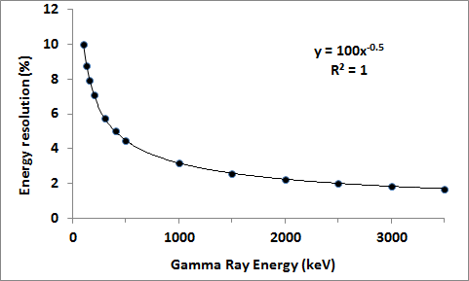

Figure 3.5

17. Plot a graph of ln[ΔE/E(%)] as a function of ln[E(keV)] for the gamma rays energies on a linear graph paper as shown Fig. 3.6.
18. Calculate the slope of the line and verify the relation (ΔE/E(%)= 1/√E(keV) by calculating the experimental uncertainty in the expected slope (−0.5) of ln[ΔE/E(%)] vs ln[E(keV)] plot.

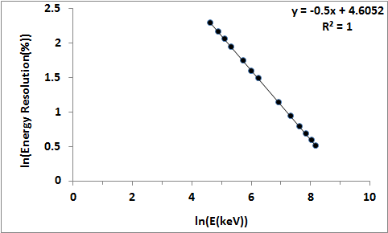

Figure 3.6

