**Compton Edge Energy Measurement**

**Purpose**

The purpose of this experiment is to explain some of the features, other than the photo peaks, usually present in a pulse-height spectrum. These are the Compton edge and the backscatter peak. The Compton interaction is a pure kinematic collision between a gamma photon and what might be termed a free electron in the NaI(Tl) crystal. By this process the incident gamma gives up only part of its energy to the electron. The amount given to the recoil electron (and the intensity of the light flash) depends on whether the collision is head-on or glancing. For a head-on collision the gamma imparts the maximum allowable energy for the Compton interaction. The energy of the scattered gamma can be determined by solving the energy and momentum equations for this billiard ball collision. The solution for these equations in terms of the scattered gamma can be written approximately as



where

Eγ′ = energy of the scattered gamma in MeV, θ = the scattered angle for γ′,

Eγ = the incident gamma energy in MeV. If θ = 180° due to a head-on collision in which γ′ is scattered directly back, Eq. (1) becomes





As an example, we will calculate Eγ′ for an incident gamma energy of 1 MeV:



The energy of the recoil electron, Ee, for this collision would be 0.80 MeV. This is true since



Then the position of the Compton edge, which is the maximum energy that can be imparted to an electron by the Compton interaction, can be calculated by Eq. (4).

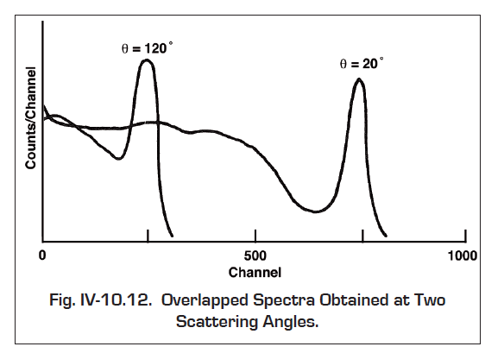

**Gamma Rays Photo peaks and Compton edge measurement.**

Setup the electronics as shown in Fig. 3.1. There are two parameters that ultimately determine the overall gain of the system: the high voltage furnished to the phototube and the gain of the spectroscopy amplifier. The gain of the photomultiplier tube is quite dependent upon its high voltage. A rule of thumb for most phototubes is that a 10% change in the high voltage will change the gain by a factor of 2. The high voltage value depends on the phototube being used. Consult your instructor to set the setting of the electronics (The instructor may wish to recommend a value).



**1.** Place the 60Co source from the gamma source kit (Eγ = 1.117, 1.330 MeV) ~2 cm in front of the NaI(Tl) detector.

**2.** Adjust the coarse and fine gain controls of the amplifier so that the 1.33 MeV photopeak for 60Co falls at approximately channel 480. For the illustrations shown in Figs. 3.2 and 3.3, the gain of the system has been set so that 1.33 MeV falls at about channel 447 to 490. Since the system is linear, 2 MeV would therefore fall at approximately channel 840 to 850.

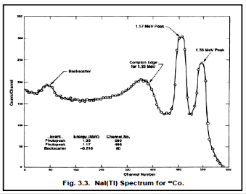

**3.** Accumulate the 60Co spectrum for a time period long enough to determine the peak position. Fig. 3.2 shows a typical 60Co spectrum that has been plotted. Although these spectra are usually plotted on semilog graph paper, the figures shown in this experiment are plotted on linear

paper to point out some of the features of the spectra.

**4.** Record the peak centroid and full width at half maximum of 1.17 and 1.33 MeV gamma rays from 60Co in Table 1. Also record full width at half maximum (FWHM) of 1.17 and 1.33 MeV gamma rays peaks in Table 1.

**5.** Then record the channel corresponding to Compton edge energy and backscattered gamma rays of 60Co sources in the Table 1. Backscatter occurs when gammas make Compton interactions in the material that surrounds the detector. If the backscatter peak is not very pronounced in your spectrum, it can be improved by accumulating a spectrum with a sheet of lead absorber placed slightly to the left of the source in Fig. 3.1.

**6.** After the 60Co spectrum has been read from the MCA erase it and replace the 60Co source with unknown source from the gamma source kit.

**7.** Accumulate the spectrum for a period of time long enough for the spectrum to be similar to that in Fig. 3.3.

**8.** Plot the 60Co spectrum.

**9.** From items 1, 2, in Table 1, make a energy calibration plot of photopeaks energy (y-axis) vs. channel number (x-axis) as shown in Fig. 3.4

**10**  Make a lest square linear fit to the data to obtain energy calibration equation shown in fig. 3.4.

**Table 1**

|  |  |  |  |  |
| --- | --- | --- | --- | --- |
| Item # | **Peaks** | **Energy**  **(MeV)** | **Channel No** | **FWHM (Channels)** |
| 1 | **1.17 MeV Photopeak** | 1.17 |  |  |
| 2 | **1.33 MeV Photopeak** | 1.33 |  |  |
| 3 | **Compton Edge Ee for 1.17 MeV** |  |  |  |
| 4 | **Backscattered Gamma Energy E' for 1.17 MeV** |  |  |  |
| 5 | **Compton Edge Ee for 1.33 MeV** |  |  |  |
| 6 | **Backscattered Gamma Energy E' for 1.33 MeV** |  |  |  |

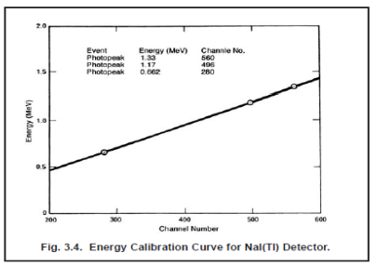

1. Calculate the energy of the Compton edge and backscattered gamma rays for the 1.17 and 1.33 MeV gammas from 60Co source using equations 1 and 2 and enter these values in Table 1.
2. Use the energy calibration equation to convert Compton edge and backscattered gamma rays channels of the 60Co spectrum into energy.
3. Enter these values in Table 1. Does this calculation agree with your measured value? Calculate percentage error in Compton edge and backscattered gamma rays for 60Co gamma rays.