Graphics

Basic Plotting
MATLAB has extensive facilities for displaying vectors and matrices as graphs, as well as annotating and printing these graphs. This section describes a few of the most important graphics functions and provides examples of some typical applications.
Creating a Plot
x = 0:pi/100:2*pi;
y = sin(x);
plot(x,y)

xlabel('x = 0:2\pi')
ylabel('Sine of x')
title('Plot of the Sine Function','FontSize',12)

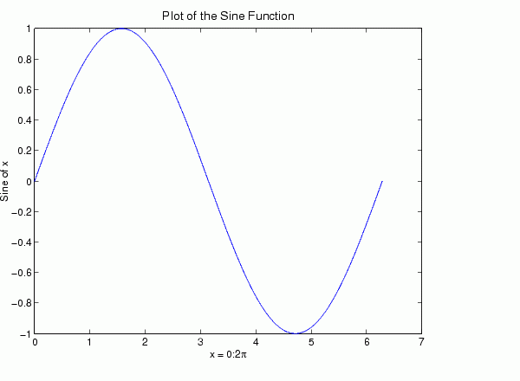
Multiple Data Sets in One Graph
y2 = sin(x-.25);
y3 = sin(x-.5);
plot(x,y,x,y2,x,y3)

legend('sin(x)','sin(x-.25)','sin(x-.5)')

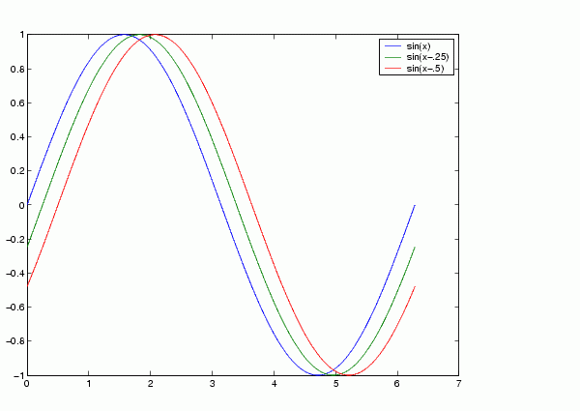
Specifying Line Styles and Colors
plot(x,y,'color_style_marker')
color_style_marker is a string containing from one to four characters (enclosed in single quotation marks) constructed from a color, a line style, and a marker type:
- Color strings are 'c', 'm', 'y', 'r', 'g', 'b', 'w', and 'k'.
- Linestyle strings are '-' for solid, '--' for dashed, ':' for dotted, '-.' for dash-dot, and 'none' for no line.
- The marker types are '+', 'o', '*', and 'x' and the filled marker types 's' for square, 'd' for diamond, '^' for up triangle, 'v' for down triangle, '>' for right triangle, '<' for left triangle, 'p' for pentagram, 'h' for hexagram, and none for no marker.
Plotting Lines and Markers
- If you specify a marker type but not a linestyle, MATLAB draws only the marker. For example,
plot(x,y,'ks')
plots black squares at each data point, but does not connect the markers with a line.
- The statement
plot(x,y,'r:+')
plots a red dotted line and places plus sign markers at each data point.
- You may want to use fewer data points to plot the markers than you use to plot the lines. This example plots the data twice using a different number of points for the dotted line and marker plots.
x1 = 0:pi/100:2*pi;
x2 = 0:pi/10:2*pi;
plot(x1,sin(x1),'r:',x2,sin(x2),'r+')

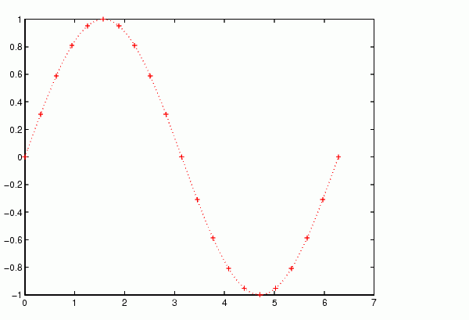

Adding Plots to an Existing Graph
- The hold command enables you to add plots to an existing graph. When you type
hold on
Multiple Plots in One Figure
- The subplot command
subplot(m,n,p)
partitions the figure window into an m-by-n matrix of small subplots.
- The plots are numbered along first the top row of the figure window, then the second row, and so on. For example,
t = 0:pi/10:2*pi;
X = 4*cos(t);Y=4*sin(t);Z=t.*exp(-t);W=sin(t).*log(t+1);
subplot(2,2,1); plot(t,X)
subplot(2,2,2); plot(t,Y)
subplot(2,2,3); plot(t,Z)
subplot(2,2,4); plot(t,W)
Mesh and Surface Plots
- MATLAB defines a surface by the z-coordinates of points above a grid in the x-y plane, using straight lines to connect adjacent points.
- The mesh and surf plotting functions display surfaces in three dimensions.
  - mesh produces wireframe surfaces that color only the lines connecting the defining points.
  - surf displays both the connecting lines and the faces of the surface in color.
Visualizing Functions of Two Variables
To display a function of two variables, z = f (x,y):
- Generate X and Y matrices consisting of repeated rows and columns, respectively, over the domain of the function.
- Use X and Y to evaluate and graph the function.
- The meshgrid function transforms the domain specified by a single vector or two vectors x and y into matrices X and Y for use in evaluating functions of two variables.
- The rows of X are copies of the vector x and the columns of Y are copies of the vector y.
Example - Graphing the sinc Function
[X,Y] = meshgrid(-8:.5:8);
R = sqrt(X.^2 + Y.^2) + eps;
Z = sin(R)./R;
mesh(X,Y,Z,'EdgeColor','black')

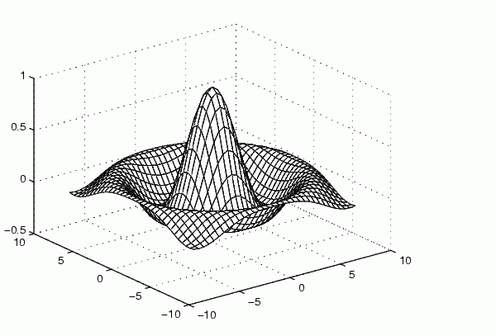

You can create a transparent mesh by disabling hidden line removal.
hidden off
Example - Colored Surface Plots
A surface plot is similar to a mesh plot except the rectangular faces of the surface are colored.
surf(X,Y,Z)
colormap hsv
colorbar

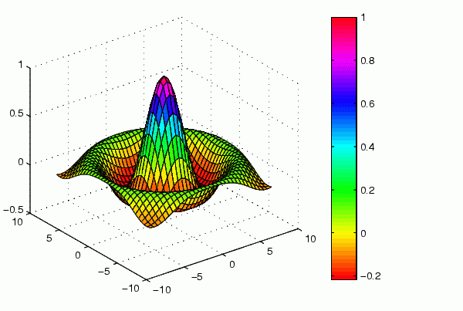

Surface Plots with Lighting
Lighting is the technique of illuminating an object with a directional light source. In certain cases, this technique can make subtle differences in surface shape easier to see. Lighting can also be used to add realism to three-dimensional graphs.
This example uses the same surface as the previous examples, but colors it red and removes the mesh lines. A light object is then added to the left of the "camera" (that is the location in space from where you are viewing the surface).
After adding the light and setting the lighting method to phong, use the view command to change the view point so you are looking at the surface from a different point in space (an azimuth of -15 and an elevation of 65 degrees). Finally, zoom in on the surface using the toolbar zoom mode.
surf(X,Y,Z,'FaceColor','red','EdgeColor','none');
camlight left; lighting phong
view(-15,65)

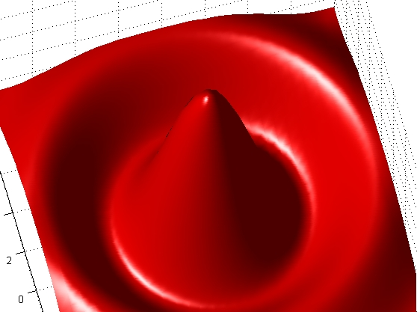
Images
- Two-dimensional arrays can be displayed as images, where the array elements determine brightness or color of the images. For example, the statements
load durer
whos
Name Size Bytes Class

X 648x509 2638656 double array
caption 2x28 112 char array
map 128x3 3072 double array
load the file durer.mat, adding three variables to the workspace. Then
image(X)
colormap(map)
axis image
reproduces Dürer's etching.

Programming with MATLAB

Flow Control
MATLAB has several flow control constructs:
- if statements
- switch statements
- for loops
- while loops
- continue statements
- break statements
if
- The if , elseif and else keywords control the program flow based on a logical statement
- Terminates with an end keyword.
- No braces or brackets are involved.
Example: Generation of the magic square when n is odd, when n is even but not divisible by 4, or when n is divisible by 4.
if rem(n,2) ~= 0
M = odd_magic(n)
elseif rem(n,4) ~= 0
M = single_even_magic(n)
else
M = double_even_magic(n)
end
- Example: difference between numbers and matrices.
if A > B
'greater'
elseif A < B
'less'
elseif A == B
'equal'
else
error('Unexpected situation')
end
- Several functions are helpful for reducing the results of matrix comparisons to scalar conditions for use with if, including
isequal
isempty
all
any
switch and case
The switch statement executes groups of statements based on the value of a variable or expression. The keywords case and otherwise delineate the groups. Only the first matching case is executed. There must always be an end to match the switch.
The logic of the magic squares algorithm can also be described by
switch (rem(n,4)==0) + (rem(n,2)==0)
case 0
M = odd_magic(n)
case 1
M = single_even_magic(n)
case 2
M = double_even_magic(n)
otherwise
error('This is impossible')
end
for
The for loop repeats a group of statements a fixed, predetermined number of times. A matching end delineates the statements.
for n = 3:32
r(n) = rank(magic(n));
end
r
It is a good idea to indent the loops for readability, especially when they are nested.
for i = 1:m
for j = 1:n
H(i,j) = 1/(i+j);
end
end
while
The while loop repeats a group of statements an indefinite number of times under control of a logical condition. A matching end delineates the statements.
Example: The bisection method
a = 0; fa = -Inf;
b = 3; fb = Inf;
while b-a > eps*b
x = (a+b)/2;
fx = x^3-2*x-5;
if sign(fx) == sign(fa)
a = x; fa = fx;
else
b = x; fb = fx;
end
end
x
Result:
x =
2.09455148154233
continue
The continue statement passes control to the next iteration of the for or while loop in which it appears, skipping any remaining statements in the body of the loop.
Example: Counting code lines in an m-file
fid = fopen('magic.m','r');
count = 0;
while ~feof(fid)
line = fgetl(fid);
if isempty(line) | strncmp(line,'%',1)
continue
end
count = count + 1;
end
disp(sprintf('%d lines',count));
break
The break statement lets you exit early from a for or while loop.
Example: The bisection method revisited
a = 0; fa = -Inf;
b = 3; fb = Inf;
while b-a > eps*b
x = (a+b)/2;
fx = x^3-2*x-5;
if fx == 0
break
elseif sign(fx) == sign(fa)
a = x; fa = fx;
else
b = x; fb = fx;
end
end
x
Scripts and Functions
- Files that contain code in the MATLAB language are called M-files. You create M-files using a text editor, then use them as you would any other MATLAB function or command.
- There are two kinds of M-files:
- Scripts, which do not accept input arguments or return output arguments. They operate on data in the workspace.
- Functions, which can accept input arguments and return output arguments. Internal variables are local to the function.
Scripts
When you invoke a script, MATLAB simply executes the commands found in the file. For example, create a file called bisect.m that contains these MATLAB commands.
a = 0; fa = -Inf;
b = 3; fb = Inf;
while b-a > eps*b
x = (a+b)/2;
fx = x^3-2*x-5;
if fx == 0
break
elseif sign(fx) == sign(fa)
a = x; fa = fx;
else
b = x; fb = fx;
end
end
x
Typing the statement
bisect
causes MATLAB to execute the commands, compute the solution x.
Functions
- Functions are M-files that can accept input arguments and return output arguments.
- The name of the M-file and of the function should be the same.
- Functions operate on variables within their own workspace, separate from the workspace you access at the MATLAB command prompt.
Example: The bisection method in general
Create a file named genfun.m containing the following statements
function y = genfun(x)

y = x^3-2*x-5; %other function definitions can be used here

Modify the script file bisect.m as follows
a = 0; fa = genfun(a);
b = 3; fb = genfun(b);
while b-a > eps*b %can you see anything wrong here?
x = (a+b)/2;
fx = genfun(x);
if fx == 0
break
elseif sign(fx) == sign(fa)
a = x; fa = fx;
else
b = x; fb = fx;
end
end
x

