Trigonometric Identities
Identities involving trig functions are listed below.
Pythagorean Identities  sin² θ + cos² θ = 1  tan² θ + 1 = sec² θ  cot² θ + 1 = csc² θ |  |  |  |  |  |  |  |  |  |  |  |  |  |  |  | Ratio Identities  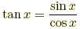  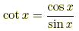
  Reciprocal Identities
  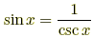 | 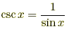
  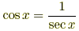 | 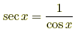
  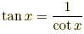 | 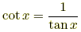
Odd/Even Identities
sin (–x) = –sin x  cos (–x) = cos x  tan (–x) = –tan x | csc (–x) = –csc x  sec (–x) = sec x  cot (–x) = –cot x
Cofunction Identities, radians |  |  |  |  |  |  |  |  |  |  |  |  | Cofunction Identities, degrees
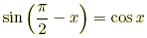 |  |  | 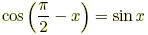 |  |  |  |  |  |  |  |  |  | sin (90° – x) = cos x |  |  |  | cos (90° – x) = sin x
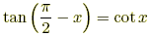 |  |  | 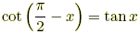 |  |  |  |  |  |  |  |  |  | tan (90° – x) = cot x |  |  |  | cot (90° – x) = tan x
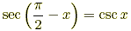 |  |  | 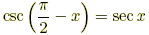 |  |  |  |  |  |  |  |  |  | sec (90° – x) = csc x |  |  |  | csc (90° – x) = sec x
Periodicity Identities, radians |  |  |  |  |  |  |  | Periodicity Identities, degrees
sin (x + 2π) = sin x |  | csc (x + 2π) = csc x |  |  |  |  |  | sin (x + 360°) = sin x |  |  |  |  |  |  | csc (x + 360°) = csc x
cos (x + 2π) = cos x |  | sec (x + 2π) = sec x |  |  |  |  |  | cos (x + 360°) = cos x |  |  |  |  |  |  | sec (x + 360°) = sec x
tan (x + π) = tan x |  | cot (x + π) = cot x |  |  |  |  |  | tan (x + 180°) = tan x |  |  |  |  |  |  | sin (x + 180°) = cot x
Sum/Difference Identities  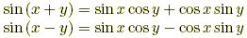  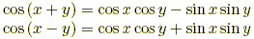  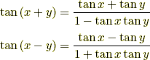 |  |  |  |  |  |  |  |  |  |  |  | Double Angle Identities  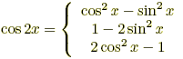  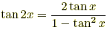
Half Angle Identities
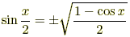 or 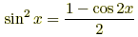
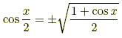 or 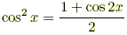
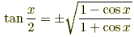 or 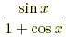 or 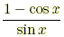
Product to Sum Identities  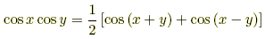  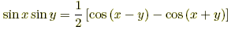  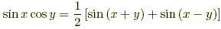 |  |  |  |  |  |  |  |  |  |  | Sum to Product Identities  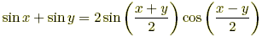  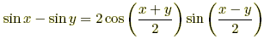  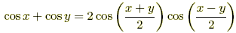  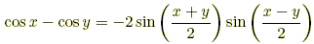
Trigonometric Identities
sin ( - x ) = - sin x
cos ( - x ) = cos x | cos ² A + sin ² A = 1
tan ( - x ) = - tan x | cos ² A = 1 - sin ² A
csc ( - x ) = - csc x | sin ² A = 1 - cos ² A
sec ( - x ) = sec x | sec ² A = 1 + tan ² A
cot ( - x ) = - cot x | csc ² A = 1 + cot ² A
Cos 2A = cos ²A – sin² A  = 2 cos ²A – 1  = 1 – 2 sin² A | cos ( A + B ) = cos A cos B - sin A sin B
sin 2 A = 2 sin A cos A | cos ( A - B ) = cos A cos B + sin A sin B
tan 2 A = 2 tan A /(1 - tan ² A ) | sin ( A + B ) = sin A cos B + cos A sin B
tan 2 A = 2 tan A /(1 - tan ² A ) | sin ( A - B ) = sin A cos B - cos A sin B
 | tan ( A + B ) = (tan A + tan B)/(1 - tan A tan B)
sin ( A + 2 π ) = sin A | tan ( A - B ) = (tan A -tan B)/(1 + tan A tan B)
cos ( A + 2 π ) = cos A
sin ( A + π ) = - sin A
cos ( A + π ) = - cos A | 2 sin A cos B = sin ( A + B ) + sin ( A - B )
tan ( A + π ) = tan A | 2 sin A cos B = cos ( A - B ) - cos ( A + B )
sin ( π/ 2 - A ) = cos A | 2 cos A cos B = cos ( A + B ) + cos ( A - B )
cos ( π /2 - A ) = sin A | sin A + sin B = 2 sin(( A + B)/ 2 ) cos (( A – B)/ 2 )
sin ( π - A ) = sin A | cos A + cos B = 2 cos(( A + B)/ 2 ) cos((A – B)/ 2 )
cos ( π - A ) = - cos A | cos A - cos B = - 2 sin ((A + B)/ 2 ) sin ((A – B)/ 2 )
a cos θ + b sin θ = R cos ( θ - α ) where , cos α = b/ R and sin α = a/R

