ICS 103-02 Quiz#02 Key (Term 102) (4 %)

- [5 Points] Show the order of evaluation of the operators in the assignment statement below by drawing the evaluation tree, and then determine whether the variable comparison has a value true (non zero) or false (zero):
int a = 2, b = 5, c = 3;
int comparison = ! (b - a = = c ) && b * a >= c | | b < a ;

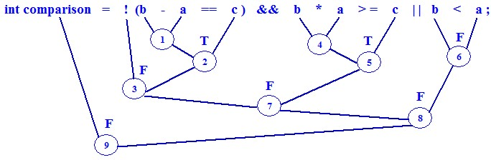

comparison has the value: 0 (false)

- [5 Points] What is the output of the following C program fragment?
int x = 120, y = 100;
if(x > 80 && y < 100)
y = y + 25;
else if(x > 95 && y > 50)
y = y + 45;
else if(x == 120 && y == 100)
y = y + 75;

printf("y = %d", y);

y = 145

- [5 Points] Re-write the following if-else statement using a switch-statement:

if(color == ‘R’ || color == ‘r’)
printf(“Red”);
else if(color == ‘B’ || color == ‘b’)
printf(“Blue”);
else if(color == ‘G’ || color == ‘g’)
printf(“Green”);
else
printf(“Not Primary Color”);

switch(color){
case ‘r’:
case ‘R’: printf(“RED”); break;
case ‘g’:
case ‘G’: printf(“GREEN”); break;
case ‘b’:
case ‘B’: printf(“BLUE”); break;
default: printf(“Not Primary Color”);
}

- [25Points: 15 + 10]
- Write a pseudo-code algorithm to prompt and input the number of courses a student takes in a private university, it then displays the total charge to be paid based on the following conditions:

Number of courses | Payment
<= 3 | 200 Riyals per course
> 3 | 600 Riyals plus 150 Riyals for each course above 3 courses

Note: Your algorithm must assume that the input is valid (i.e., it is not negative)

- Translate the above algorithm into a complete C program

- 1. Prompt for number of courses
2. Input number of courses
3. if numberOfCourses <= 3
charge ⬅ numberOfCourses * 200
else
charge ⬅ 600 + (numberOfCourses – 3)*150

4. Display charge

#include <stdio.h>

int main(void){
int numCourses, charge;

printf("Enter number of courses: ");
scanf("%d", &numCourses);

if(numCourses <= 3)
charge = numCourses * 200;
else
charge = 600 + (numCourses - 3)*150;

printf("Charge = %d Saudi Riyals\n", charge);

system("pause");

return 0;
}

========================================================
Note: No need to include statements to freeze the output window

