Information and Computer Science Department
Spring Semester 072
ICS 324 – Database Systems
Entity Relationship Model

Objectives
The objective of this lab is to start using case software tool (TOAD Data Modeler) to draw an Entity Relationship (ER) diagram, including different type of entities, attributes, and relationships

Outcomes
After completing this Lab, students are expected to:
- Be able to use case software tools to draw an ER diagram from a given specification (or problem statement).
- Be able to use some features of the software on representing the ER diagram as close as to the manual (or standard) ER diagram notification.

Discussion

- Introduction
The Entity-Relationship (ER) model is a high-level conceptual data model that is widely used in the design of a database application. The ER model represents data in terms of:
- Entities
- Attributes of entities
- Relationships between entities

There are several case tools to automate the drawing of diagram. Most of them have a feature of associating the diagram with specific database. This feature make easy to further process in designing and implementing to specific database.

To start creating an ER diagram on TOAD Data Modeler, select File à New Model, then select target database.

- Entity
An entity is an object or a concept that is identified by the enterprise as having an independent existence, i.e. EMPLOYEE, DEPARTMENT, etc. An Entity (or entity type) usually has an attribute whose value is distinct for each individual entity in the collection. Such attribute is called a key attribute, i.e. SSN for EMPLOYEE entity.
To create an entity, Click the Entity on the toolbar area, and then place it on the working area.
There are two types of Entity based on existence of key attribute:

- Strong Entity (independent entity): Entity that has key attribute.

Standard Notation | TOAD Data Modeler Notation
Entity Name | Entity Name  Attribute  Attribute

- Weak Entity (dependent entity): Entity that has no key attribute of its own.
Standard Notation | TOAD Data Modeler Notation

Entity Name
Entity Name
Attribute
Attribute

The TOAD will automatically change the notation from strong entity to weak entity for any entities that are the child side of identifying relationship.

- Attribute
Attributes are the information that explains the properties of an entity. To add (or create) attributes to the entity, edit the entity by double-clicking the entity or right click and select Edit Entity. Select Attribute tab on Entity window. Then click Add Button, to create attribute. The Attribute dialog will open. Supply the name, type of attribute, and other attribute's properties as necessary.

Meanwhile, the attributes on standard ER diagram are represented in oval attached to the entity.

The following are different types of attribute.
Type of Attribute | Standard ER notation | TOAD property
Ordinary |  | Default
Key | 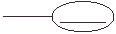 | Indicated by (PK) and red color
Multi-valued |  | Not applicable
Composite | 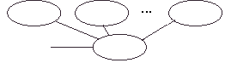 | Not applicable
Derived |  | Not applicable
Foreign Key | Inferred from relation | Indicated by (FK) and green color

- Relationship
Relationship (relationship type) is a meaningful association among entity types. Generally, a relationship is represented as a connection between (or among) entities. In standard ER model, it uses a diamond shape to connect between (or among) entities, while in TOAD, it does not use any intermediate notation. There are several type of relationships based on the type, degree, cardinality, and participation.

Type of Relationship | Standard ER notation | TOAD Notation
Type
Ordinary
Identifying
Informative | Not applicable
Degree
Unary  (Self Relationship) |  | Entity
Binary
Tertiary …. |  | Not Applicable
Cardinality
One-to-one | 1  1 | 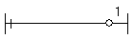
One-to-many | n  1
Many-to-Many | n  m | 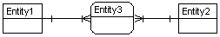

Participation
Total  (Mandatory) |  | 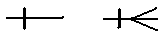
Partial  (Optional) |  | 

- Example of ER Diagram
The simplified problem statement:
The Company assigns an employee to one department but may work on several projects, which are not necessarily controlled by the same department. It keeps track of the number of hours per week that an employee works on each project. It records the direct supervisor of each employee. It stores the dependants of each employee for insurance purposes. It keeps each dependant’s: name, gender, birth date, and relationship to employee
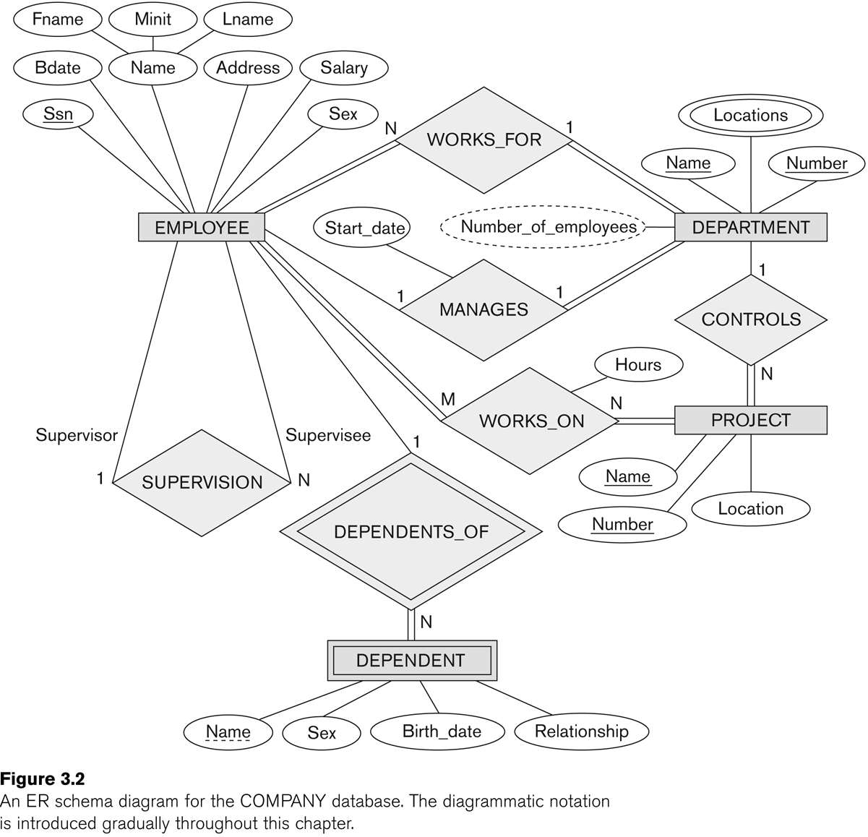

- Lab Exercises

- Draw the Company ER diagram above using TOAD Data Modeler case tool.

