**4.44)**



________________________

VEB = 0.7 V & VC < VB BJT is in active mode

RC=?? While BJT at the edge of saturation

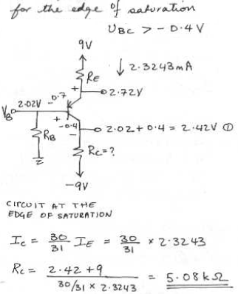

**4.45)**



**4.46) e**

