KFUPM-EE DEPT.
EE430: Information Theory and Coding
Problem Set # 1: Dr. Ali Muqaibel Due: 1/Week3

1. A source emits one of four symbols s₀, s₁, s₂, and s₃ with probabilities 1/3, 1/6, 1/4, and 1/4, respectively. The successive symbols emitted by the source are statistically independent. Calculate the entropy of the source.

2. Let X represents the outcome of a single roll of a fair die. What is the entropy of X?

3. The sample function of a Gaussian process of zero mean and unit variance is uniformly sampled and then applied to a uniform quantizer having the input-output amplitude characteristic shown in the Figure below. Calculate the entropy of the quantizer output.

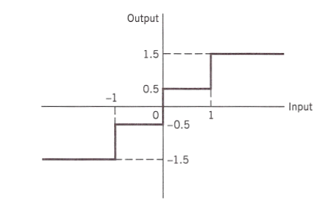
4. Consider a discrete memoryless source with source alphabet : S={s₀, s₁, s₂ }and source statistics{0.7,0.15,0.15}.
(a) Calculate the entropy of the source.
(b) Calculate the entropy of the second-order extension of the source. (two symbols)

From our text book "Applied Information Theory and Coding"
1.2.5
1.2.6
1.2.7
1.2.8
1.2.11

Note: not all answers will be posted.

