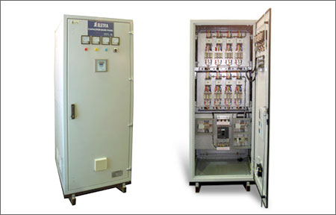
The ELETRA Capacitor Bank (Power Factor Control Panel), which improves power factor to increase energy efficiency, is a comprehensive automatic power factor regulation panel which can better save energy and electric power for greater profits.

