**King Fahd University of Petroleum & Minerals**

Electrical Engineering Department

EE315: Probabilistic Methods in Electrical Engineering (121)

**Major Exam II**



December 5, 2012

6:00-7:30 PM

Name: ___________________________

ID#______________________________

|  |  |
| --- | --- |
| **Question** | **Mark** |
| 1 | /20 |
| 2 | /20 |
| 3 | /20 |
| Total | /60 |

**Instructions:**

1. This is a closed-books/notes exam.
2. The duration of this exam is one and half hours.
3. Read the questions carefully. Plan which question to start with.
4. CLEARLY LABEL ALL SIGNIFICANT VALUES ON BOTH AXIES OF ANY SKETCH
5. Work in your own.
6. Strictly no mobile phones are allowed.
7. Tables Attached

**Good luck**

|  |  |  |
| --- | --- | --- |
| **Mark at your section** | **Sec** | **Instructor** |
|  | 1 | Dr. Wail **Mousa** |
|  | 2 | Dr. Saad **Al-Ahmadi** |
|  | 3 | Dr. Saad **Al-Abeedi** |

**Problem 1: (20 points)**

1. A discrete random variable *X* has the following probability density function:
$$f_{X}\left(x\right)=\frac{1}{3}\sum_{k=0}^{2}{δ(x-2k)}$$

2. Find the characteristic function of *X* and use it to obtain the second moment of *X*.
3. Find the moment generating function of *X* and use it to obtain the mean of *X*.

______________________________________________________________________

1. Given the following probability density function for a random variable *X*

$$f_{X}\left(x\right)=ke^{-2|x|}$$

where *k* is a constant and $-∞<x<∞$.

1. Find the value of *k*.
2. Find the mean and variance of *X.*

_______________________________________________________________________________

1. A random variable *X* is uniformly distributed on the interval (-4,4). It is transformed into a new variable *Y* by the transformation $Y=2X^{2}$. Find and sketch the density function of *Y*.

**Problem 2: (20 points)**

**A.** i) Determine the constant b such that the following is a valid joint probability density function (p.d.f.):



ii) Derive the marginal p.d.f’s *fX*(*x*) and *fY*(*y*).

**____________________________________________________________________________________**

**B.** The joint p.d.f. of two joint RVs X and Y is given as

|  |  |  |  |
| --- | --- | --- | --- |
|  | -1 | 0 | 1 |
| -1 | 1/16 | 3/16 | 1/16 |
| 0 | 3/16 | 0 | 3/16 |
| 1 | 1/16 | 3/16 | 1/16 |

i) Sketch the marginal p.d.f,s *fX*(*x*) and *fY*(*y*).

ii) Are X and Y independent? Explain.

**__________________________________________________________________________________**

**C.** A point is chosen uniformly from the area of a rectangle that is formed by joining the points (0,0), (0,2), (2,0), and (2,2). Let X and Y be the coordinates of the chosen point.

i) What is the joint p.d.f of X and Y?

ii) Derive the marginal p.d.f’s?

iii) Repeat parts a and b for a triangular area that is formed by the points (0,0), (0,2) and (2,0).

**Problem 3: (20 points)**

**A.** Consider two random variables $X_{1}$ and $X_{2}$ have the following joint pdf:

$$f_{X_{1},X_{2}}(x_{1},x_{2})=\left\{\begin{aligned}2e^{-x_{1}}e^{-x_{2}} for 0≤x_{1}≤x_{2}<∞ \\ 0 elsewhere \end{aligned}\right.$$

(i) Find the **correlation** and the **covariance** of $X_{1}$ and $X_{2}$.

(ii) Are X1 and X2 **correlated**?, why (show your work)?

(iii) Are X1 and X2 **independent**?, why (show your work)?

**_____________________________________________________________________________________**

**B.** Consider two **orthogonal** Gaussian random variables $X_{1}$ and $X_{2}$. Both have a unit variance but $X_{1}$ has Zero mean while the mean of $X_{2}$ equals 1. Find the **joint** **probability density function** **(pdf)** of $X_{1}$ and $X_{2}$.

**_____________________________________________________________________________________**

**C.** Two random variables $X_{1}$ and $X_{2}$ are added together to form a new random variable Y. If $X_{1}$ is uniformly distributed between 0 and 1, whereas $X_{2}$ has an exponential distribution with parameters $b=1$ and $a=0$, **find** and **sketch** the **probability density function** **(pdf)** of Y.

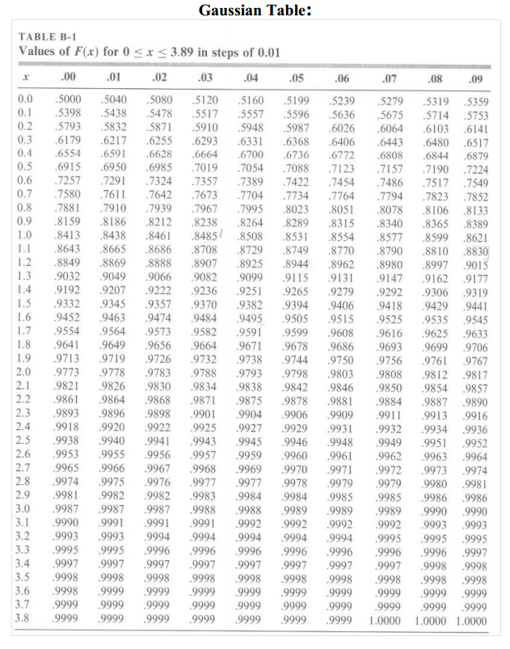

**The pdf of Different Distributions:**

Binomial Distribution

$f_{X}\left(x\right)=\sum_{k=0}^{N}{\left({N \atop k}\right)}p^{k}{\left(1-p\right)}^{N-k}δ(x-k)$

Poisson Distribution

$f_{X}\left(x\right)=e^{-b}\sum_{k=0}^{∞}{\frac{b^{k}}{k!}}δ(x-k)$

Uniform Distribution

$f_{X}(x)=\left\{\begin{matrix}\frac{1}{b-a} & a≤x≤b \\ 0 & elsewehere\end{matrix}\right.$

Gaussian Distribution

$f_{X}\left(x\right)=\frac{1}{\sqrt{2πσ_{X}^{2}}}e^{-\frac{{\left(x-a_{X}\right)}^{2}}{2σ_{X}^{2}}}$

Exponential Distribution

$f_{X}\left(x\right)=\left\{\begin{matrix}\frac{1}{b}e^{-\frac{x-a}{b}} & x≤a \\ 0 & x>a\end{matrix}\right.$

Rayleigh Distribution

$$f_{X}\left(x\right)=\left\{\begin{matrix}\frac{2}{b}(x-a)e^{-\frac{{\left(x-a\right)}^{2}}{b}} & x≤a \\ 0 & x>a\end{matrix}\right.$$