To create a file system Web site
- Open Visual Web Developer.
- On the File menu, click New Web Site.
The New Web Site dialog box appears.
- Under Visual Studio installed templates, click ASP.NET Web Site.
- In the left-most Location box, click HTTP.
- Click Browse.
The Choose Location page appears.
- Click Local IIS, and then click Default Web Site.
- Click the create new Web application icon (), and then name the new Web application AccessSample.
- Click Open.
The New Web Site dialog box appears with the location of your new Web application in the right-most Location box.
- In the Language list, click the programming language that you prefer to work in.
The programming language that you choose will be the default for the Web site, but you can set the programming language for each page individually.
- Click OK.
Visual Web Developer creates the folder and a new page named Default.aspx. The Web site is displayed in Solution Explorer.

Configuring Permissions for an Access Database
An important aspect of working with an Access .mdb file is to correctly configure permissions. When a Web application uses an Access database, the application must have Read permission to the .mdb file so the application can access the data. Additionally, the application must have Write permission to the folder that contains the .mdb file. Write permission is required because Access creates an additional file that has the extension .ldb in which it maintains information about database locks for concurrent users. The .ldb file is created at run time.
By default, ASP.NET Web applications run in the context of a local machine account named ASPNET (for Windows 2000 and Windows XP) or in the context of the account NETWORK SERVICE (for Windows Server 2003). For example, for Windows 2000 or Windows XP Professional, if the Web server is named ABCServer, ASP.NET applications on the ABCServer computer run in the context of the local account ABCServer\ASPNET. For more information, see Access Permissions for Web Applications (Visual Studio). Therefore, to use an Access database in an ASP.NET Web application, you must configure the folder that contains the Access database to have both Read and Write permissions for the local ASPNET user account.
When you create a Web site in Visual Web Developer, Visual Web Developer creates a folder named App_Data below the current root folder. The folder is designed to be a store for application data, including Access databases. The App_Data folder is also used by ASP.NET to store databases that the system maintains, such as the database for membership and roles. When Visual Web Developer creates the App_Data folder, it grants Read and Write permissions for the folder to the ASPNET or NETWORK SERVICE user account.
Note
As a security measure, files in the App_data folder are not served by the Web server. Do not store any Web pages in the App_Data folder, because users will see an error if they request a page from that folder.

To set permissions in the App_Data folder
- In Windows Explorer, move to the root folder for the Web site.
The default location for your new Web site is c:\inetpub\wwwroot\AccessSample.
- If the App_Data folder does not already exist, create one.
By default, Visual Web Developer creates the folder when you create a new Web site.
- Right-click the App_Data folder, click Properties, and then click the Security tab.
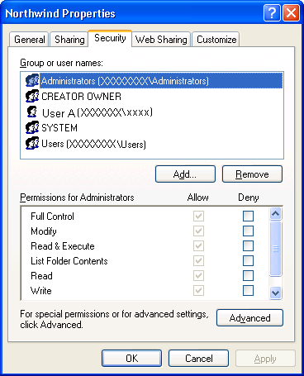
- Under Group or user names, look for either of these user accounts:
  - If the computer is running Windows XP Professional or Windows 2000, look for computer\ASPNET.
  - If the computer is running Windows Server 2003, look for NETWORK SERVICE.
- Verify that the account has Read and Write permissions for the App_Data folder.

Using Access Data on an ASP.NET Web Page
You can now use your Access database in a Web page. You will use an AccessDataSource control.

To add an AccessDataSource control to the page
- In Visual Web Developer, in Solution Explorer, right-click the App_Data folder, and then click Add Existing Item.
- Locate the Northwind.mdb file that you want to use for this walkthrough.
- In the App_Data folder, click the .mdb file, and then click Add.
The .mdb file is added to your application.
- Open the Default.aspx page and switch to Design view.
- From the Data group in the Toolbox, drag an AccessDataSource control onto the page.
  - If the Access Data Source Tasks shortcut menu does not appear, right-click the AccessDataSource control, and then click Show Smart Tag.
- On the Access Data Source Tasks shortcut menu, click Configure Data Source.
The Configure Data Source - <DataSourceName> wizard appears.
- On the Choose a database page, in the Microsoft Access Data file box, type ~/App_Data/Northwind.mdb.
  - Alternatively, click Browse, and then in the Select Microsoft Access Database dialog box, move to the Northwind.mdb file in the App_Data folder.
- Click Next.
The Configure Select Statement page appears.
- Click Specify columns from a table or view.
- In the Name list, click Categories.
- Select the CategoryID, CategoryName, and Description check boxes.
- Click Next.
The Test Query page appears.
  - Optionally, click Test Query to test your query.
- Click Finish.
- From the Data group in the Toolbox, drag a GridView control onto the page.
  - If the GridView Tasks shortcut menu does not appear, right-click the GridView control, and then click Show Smart Tag.
- On the GridView Tasks menu, in the Choose Data Source box, click AccessDataSource1.

Testing the Page
You can now run the page.

To test the page
- Press CTRL+F5 to run the page.
The GridView control displays all data rows from the Categories table.

