CHEM 515
Homework
Set # 2
(Due November 23, 2008)

---------------------------------------------------------------------------------------------------------

1- Locate from the literature a rotational spectrum for a diatomic or linear species of your choice (HF, HCl, HCN, etc.). Provide the citation of your source.
Make a simple diagram showing the rotational energy levels associated with the rotational transitions for that molecule. On the diagram show the rotational level quantum numbers and rotational constants, $\bar{B}$, in unit of wavenumebrs.

2- Do matrices commute? Give an example that proves your answer.

3- List symmetry elements and point groups for the following molecules:

(a) CH₂=CIF. (Cs)
(b) 1,3,5-trichlorobenzene. (D3h)
(c) Cyclohexane (boat and chair conformations). (c2v and D3d)
(d) SF₆. (Oh)

4- In an extended format and using the tables of chapter 7 in your textbook, write down the vibration wave functions associated with the quantum levels v=4 and v=5.

5- Derive the D₃ multiplication table. The symmetry elements for the D₃ point group are: E, C₃ , C₃⁻¹, C₂ , C₂’ and C₂’’. The below diagram could be of help to you.

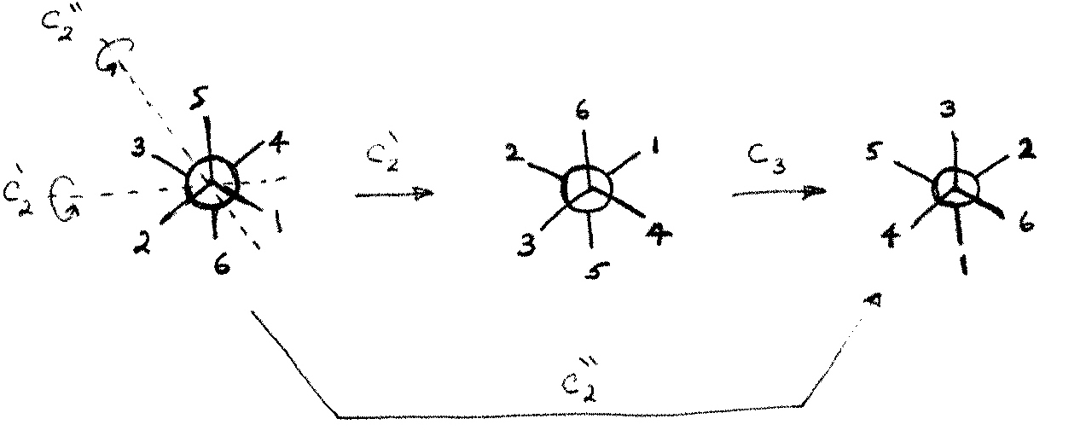

Show the six operations, i.e. E, C₃ , C₃⁻¹, C₂’ and C₂’’ , associated with the symmetry element C₂.

6- Born-Openheimer approximation made a great breakthrough in the field of quantum chemistry. Briefly explain its major aspect with the help of some simplified expressions.

