KING FAHD UNIVERSITY OF PETROLUEM AND MENERALS

ARC-251

URBAN DESIGN

FINAL REPORT

TRAFFIC CALMING

PREPARED BY: NAIF ALMOHAYA
259631

PREPARED FOR: DR. ALI ALNASER

Traffic calming issues
Definitions of traffic calming may vary but they all share the goal of reducing vehicle speeds, improving safety, and enhancing quality of life. Traffic Calming involves changes in street position, setting up of barriers, and other physical measures to reduce traffic speeds and/or cut-through volumes, in the interest of street safety, livability and other public purposes.
Traffic Calming is a holistic, integrated approach based on common sense which seeks to maximize mobility while creating a more livable city by reducing the undesirable side effects of that mobility. One definition of traffic calming is 'environmentally compatible mobility management.
In the flowing are issues that are related to traffic calming and there solution is giving according to implementation By other designers
ISSUE
Each of the different components of crossroads design can cause conflicts between the need for a safe and sufficient design, on one hand, and the need to minimize impact to the surrounding physical and human environments, on the other. In addition, the need to accommodate pedestrians and bicyclists can sometimes cause conflicts with the need to provide an efficient working environment for vehicular traffic.
Accommodating Pedestrians
The safe and efficient accommodation of pedestrians at intersections is equally important as the necessities made for vehicles. Pedestrian movements should be provided for and their locations controlled to maximize safety and minimize conflicts with other traffic flows. Too often, pedestrians are a secondary consideration in the design of roadways, particularly at intersections in suburban areas.
Solution
Pedestrian crosswalks should be located at intersections, should be appropriate for accessibility, and should be heavily marked. Two parallel painted lines generally are not enough of a distinguishing marking. Often motorists confuse these lines with the stopping line and pull right up to the edge of the crosswalk. At a minimum, some type of striping or painting inside the crosswalk area is recommended to improve safety. Many cities and suburban areas have gone beyond this and added aesthetic treatments to their crosswalk designs, including use of the following:
- Distinguishing materials for crosswalks, such as brick, patterned concrete, and cobblestone as done in Al- Khobar and Dammam
- Granite edging
- Colored pavement or solid painting of crosswalks.
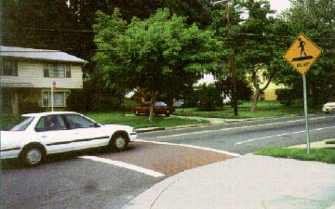 | 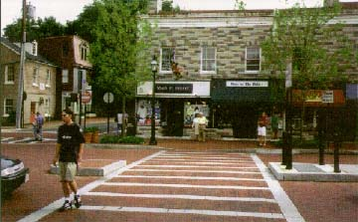

Pedestrian signals should be used in combination with vehicular traffic signals at all signalized intersections where pedestrians are likely to be present. Push buttons can be used at isolated intersections or where vehicular demand warrants maximizing the time for vehicular movement through the intersection. Fixed time traffic signals with relatively short cycle lengths are more appropriate in urban or downtown areas.

Appropriate Corner Radius Design
As mentioned earlier, there are many tradeoffs involved in the selection of the appropriate type and dimension of radius designs.For example, if the primary goal of the intersection design is to move traffic through as quickly as possible, a higher corner radius would be selected. The dimension of the corner radius sends a message to drivers entering residential neighborhoods regarding the speed they can drive and should be designed with this in mind. Encouraging fast speeds around intersection corners into residential areas will weaken efforts to lower working speeds within the neighborhoods themselves. In addition, faster speeds create an unsafe environment for pedestrians.
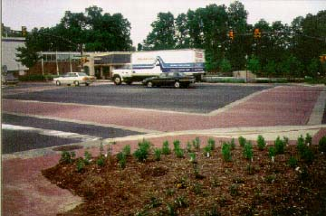

Addition of Left Turn Lanes
A common conflict arising from the use of separation of traffic into specific paths of travel by traffic islands, medians, or pavement markings, is the addition of left turn lanes. While there is no doubt that this can create a smoother flowing intersection, especially on two-lane roads, the addition of a left turn lane can significantly widen the width of the roadway, unless there is a median. This can change the character of an area, affect adjacent development or resources, and cause the road to be out of scale with its surroundings.
Solution
In cases where a left turn lane is truly needed to improve safety and operational efficiency in a slim right-of-way, there may not be an easy solution to this issue. Sometimes the addition of left turn lanes depends on new growth and development along the corridor. If the attractive, historic, or cultural resources are such that any additional widening would affect these resources, it may be that decisions made at the land use stage of planning should be reconsidered. Limiting development along the corridor will limit traffic volumes and the need for additional left turn lanes. Another option is to lower traffic volumes on the roadway through other means, including creating or widening alternative routes.
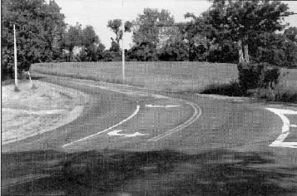
ISSUES
The conflicts in design of highway bridges relating to visual, attractive, historic, and cultural resources commonly boil down to one of two issues:
- Should an existing structure be rehabilitated or should a new bridge be constructed?
- Is a new structure out of scale with its surroundings or is its design unsuited with its environment?

Reconstruction versus Rehabilitation
In many instances, particularly for bridges of historic or visual value, the rehabilitation of the bridge is the preferred solution, rather than total replacement. This option is not always feasible, but should be pursued as much as possible.

Solution
As stated above, existing bridges that bearably meet geometric criteria can be retained. Each bridge needs to be examined on an individual basis, considering the design factors unique to that structure. Only after careful analysis and consultation with the community, should a determination be made.
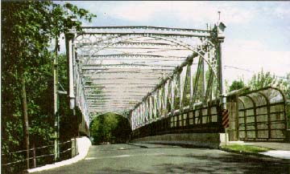 | This historic bridge was restored by building a new bridge within the existing trusses. The new bridge carries its own weight, as well as the weight of all traffic crossing it.

A project scoping report recommended demolishing the existing structures and replacing them with more modern style steel or concrete structures designed to satisfy current seismic design criteria.
While it had been originally assumed that the structural capacity of the bridges was limited with regard to vehicle weight, further investigations determined that the actual limiting feature was the size of the vehicles that could pass through the highway tunnels located on either side of the bridges. The bridges were determined to have very few problems with vehicle height or width restrictions.
As a result of this finding, several rehabilitation schemes designed to increase the structural capacity and seismic stability of the structures without changing their basic designs or appearances.

Compatible Design Scale
When rehabilitation of existing bridges is not possible, a common concern of local residents is whether the proposed new structure will visually fit into the community.
Solution
The solution for designing a visually attractive and context sensitive new bridge is to be flexible and to work with the community from the beginning to obtain public contribution. Professionals from other disciplines, such as architects, can also assist, especially if engaged early in the design of the structure. It is important to consider how the use of the geometric criteria will affect the overall scale of the bridge in relation to the surroundings.
New replacement bridge and downstream pedestrian/bicycle bridge. | 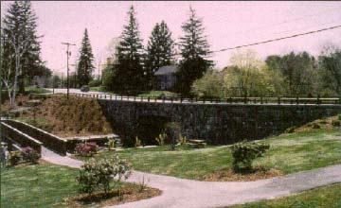

ISSUES
Some of the challenging aspects of highway design have to do with cross-section elements. Decisions that designers need to make may include the number of lanes proposed for the improvement, the width of travel lanes and shoulder areas, the type of drainage proposed, or the desirability of including sidewalks or bicycle/pedestrian paths as part of the project.
Restricted Right-of-Way
Many roads currently exist that were not built to today's standards. These roads may be located in restricted right-of-way corridors that have attractive or historic resources adjacent to the roadway. It is necessary to try to avoid impacting these resources when considering highway improvements.
Solution
One option, as has been discussed previously, is to reconsider the functional classification and design speed of a particular section of highway, because these decisions go a long way toward defining the basic design parameters that can be used in connection with an improvement of the facility. Lowering the design speed or changing the functional classification results in a lowering of the minimum width dimensions for the cross-sectional elements.
Another option is to seek design exceptions. Whichever alternative is chosen, the designer should try to maintain consistency in the roadway cross section. If only a small stretch of highway is located within restricted right-of-way, it would be unsafe to narrow that stretch while maintaining a much higher roadway width before and after it.
The Design of Cross-Section Details
Some highway facilities may be designed with the greatest concern to fit into their surrounding environments, but if the details are not carefully thought out, they can still leave the impression of an unappealing roadway.
Solution
The design of all elements of the highway cross section adds greatly to its appearance. Design details include the design and width of the median and traffic barriers and the selection of plant material. All these elements contribute to the theme of the roadway and should be considered as a unit.
Details are some of the first elements users of a facility will notice. For example, designers may go through a lot of trouble to preserve vegetation along the roadway because of its importance to the community and its scenic qualities, but if designers use concrete barriers as shields in front of this vegetation, that one element may catch the users' attention.
Another option that aids designers in the details of crosssection elements is the use of computerimaging technology..
With the increasing need to ensure meaningful and continuous public involvement on all such projects, the use of computer imaging to illustrate design alternatives to communities will help to alleviate potential conflicts and misunderstandings and lead to the best design decisions.

Here are some of the benefits that a German city found by using traffic calming:
50 percent increase in bicycle use.
57 percent reduction in fatal accidents.
45 percent reduction in severe accidents.
40 percent reduction in slight injuries.
43 percent reduction in pedestrian accidents.
16 percent reduction in cyclist accidents.
16 percent reduction in traffic accident costs.
66 percent reduction in child accidents.

Concluding this issue
There are still more factors to be considered in the presute of stable traffic environment. But the issue still remains that the small principles of design should be considered in oreder to achive perfect traffic environment.

