King Fahd University of Petroleum and Minerals
College of Environmental Design
Architecture Department

ARC – 281: Introduction to Urban Design

The Development of
“Qasr Al-Hukm” Area from
Urban Design Point of View

Instructor: Dr. Ali Al-Naser
By: Anas Al-Wohaibi
205941

Table of Contents

Introduction 3
The Landmarks of the Area:
1. Governance Palace (Qaser Al-Hukm) 3
2. Suwaiqa Commercial Compound 4
3. Al Masmak Yard 4
4. Justice Court 5
5. The Great Mosque 5
6. Al Safah Courtyard 6
7. Imam Mohammed bin Saud Square 6
8. Souq Al-Deera 7
9. Maaghliya Commercial Center 7
10. Old City Walls and Historical Gates 7
11. Souq Azzal 8
Zoning of Qasser Al-Hukm Area 8
Circulation of Qser Al-Hukm Area 10
Suggested enhancement 11
References 11

Introduction
The Governance Palace site, which resembles the nucleus of Riyadh city and the starting point for the Unification of the Kingdom, deserves the attention which it is receiving today, and which indicates the loyalty of sons to their family and their determination to continue their path and responsibilities towards the religion, the country and the nation. The development of Governance Palace (Qasr Al-Hukm) area had renewed the downtown to continue its role as political, administrative and trade center. In this report I will describe the main features of the project, and then I will do an analysis for the circulation and the zoning of the area. Finally, I will suggest solutions that will more enhancement of the area.
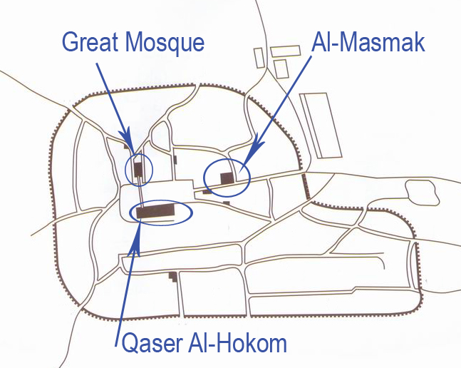
The old city of Riyadh which is called now Qaser Al-Hukm

The Landmarks of the Area:
1. Governance Palace (Qaser Al-Hukm)
This palace was the head office for the Governor and the place where citizens met their leaders. As one of the main buildings that need to be developed, the palace was rebuilt at the previous site over an area of 12500 square meters. The palace was designed according to traditional Islamic architecture. It appears as if it was built of two sides: One at the southern part consists of six stories in the shape of a fortress that contains four towers at its corners in addition to fifth tower in the middle for lighting and ventilation for the offices and building located under it. Another part linked with this tower from the northern direction consists of five stories. The outside facades of this palace semi closed but inside we can notice a series of ports of different sizes.
The palace inside the royal court covers an area of 2000 square meters with 14 meters height. At the surroundings of this court you can notice a number of pillars covered with marble. Its walls were decorated according to traditional type. The first floor contains an office of the Custodian of the Two Holy Mosques, as well as additional rooms, dinning room, covers 1120 square meters in addition to other halls. The first floor also includes the office of Riyadh Governor, a hall for receiving citizens as well as special suite for The Governor, meeting room and dinning room. This storey also contains the office of Deputy Governor of Riyadh and special suite for him.
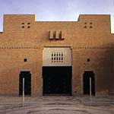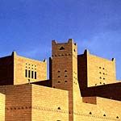

2. Suwaiqa Commercial Compound
This compound was designed in the shape of popular Suq with pillars and passages covered with tents. It contains 260 commercial stores at the eastern side of the compound. Apart of the ancient wall, the city was rebuilt at the Western part of Suwaiqa compound. There is a public yard surrounding Al Masmak fortress which was built in 1400H.
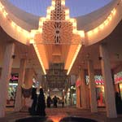
3. Al Masmak Yard
This yard has been built to make the fortress appeared in good shape due to its historical importance. The yard was built over an area of 4500 square meters At its southern part Palm trees were planted in addition to other trees and pushes in the rest of the yard except the eastern side, which decorated by desert coordination that ended with high steps over the ground service for sitting and protecting the fortress. Among the yards there are passages for the passer-by paved with stones and furnished for drama activities such as popular arts. The most near Al Masmak was rebuilt according to Islamic architecture. Al Masmak yard was linked from the western side with justice court.
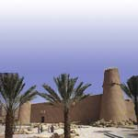

4. Justice Court
The area of the court is 14000 square meters with dimension suitable to the height of the building at its vicinity. It was limited from the north by administrative offices and commercial stores on the ground floor. From the south it was limited by the Charity Markets. The eastern side of the court forms covered corridors under which a number of commercial stores were built. At it surroundings palm trees were planted according to passer-by directions.
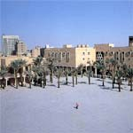

5. The Great Mosque (Imam Turki bin Abdullah Mosque)
The mosque continues to perform his mission as grand mosque in the city for long decades. It was rebuilt on its previous sites over an area of 16800square meters. The height of the mosque is 14.8m. It accommodates 17000 worshipers. At its surroundings 50 light stand were built on traditional architecture type.
The mosque also contains libraries for both gender men and woman. The area of each library is about 325square meters The Imam residence was built by its side in addition to official offices and commercial stores of the concerned governmental bodies. The mosque was set up with television and broadcasting transmitting equipment as well as television camera operated by remote control. Imam Turki Mosque is linked with Justice Palace by two bridges at the level of the first floor across Al-Safah yard.
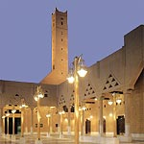

6. Al Safah Courtyard
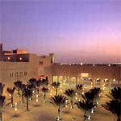
This yard is located between Imam Turki Mosque and the Governance Palace and it was linked with Justice Court from the Western side. The Main entrance of the Royal Palace is open at this yard. This yard was covered with a number of palm trees.

7. Imam Mohammed bin Saud Square
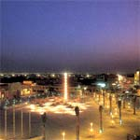
This yard is limited from the west side with a series of courts as well as public open yards which represents the main architectural elements in the Governance Palace area and it casts on its planning a distinguished type of architecture. The yard occupied an area of 14000 sq, m which is planted with palm trees and various types of trees as well as it is furnished with sitting shaded area and fountains. It is overlooked by the Governance Palace from eastern side and Riyadh Secretariat from southern side and Maaghliya Commercial Center from northern side.

8. Souq Al-Deera
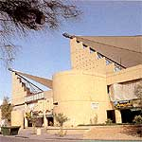
It is located almost at the center of the area, and built during the first stage. It was built with a traditional style. The corridors of this Suq dose not have HVAC, but were completely shaded with a tensile structure.

9. Maaghliya Commercial Center
It is located at the far western side of the second phase area of the Governance Palace development program. The center contains about 1000 commercial stores in addition to offices and residential apartments as well as car parking that contain about 200 cars.
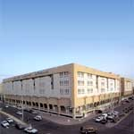

10. Old City Walls and Historical Gates
During this phase Dukhna and Al Thumairi Gates were rebuilt in addition to Deera Tower and a part of the old wall. Dukhna Gate was rebuilt at its previous site at the intersection of Imam Mohammed bin Abdulwahab and Tareq bin Ziad Streets. In addition to that the tower near the gate was rebuilt and including a part of the wall as well.

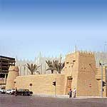

11. Souq Azzal
The area is located between Tareq bin Ziad and Imam Mohammed bin Abdulwahab Street over an area of 38080 square meters. It contains commercial activities in the northern side for sale and manufacturing traditional and heritage materials such as sorts, carpets and shoes. At the south western, the work continues on rebuilding the mosque of Imam Mohammed bin Ibrahim and Imam Mohammed bin Abdulwahab.

Zoning of Qasser Al-Hukm Area

This area has a wide variety of zones, since it is considered as the downtown of Al-Riyadh city. However, the main zone of the area is the commercial one and it takes about 63% of the area. There is sensitive zone in the area which is the governmental one or Qaser Al-Hukm itself. This building needs a very high security, which affects the surrounding urban area. The south urban fabric have is mostly residential and storage spaces. However, the open spaces between them are used for commercial purposes. The emphasis on courtyard is clear in that area. Some of those are redesigned with hardscape, softscape and coffee shops, but some are not.

There are a lot of spaces are designed for parking, and one space of those is multistory parking. The parking itself is divided to three zones. The first is for public and it is free from charge. The other one is for public also but with charge. The last one is privet, for the people working in Qaser al-Hukm and The great Mosque.

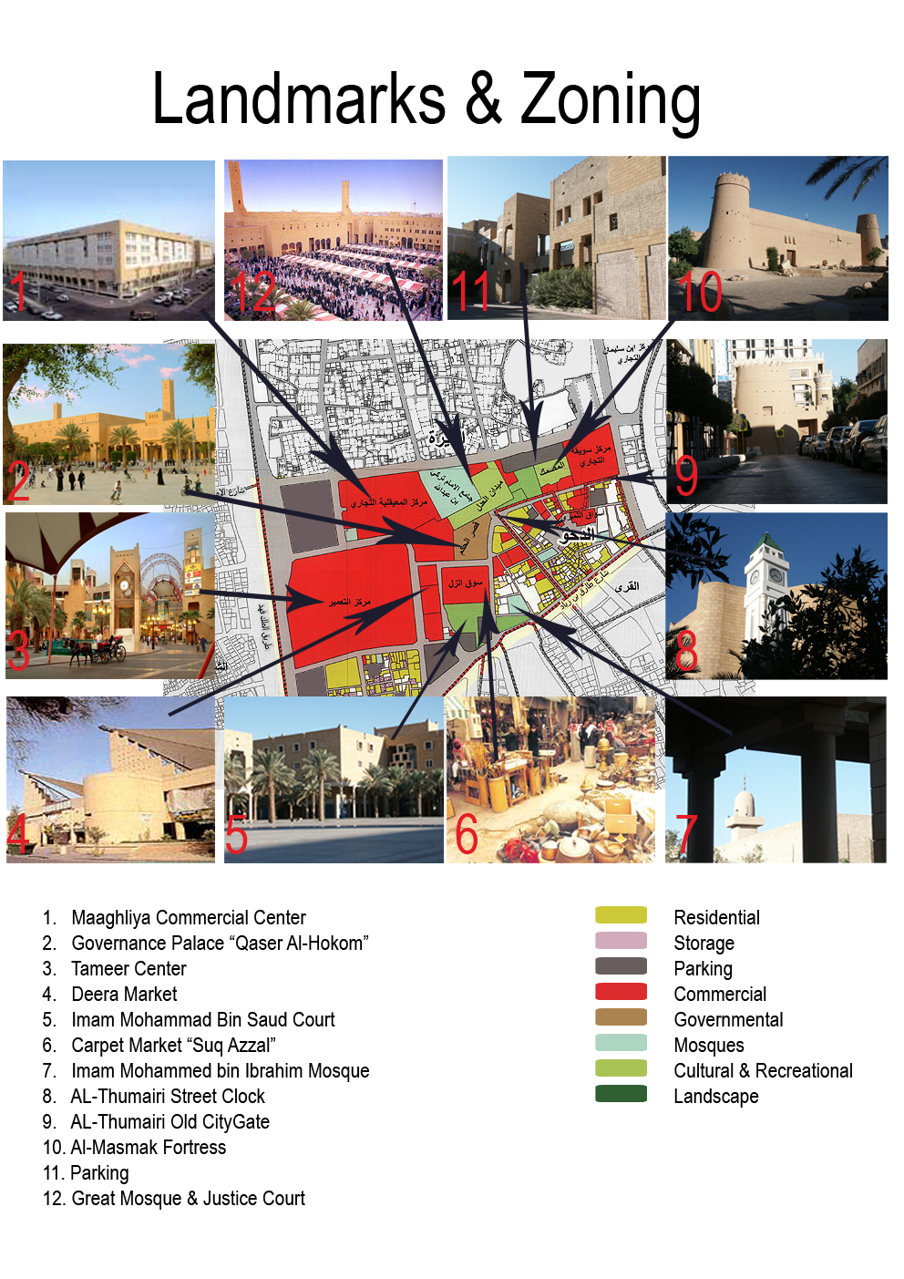
Circulation of Qser Al-Hukm Area

There are three different types of circulation in that area: the one way vehicular, the 2 way vehicular, and the pedestrian. The one way vehicular circulation is located at the narrow streets, the non-developed streets, and Thumairi Street. The 2 way vehicular circulation is mainly surrounding the area. And the traffic lights are reduced to avoid the traffic jam. The pedestrian circulation is mainly concentrated at the south-western area at a block called “Suq Al-Sogor”. In the center, there are two streets that work as pedestrian circulation, but they are work as vehicular circulation for the formal occasions. There are three streets linked to Thumairi Street were changed from vehicular to pedestrian after the development.

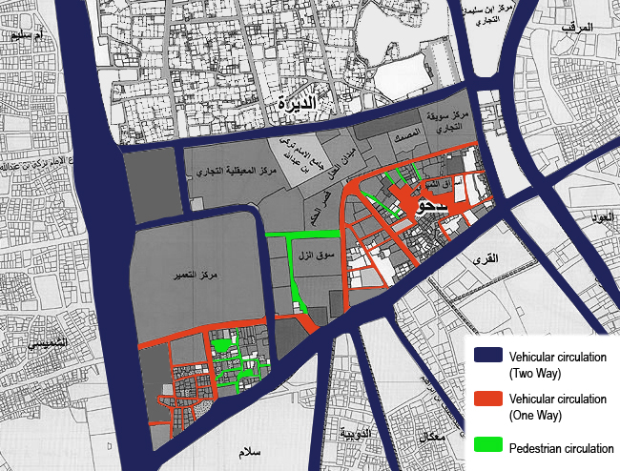

Suggested enhancement

- There is a very busy parking at Al-Thumairi Street that could be solved redesigning the open area, which is in the south of the street, as parking area.

- The area is very hot during summer days, but since that Riyadh climate is dry, installing the devices that spry water vapor will solve the problem.

- The area has too many open spaces that exposed to the sun and the shading devices are very massive, so using removable shading devices that are made from a light material will be effective.

- Valuable lands are used just for storing goods. Renovating those areas and use them for commercial, cultural or recreational will increase the urban quality of the area.

- Most of the courts and yards are missing some of the services. So, there is a need to allow the movable sellers, increasing the cafés, and provide information help spaces in each court. By doing that people will like to spend more time in that area.

References
  - “Traditional Architecture in Saudi Arabia: The Central Region”
  - “The Architecture of Rasem Badran”
  - “Introducing Urban Design: Interventions and Responses”
  - www.archnet.com

