PN CCCR2206
This is a proprietary document of the King Fahd University of Petroleum & Minerals. It is not to be disclosed or reproduced without prior written permission of the University.

PROGRESS report on Saudi telecom company enterprise NETWORK SIMULATION STUDY

Submitted to

Saudi Telecom Company
Riyadh, Saudi Arabia

Prepared by

King Fahd University of Petroleum & Minerals

Jumada1 1425H
July 2004G

Summary
The main task of this project is to study the Saudi Telecom Company (STC) high speed enterprise network backbone. This study models the deployment of MultiProtocol Label Switching (MPLS) based Virtual Private Networks (VPNs) in the STC high speed backbone. Comparison of different “what-if” scenarios is accomplished. Several traffic engineering parameters are studied for the network backbone behavior with and without the MPLS VPN deployment.

Table of Contents
Section Title Page
section 1 Introduction 1
section 2 tasks accomplished 1
2.1 Task I – CONSTRUCTION OF NETWORK MODELS 1
2.1.1 Creating Custom Process Models in OPNET 1
2.1.2 Deployment of Intermediate System – Intermediate System (IS-IS) 1
2.1.3 Deployment of Border Gateway Protocol (BGP). 1
2.1.4 Deployment of MPLS VPNs. 2
2.1.5 Deployment of Quality of Service (QoS) on the HSBB. 2
2.2 Task II – VALIDATION AND VERIFICATION 2
2.3 Task III – SIMULATION RUNS 2
section 3 Simulation results 3
3.1 Medium load of HTTP, Email and FTP 4
3.2 Heavy load of HTTP, Email and FTP 7
3.3 Comparison of the different scenarions 9
section 4 conclusions AND RECOMMENDATIONS 14

section 1 Introduction
The STC High Speed Backbone (HSBB) network has been modeled using OPNET tool and simulated. OPNET is one of the major network modeling, simulation and analysis tool available today. The network details have been taken from the technical drawings provided. The ‘network design description document’ forms the basis of all the technical and operational details of the network.
The current network architecture comprises the Centralized Operation Management/Information System (COM/IS) network and Enterprise Data Network (EDN). STC is undertaking a phased approach in upgrading the backbone. The models developed for the HSBB design incorporate all the changes targeted by STC in all phases.
This progress report is organized as follows. In Section 2 we list the tasks that have been accomplished. In Section 3, we discuss the result for the simulation models with different scenarios.

section 2 tasks accomplished
The tasks that have been accomplished are detailed in this section. Some tasks are currently under progress and are thus indentified as incomplete.

2.1 Task I – CONSTRUCTION OF NETWORK MODELS
STC HSBB network has been modeled using OPNET. HSBB upgrade Phase 1 and Phase 2 network design details have been incorporated in the model. Some of the major subtasks completed in this task include:

2.1.1 Creating Custom Process Models in OPNET
To model the Gigabit Switch Routers (GSRs), the 7513 Cisco routers, and other network devices with the device hardware configurations outlined in the design document, custom process models are created that are based on the basic model shipped as part of the OPNET library.

2.1.2 Deployment of Intermediate System – Intermediate System (IS-IS)
IS-IS is deployed as the backbone routing protocol, with all features and specifications as outlined in the design document.

2.1.3 Deployment of Border Gateway Protocol (BGP).
Peer relationships are established between Provider Edge (PE) and Customer Edge (CE) routers. Internal BGP (IBGP) peer relationship is established between PE routers. Route redistribution is configured. All other ll features and specifications as outlined in the design document…. Some text is missing here…sentence is incomplete.

Some of the subtasks that are currently underway are:

2.1.4 Deployment of MPLS VPNs.
Label Switched Paths (LSPs) have been configured; Three VPNs – EDN, COM/IS and Management are to be deployed. Model configuration is complete. Simulation is yet to be performed.

2.1.5 Deployment of Quality of Service (QoS) on the HSBB.
This task has not yet started.

2.2 Task II – VALIDATION AND VERIFICATION
The latest updates as provided by STC, have been included in the new simulation models (you mean new developed models?). An intial verification of the model was done by communicating a subset of the model developed to STC. Built-in OPNET model, link and nodes consistency checking tools have been used to verify the correctness of the model. All the parameters that are fed into the attributes of the links and devices are based on the design document furnished by STC.

2.3 Task III – SIMULATION RUNS
Once the model validation was complete, simulation runs were done on the model to study the HSBB network performance for various traffic types. These simulation runs were done to arrive at a baseline of network performance with switching and routing, without any deployment of MPLS VPNs. This baseline shall be used to compare with the MPLS VPN results once they are available.
Traffic profiles for different kinds of users were used from the built-in profiles available under OPNET.
Traffic types modeled and simulated include the web traffic (http), the file transfer protocol traffic (ftp), and the email traffic.
The outcomes of this task are discussed further in Section 3.

section 3 Simulation results
Simulation results were obtained for two scenarios:
1. Medium load of Web, ftp and email
2. High load of Web, ftp and email

These scenarios are compared and the results are given in this section. The traffic parameters under which the different services were modeled are given in Tables 1-3.

 | Medium Load | Heavy Load
Page Inter-arrival Time (Seconds) | Exp (60) | Exp (10)
Object Size (Bytes) | Constant (1000) | Constant (1000)
Number of objects | Constant (1) | Constant (1)
Image object size (Bytes) | Uniform (500, 2000) | Uniform (2000, 10000)
Number of images | Constant (5) | Constant (7)
Type of service | Best Effort | Best Effort
Table 1: Traffic parameters for web (HTTP) service.

 | Medium Load | Heavy Load
Send Inter-arrival Time (Seconds) | Exp (720) | Exp (360)
Send Group Size (Bytes) | Constant (3) | Constant (3)
Receive Interarrival Time (Seconds) | Exp (720) | Exp (360)
Receive Group Size (Bytes) | Constant (3) | Constant (3)
Email size (Bytes) | Constant (3000) | Constant (5000)
Type of service | Best Effort | Best Effort
Table 2: Traffic parameters for the email service.

 | Medium Load | Heavy Load
Inter-request Time (Seconds) | Exp (720) | Exp (360)
File Size (Bytes) | Constant (5000) | Constant (50000)
Number of ‘get’ commands | 50 % | 50 %
Number of ‘put’ commands | 50 % | 50 %
Type of service | Best Effort | Best Effort
Table 3: Traffic parameters for the FTP service.
A discussion of the results obtained in these two scenarios follows below. A web report, accessible by any web browser is generated.

3.1 Medium load of HTTP, Email and FTP
The response times for different http, ftp and email traffic for medium loads is shown in Figures 1, 2 and 3 respectively.

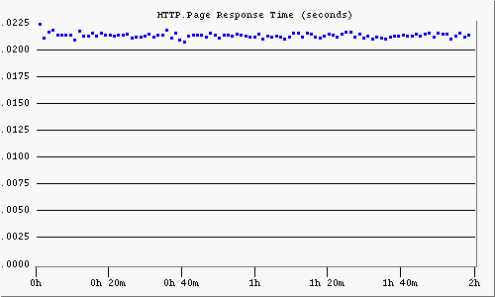
Figure 1 HTTP page response time for medium load

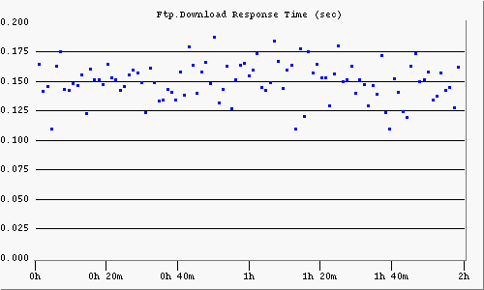
Figure 2 FTP download response time for medium load

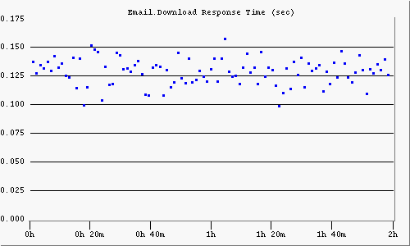
Figure 3 Email download response time for medium load

3.2 Heavy load of HTTP, Email and FTP
The response times for different http, ftp and email traffic for medium loads is shown in Figures 4, 5 and 6 respectively.
.

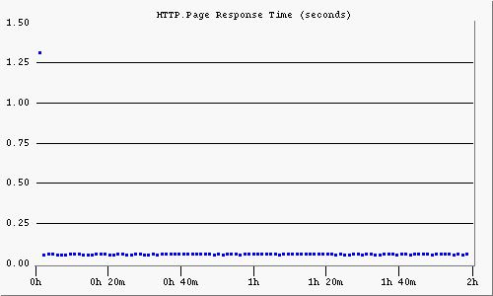
Figure 4 http page response time for high load

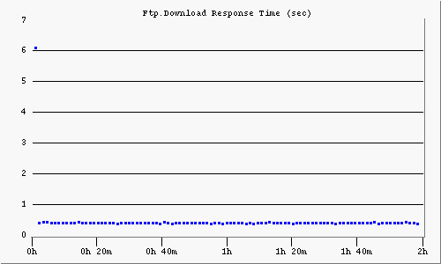
Figure 5 FTP download response time for high load

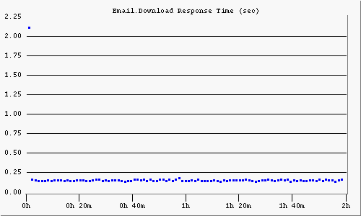
Figure 6 Email download response time for high load

3.3 Comparison of the different scenarions
A comparison was done among the results described in Sections 3.1.1, and 3.1.2. Consolidated graphs for the point-to-point utilizations of some of the links are presented below.

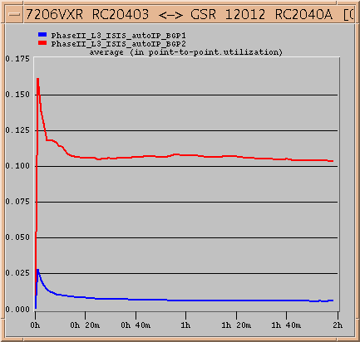
Figure 7 Comparison of point-to-point utilization for different loads

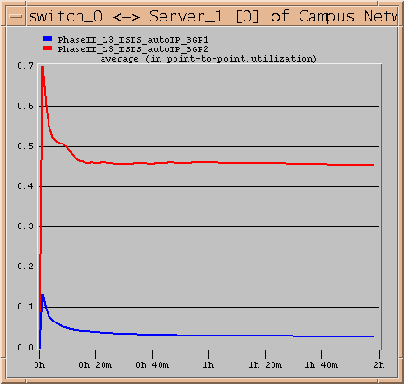
Figure 8 Comparison of point-to-point utilization for different loads

Figure 9 shows the comparison of delay in the network between the two scenarios.

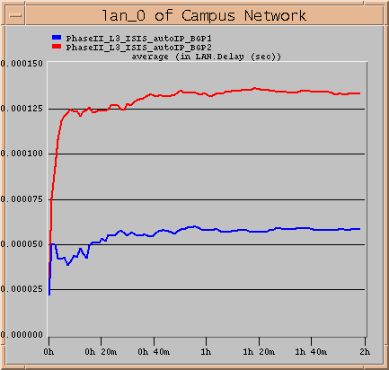
Figure 9 Comparison of average LAN delay for different loads

Figures 10, 11 and 12 respectively show the comparion of the web page response time, the FTP download response time, and the email response time for the different traffic loads.

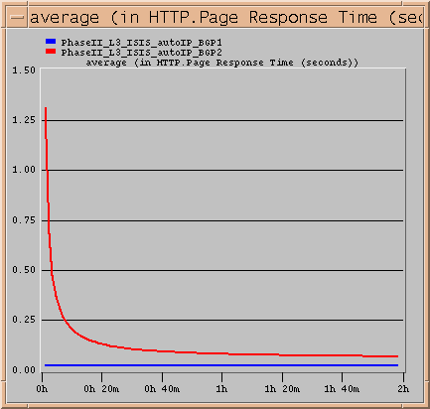
Figure 10 Comparison of http page response time for different loads

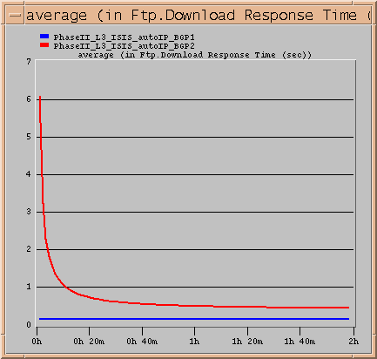
Figure 11 Comparison of FTP download response time for different loads

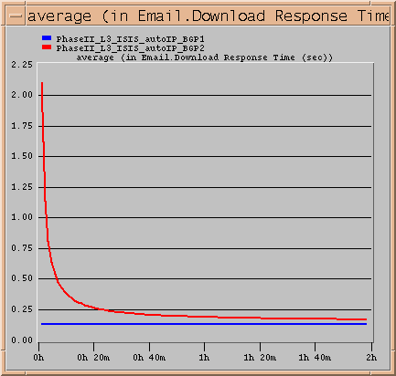
Figure 12 Comparison of FTP download response time for different loads

section 4 conclusions AND RECOMMENDATIONS
The simulations done on the network model for the STC HSBB network indicate that the Layer 3 traffic performance is good. Utilization of the links is reasonable and under acceptable limits.
A comparison of the network baseline with the introduction of MPLS VPN will lead to pointers to the efficacy of MPLS VPNs on the HSBB network.
To fully capture and mimic the behavior of the STC backbone network, we recommend the following:
- We recommend that traffic traces are collected and analyzed in order to understand the behavior of the user and to easily project future needs and expansions. Although application behavior is predicted, user plays a significant role in the usage of network resources.
- Topology capturing software and/or devices are highly recommended to a network of this size. Further the integration with network documentation software such as OPNET is highly advisable.
- We recommend that portions of the network need to be studied in detail that includes simulation runs with quality of service parameters set and fault tolerance aspects of the network incorporated. This is essential since many huge networks lack adequate active redundancy.

