Title of Lab: Senior Design Project Lab

Area/Space Requirements
- Length: 9 m
- Width: 7 m
- Capacity
  - (# Students) 12
  - Lectern 0

Seating Requirement: a
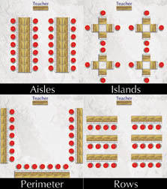
a
b
c
d

Electrical and Internet Cabling System
- Raised floor Yes
- Static-free floor Yes
- Cable trough No
- Side wall conduit No

Furniture
- Tables
  - Area (/ student): 1 m²
  - LAN Connectors No
  - USB Connectors Yes
  - Headset Connectors No
  - Other Connectors N/A
  - Electrical Outlet No
- Chairs Swivel
- Closets Yes (Manuals, Storage, Stationary, etc)

Equipment
- Audio/Visual
  - Ceiling-mounted projector No
  - Video Cassette/DVD Player No
  - Pull-down screen No
  - White Board No
  - Large-screen monitors No
- PC
  - CPU (footprint) Yes
  - Keyset and Mouse Yes
  - Monitor Yes

- Peripherals
  - Scanner No
  - Printer No
  - Digital Camera No
  - Input Microphone No

- Software and Equipments

No. Of Pieces | Equipment
2 | Oscilloscope (TDS Family)
3 | Logic Analyzer
4 | Digital Design Board

- Switches Yes (1)
- Networking Networked
  - Routers No
- Security and Safety
  - Surveillance Camera System No
  - Fire Extinguisher No
  - Sprinkler System No
  - Smoke Detectors Yes
- Other
  - Nearby Systems Room No
  - In-house technician No
  - Additional Hardware No

