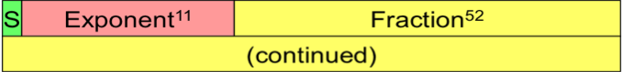
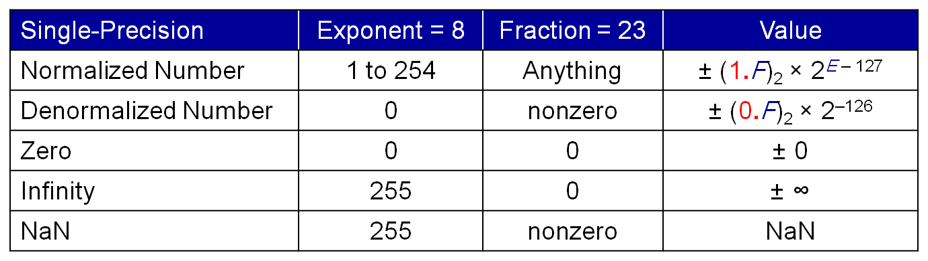
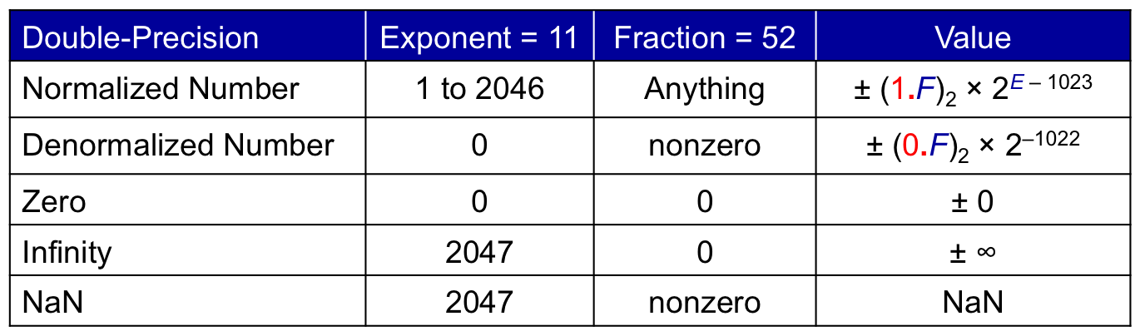
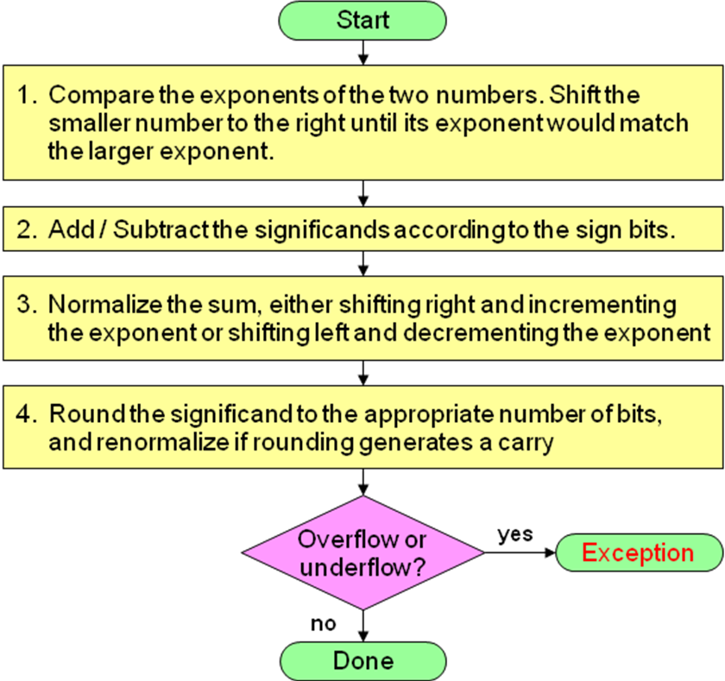
Floating Point Multiply
Floating Point Add/Subtract

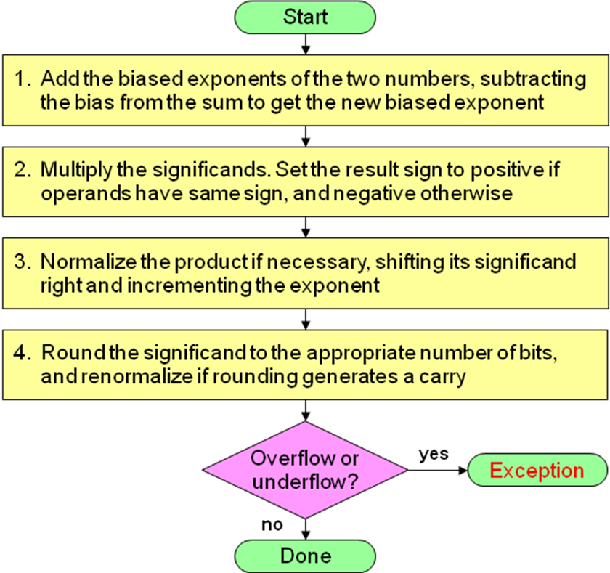

Round to Nearest Even: default rounding mode
Increment result if: r s = “11” or (r s = “10” and f_{l} = ‘1’)
Otherwise, truncate result significand to 1. f₁ f₂ … f_{l}
Round toward +∞: result is rounded up
Increment result if sign is positive and r or s = ‘1’
Round toward –∞: result is rounded down
Increment result if sign is negative and r or s = ‘1’
Round toward 0: always truncate result

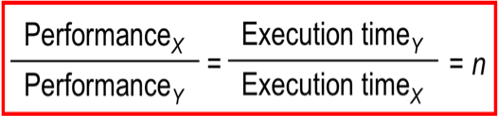
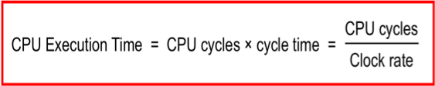
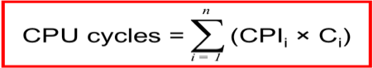
Clock cycle = 1/Clock rate; Clock rate = Cycles per second


