PARALLEL SIMULATION OF GRAVITATIONAL N-BODY PROBLEM

A. Qahtan A. Al-Rabeei
Department of Information and Computer Science
King Fahd University of Petroleum and Minerals
Dhahran 31261, Saudi Arabia

Email: {kahtani,g200405720@kfupm.edu.sa}

- Introduction

Large and complex engineering problems often need too much computation time and storage to run on ordinary single processor computers. Even if they can be solved, powerful computation capability is required to obtain more accurate and reliable results within reasonable time. Parallel computing can fulfill such requirements for high performance computing.

HPC refers to the use of high-speed processors (CPUs) and related technologies to solve computationally intensive problems. In recent years, HPC has become much more widely available and affordable, primarily due to the use of multiple low-cost processors that work in parallel on the computational task. Important advances have been made in the development of multiple-instruction, multiple-data (MIMD) multiprocessing systems, which consist of a network of computer processors that can be programmed independently. Such parallel architectures have revolutionized the design of computer algorithms, and have had a significant influence on finite element analysis. Nowadays, clusters of affordable compute servers make large-scale parallel processing a very viable strategy for scientific applications to run faster. In fact, the new multi-core processors have turned even desktop workstations into high-performance platforms for single-job execution.

This wider availability of HPC systems is enabling important trends in engineering simulation by developing simulation models that require more computer resources. These models need more computer memory and more computational time as engineers include greater geometric detail and more-realistic treatment of physical phenomena. These higher-level of details models are critical for simulation to reduce the need for expensive physical testing. However, HPC systems make these higher-fidelity simulations practical by yielding results within the engineering project’s required time. A second important trend is toward carrying up many simulations for the same problem so that engineers can consider multiple design ideas, conduct parametric studies and even perform automated design optimization. HPC systems provide the throughput required for completing multiple simulations simultaneously, thus allowing design decisions to be made early in the project.

Computational methods that track the motions of bodies interacting with one another, and possibly subject to an external field as well, have been the extensively studied for centuries. These methods were called “N-body” methods and have been applied to problems in astrophysics, semiconductor device simulation, molecular dynamics, plasma physics, and fluid mechanics. The problem states that: given initial states (position, mass and velocity) of N bodies, compute their states after time interval T. such kind of problems are computational extensive and will gain from the use of HPC in developing approximate solutions that helps in studying such phenomena. [LIU00]

The simplest approach to tackle N-Body problem is to iterate over a sequence of small time steps. Within each time step, the acceleration on a body is computed by summing the contribution from each of the other $N−1$ bodies which is known as brute force algorithm. While this method is conceptually simple, easy to parallelize on HPC, and a choice for many applications, its $O\left(N^{2}\right)$ time complexity make it impractical algorithm for large-scale simulations involving millions of bodies.

To reduce the brute force algorithm time complexity, many algorithms has been proposed to get approximated solution for the problem within a reasonable time complexity and acceptable error bounds. These algorithms include Appel [APP85] and Barnes-Hut [BAR86]. It was claimed that Appel’s algorithm run in $O\left(N\right)$ and Barnes-Hut (BH) run in $O\left(N\text{log}N\right)$ for uniformly distributed bodies around the space. Greengard and Rokhlin [GRE87] developed the fast multi-pole method (FMM) which runs in $O\left(N\right)$ time complexity and can be adjusted to give any fixed precision accuracy.

All of these algorithms were initially proposed as sequential algorithms. However, with the evolution of vector machines and HPC clusters recently, there were many parallel implementations for these algorithms on different machine architectures. Zhao and Johnsson [ZHAO91] describe a nonadaptive 3D version of Greengard's algorithm on the Connection Machine CM-2. Salmon [SAL90] implemented the BH algorithm, with multipole approximations, on message passing architectures including the NCUBE and Intel iPSC. Nyland et al. implemented a 3D adaptive FMM with data-parallel methodology in Proteus, an architecture-independent language [MIL92], [NYL93] and many other implementations on different machines.

In this, term project we are targeting implementing the BH algorithm and parallelize it on IBM-e1350 eServer cluster. Our application of BH will be for a special N-Body problem which is the gravitational N-Body or Galaxy evolution problem. First we will implement the sequential algorithm; then, we will parallelize it using OpenMP set of directives with Intel C++ compiler installed on Redhat Linux server.

The rest of this paper will be organized as follows: in Section 2, we will present the sequential BH algorithm and different approaches to parallelize it. In section 3, we will present our implementation of the BH algorithm concentrating on the aspects that allow us to parallelize it easily. Section 4 will be about different parallelization techniques included with openMP. In section 5, we will present the results that we get from our simulation and will discuss these results. Section 6 will conclude our work and give some future work guidlines.

- Barnes-Hut (BH) algorithm

BH algorithm [BAR86] is based on dividing the body space that contributes on a given body into near and far bodies. For near bodies, the brute force algorithm can be used to compute force applied on that body from other bodies while far bodies can be accumulated into a cluster of bodies with a mass that equal to the total mass of the bodies in that cluster and the position of the accumulated cluster is the center of mass of all bodies in that cluster.

BH suggested the use of tree data structure to achieve this clustering while working within a reasonable time complexity. Tree data structures exploit the idea that an internal node in the tree will contain the center of mass and total mass of all of its descendants. In this case, computing the force applied on a far body from a given sub-tree will require accessing to the parent of the sub-tree and use its center of mass and total mass without the need to go farther in the sub-tree. This will decrease the time required for computing force on a given body noticeably. Sequential BH algorithm is sketched in the Table 1 which can be applied and implemented for both 2-D and 3-D space. This algorithm is repeated iteratively as many as required number of iterations.

For each time step:
- Construct the BH tree (quad-tree for 2-D and oct-tree for 3-D)
- Compute center of mass and total mass bottom-up for each of the internal nodes.
- For each body:
- Start depth-first traversal for the tree, if center of mass in a given internal node is far from the body of interest then compute force from that node and ignore the rest of the sub-tree
- Finished traversing the tree then update the position of the body and its velocity.
- delete the tree
Table 1. The BH algorithm

One point that should be considered carefully is computing the distance between the body and an internal node. One choice can be done is considering the distance between the body and the perimeter of the internal node. Another choice can be done by computing the distance from the body to the center of the square. A third choice is that computing the distance from the body to the center of the mass of that internal node. In choices 2 and 3, a parameter that indicates when to cluster the set of bodies and when to go deeper in the tree should be specified and selected carefully. The parameter defines the ratio of the distance between the body which we are computing the gravitational force applied on it and the center of mass of a set of bodies $\left(r\right)$ to the length of the square’s side that surrounds the set of bodies $\left(D\right)$. This parameter $\left(r/D\right)$ is often selected to be tow. If someone wants better error bound compared to the result obtained by brute force algorithm then he should select larger parameter.

Each step of algorithm in Table 1 has its own algorithm. Interested readers should refer to [DEM96] for detailed algorithms for each of the above steps. In this paper, we are going to discuss our method in implanting that algorithm.

2.1. Efficient algorithm vs HPC

Developing efficient sequential algorithms is a way to speed up the execution time of a given problem. Most of times, overcoming with better time complexity algorithm give you a speedup that can be achieved using thousands of processors with the maximum work sharing between these processors. Sorting is a good example for such algorithms. Comparing the execution time for sorting 100,000 and 500,000 double precession floating point numbers with selection sort that use brute force technique in sorting and merge sort we get a speedup of 2940 and 7410 for the sets of inputs respectively. This speedup will increase also as the number of input increases. However, achieving this speedup with parallel computing will require more than 7500 processor with the best work sharing distribution between processors.

BH algorithm is also a good example for a sequential algorithm that can save time and achieve speedup that we can not get with hundreds of processors. The next table represents a comparison between execution time recorded using brute force algorithm and BH algorithm for gravitational N-Body problem with different problem sizes for 30 iterations. However, it is expected that if we increase the problem size into millions of bodies then the speedup obtained by BH algorithm will be greater than 1000. because lack of time before submitting this report, we compared the two algorithms with problem size up to 30000 and when we run brute force algorithm it took a very long time so that we terminated the simulation before it completes its calculations.

On the other hand, using HPC machine with best work sharing and neglecting any parallelization overhead and assuming the algorithm achieve maximum speedup possible, then we will get a maximum linear speedup with the number of processors used. That is, using K number of processors will give maximum K speedup. That means, if we need to achieve the speedup stated in Table 2, then we will need 192 processor for the problem size of 30,000 bodies. This is expected to be more and more for larger problem size.

# bodies | Brute force (BF) time (sec) | BH time (sec) | BH speedup over BF
2000 | 2.9 | 0.15 | 19.33
5000 | 18.15 | 0.43 | 42.21
10000 | 72.59 | 0.95 | 76.41
15000 | 163.3 | 1.51 | 108.15
20000 | 290.35 | 2.09 | 138.92
25000 | 453.7 | 2.72 | 166.80
30000 | 653.71 | 3.41 | 191.70
Table 2. BH speedup over brute force algorithm

One can say that the speedup achieved using BH algorithm has the cost of some error bound that we are ignoring. This is true but actually we tested the results of updating the positions of the bodies after many number of iterations for both BF and BH and we got that up to 10 decimal places both algorithms are giving the same results. However, parallelizing efficient algorithms will also be beneficial to achieve better speedup for the problem, decreasing the execution time noticeably. That is, if we can achieve a speedup of 5 using 8 processors then instead of running a simulation using single processor for 5 days we can run it on 8 processors for only one day which is also beneficial with the low cost of multi-core processors in the market these days.

2.2. Issues in parallelizing BH algorithm

BH algorithm can be viewed as four step algorithm containing the following steps: 1. Creating BH tree. 2. Computing center of mass and total mass of the internal nodes. 3. Computing force applied on a body and updating the body position. 4. Deleting the tree to be reconstructed in the next iteration. Two of these are harder to parallelize which are creating and deleting the tree. Creating the tree is very hard to parallelize because it requires partitioning for the set of set of bodies and each processor will construct its sub-tree. This part can be done easily and computing center of and total mass for internal node will be done by each processor over its sub-tree efficiently. However, it will be very hard to compute force applied on a given body since the processor with that body in its share will communicate with all other processors to get information about clusters or even bodies that will contribute in changing the state of that body. Also, data partitioning over the set of processors should done carefully such that bodies can be clustered in accordance to a given body should be given to the same processor which is very hard to achieve the optimal case.

Another issue is hat BH tree (quad or oct trees) are irregularly structured, unbalanced and dynamic. Also, the tree nodes essential to a given body can not be predicted without traversing the tree and communicating with all other processors. Also, the number of essential bodies to a given body can vary tremendously so that a body may require computing force from only limited number of clusters while another body may require going deeper and deeper in the tree. However, if someone chooses to distribute the tree a special care should be done in bodies’ space partitioning so that bodies close to each other should be assigned to one processor. Many methods for partitioning the bodies’ space have been found in the literature including spatial partitioning and tree partitioning.

In [WAR92], a spatial partitioning was presented where the authors divide the plane of the bodies (the large square) which represents the tree into non-overlapping rectangles which approximately contain the same number of bodies. This is referred to as Orthogonal Recursive Bisection (ORB). Each processor gets a part of the sub-tree and also needs some other parts of the tree for calculating forces on the bodies in its sub-tree.
The ORB method split an initial configuration of the system (graph) into two by associating a scalar quantity Se with each graph node e, which can be called a separator field. By evaluating the median S of the Se, according to whether Se is greater or less than S, the median is chosen as the division so that the number of nodes in each half are automatically equal; the problem is now reduced to that of choosing the field Se so that the communication is minimized.

In [RAV09], the ORB approach was improved by presenting a parallel processing algorithm whose main goal is to balance load while reducing the overhead to compute such a partition. The main idea to increase the efficiency is to reduce body to body interactions. In ORB, the recursive bisection will increase the body to body interaction even though load is equally distributed on each processor. It also needs extra calculation of finding S_{e.}
On the other hand, two approaches are used to partition the BH tree itself instead of partition the space as in ORB. A Top-down approach [LEA92], which gives complete sub-tree to each processor, but load balancing is not guaranteed in this approach, especially in non-uniform body distribution. The second approach is bottom-up, where the work involved with each leaf is estimated and divides the tree among the processors according to equally work required. One of the famous techniques that uses this approach is cost-zones approach which was a PhD thesis [SIN93]. The main idea in this technique is to estimate the work for each node, call it total work W. Then arrange nodes of BH tree in some linear order (lots of choices). Finally, contiguous blocks of nodes with work $W/p$ are assigned to processors where p represents the number of processors.

However, steps 2 and 3 of the BH algorithm are parallelizable with different levels of difficulty. Step 2, computing center of mass Cm and total mass Tm, is recursive by nature and is very difficult to convert it to a serialized step. This can be parallelized by using top-down partitioning of tree such that every processor computes Cm and Tm of its own sub-tree then the master thread take the Cm and Tm of the root of each sub-tree to compute Cm and Tm for higher level node. That is, assuming an oct-tree was divided over 8 processors to compute Cm and Tm for internal nodes of that tree, assigning sub-trees to processors will be done in the second level (the children of the root of the original tree) then the result from each processor will be used to compute the Cm and Tm at the root for the whole tree. However, if we have more than 8 processors with oct-tree the assigning work to processors will be done on the third level then the results form processors will be used to compute Cm and Tm for computing Cm and Tm for upper levels (second and first levels of the tree).

Computing force might be quit simpler, since each processor will be assigned a sub-tree to compute forces on the bodies in that sub-tree. No action will be taken by the master thread after that. The most challenging part in this situation is load balancing since the BH tree is irregularly structured and imbalanced unless special case was assumed in which bodies are uniformly distributed over the space which is not the case for the true simulation. An efficient way to parallelize computing force is to store the states of bodies in a list of user defined data type (e.g. structures in C, classes in C++ and Java). Then partitioning this list of bodies over the set of processors so that each processor computes the forces on an equal number of bodies. Load balancing is still not guaranteed since computing forces on any body is irregular and may take different time. This can be solved by assigning only chunks of the work to each processor and once the processor finished its work it can get another chunk of work to accomplish.

3. Implementation of BH algorithm in C

Our implementation starts with defining the appropriate data types to hold information about bodies and cluster of bodies together with the data structure for better performance. We defined two types of C structures, Body and node. The body structure listed in Table 3 contains all information regarding the state of a body at any given time step. The structure node contains information regarding a square that contains a body or set of bodies as listed in Table 4. For the node structure, we defined two variables to hold the coordinates of the center of the square and a variable to store its half side length and a pointer to structure of type Body to store information about the body if it contains only one body or the Cm and Tm of bodies if it contains more than one body. The node structure also contains four pointers to node structure that will be linked to the children of that node if any exist. We defined four because we are simulating N-Body problem in plane which will require quad-tree to represent the subdivisions of the space since every time we will partition the space will create at most four partitions for a given square.
#define maxB 10240000
struct Body {
int id;
float posx, posy; // position of body
float vx, vy; // velocity
float fx, fy; // force
float mass; // mass

}*Bodies[maxB];

Table 3. Body structure

struct node {
struct Body *B;
float cx, cy; //Center of the square
float d; //Half side of the square
int isLeaf; //To differentiate internal nodes from leaves
// internal node, (1 = leaf node, 0 = internal node)
struct node * child[4]; //Pointers to the node children
};
Table 4. node structure

Then we started our simulation by creating initial states for each body by generating some random values for their masses and initial positions and velocities storing these bodies in a global list of bodies. Then, for each time step we go over the four steps of the BH algorithm by creating the quad-tree then computing Cm and Tm for internal nodes. After that, we compute forces applied on each body using for loop to go over the list of bodies and for each body we traverse the BH tree to compute forces on that body and updating the body’s position and velocity. Finally we delete the after rewriting the information of bodies in bodies’ list. That is done by storing the updated information of the body in bodies’ list before deleting the node that contains that body. The code for the whole simulation can be found in the appendix.
After implementing the sequential BH algorithm we started thinking about parallelizing the algorithm to run it on KFUPM HPC [KFUPM-HPC]. We are targeting parallelizing the algorithm using OpenMP set of directives available in recent C/C++ and FORTRAN compiler. First, we started by identifying the most computational part of the algorithm to minimize its execution time and we run the sequential algorithm for different number of bodies between 2000 and 1 Million body and we found that more than 80% of simulation time for small number of bodies is spent on computing forces while at large number of bodies also more than 75% of the simulation time was spent in computing forces. For this reason, we started targeting decreasing the simulation time by parallelizing the compute for function. Figure1 shows the simulation time distribution over the four major steps of the algorithm. It should be noted here that we are creating and destroying the tree every time step because bodies are moving and the body that will be in a given sub-tree at some time step may be in another sub-tree in the next time step. Tracking these changes in body movements will be very time consuming and may become untraceable. For that reason and noting that creating and deleting the tree every time consumes less than 18% of the simulation time, we decided to create and delete the tree at every simulation’s iteration.
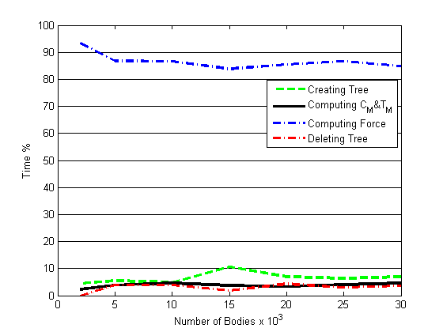  (a) | 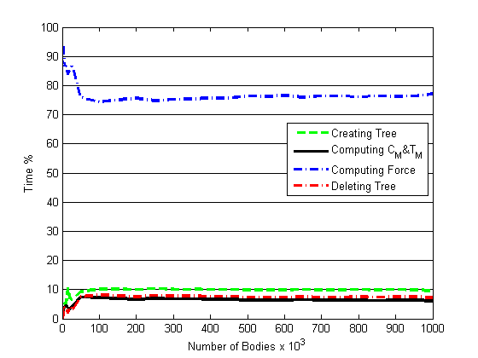  (b)

Figure1. Time distribution over BH algorithm components
(a) at small problem size (b) at large problem size

4. Implementation of Parallel BH Algorithm in C

It is worthy noting here that our implementation of computing force function helps us in parallelizing the functions easily using parallel for directive in OpenMP. Even with that, we tried examining different parallelization techniques especially the task directive available in OpenMP version3. We parallelized computing force using both techniques to see the effect of BH tree irregularity in structure and the effect of imbalanced tree on the simulation time. The results we obtained will be discussed in the next section.
#pragma omp parallel
{
#pragma omp for schedule (static, chunk) nowait
for(int i = 0; i < nBody; i++)
{
resetForce(Bodies[i]);
recurseForce(root, Bodies[i]); //Compute Forces
}
#pragma omp for schedule (static, chunk)
for(int i = 0; i < nBody; i++)
update(Bodies[i], dtime); //Update body

}

Table 5. Parallelizing computing the force function using parallel for (openMP)
Our implementation of the sequential algorithm makes it easier to parallelize the most computational part of the algorithm which is computing forces on bodies. Parallelizing the compute force function using OpenMP parallel for loop was done as stated in Table 5. We also used tasks to parallelize the compute forces function as listed in Table 6. With parallel OpenMP for, we used chunk of work to be assigned to any given thread in order to ensure better load balancing among threads.
// For the first call
#pragma omp parallel
{
#pragma omp single nowait
computeForce(root, root);
}
// For subsequent calls
for(int i = 0; i < 4; i++)
{
#pragma omp task
computeForce(treeRoot, Node->child[i]);
}

Table 6. Parallelizing computing the force function using tasks (openMP v.3)

5. Simulation Results and Analysis

First, we recorded the simulation time for different sizes of the problem using brute force algorithm implementation and BH algorithm implementation and we recorded the results presented in Table 2. Because brute force algorithm takes huge time to run we stopped at problem size of 30000 bodies. We came up with a conclusion that developing efficient algorithms will speedup the work better than using thousands of processors. However, parallelizing the optimized algorithms will add extra benefit of using the available power of low cost multi-core processors currently in the market.
We run our simulation on Red Hat Linux node with 2 processors each of them is quad core processor at KFUPM HPC IBM e1350 eServer cluster. We used openMP in parallelizing our code. We recorded the execution time for each simulation run together with the total time spent in each of the four steps of BH algorithm. We present the results for these in percentage form to compare the percentage time spent on individual step of the algorithm.
Also, we checked the effects of load balancing on simulation by monitoring the time required for each iteration in the case of parallelizing the force computation process using parallel for and using tasks. We found that using parallel for the difference in time between any two iterations is negligible while using tasks we get some iterations execution time is almost double the execution time of another iteration. Table 7 and Figure 2 present some of the fluctuation of execution time in milliseconds for consecutive iterations using for and tasks. Parallel for shows less fluctuation because using for loop we are assigning almost equal work to each while using tasks we are assigning sub-trees to each thread which are not balanced and affects the execution time noticeable. However, using OpenMP tasks will still a good choice for situations when the recursions can not be converted into loops as in the case of computing Cm and Tm.

Iteration number | Execution time using Tasks | Execution time using For
1 | 467.5 | 326.25
2 | 485 | 332.5
3 | 628.75 | 321.25
4 | 526.25 | 330
5 | 593.75 | 362.5
6 | 468.75 | 336.25
7 | 630 | 381.25
8 | 462.5 | 330
9 | 492.5 | 322.5
10 | 468.75 | 347.5
11 | 557.5 | 416.25
12 | 461.25 | 343.75
13 | 690 | 336.25
Table 7. Effects of load balancing on execution time
Finally, we run the simulation many times for different problem sizes with different number of threads and we recorded the results. We changed the problem size from 2000 bodies until 1 Million bodies, and the number of threads used in the simulation is 2, 4, and 8. For each simulation instance (same problem size, same number of threads, same parallelization technique) we recorded three readings and we average them and we removed any outstanding reading and repeated the simulation for those instances with outstanding results. This is to make sure that the recorded are the actual results achieved by the simulation instance. These outstanding results may happen because at that run, some other people submitted their jobs which affected some readings. Then we computed the speedup for each of the parallelized instance by dividing the time achieved by the sequential algorithm for that part of calculations over the time achieved by the parallelized code. Hence the obtained speedup results are only for the computing forces process. Figure 3 represents the speedup achieved on KFUPM-HPC for 2, 4, and 8 threads and for both techniques of parallelization (parallel for and tasks). For k threads in the figure means the parallelization technique is parallel for, the number of threads are k and the problem size is represented by the X-axis and the speedup is represented by Y-axis.
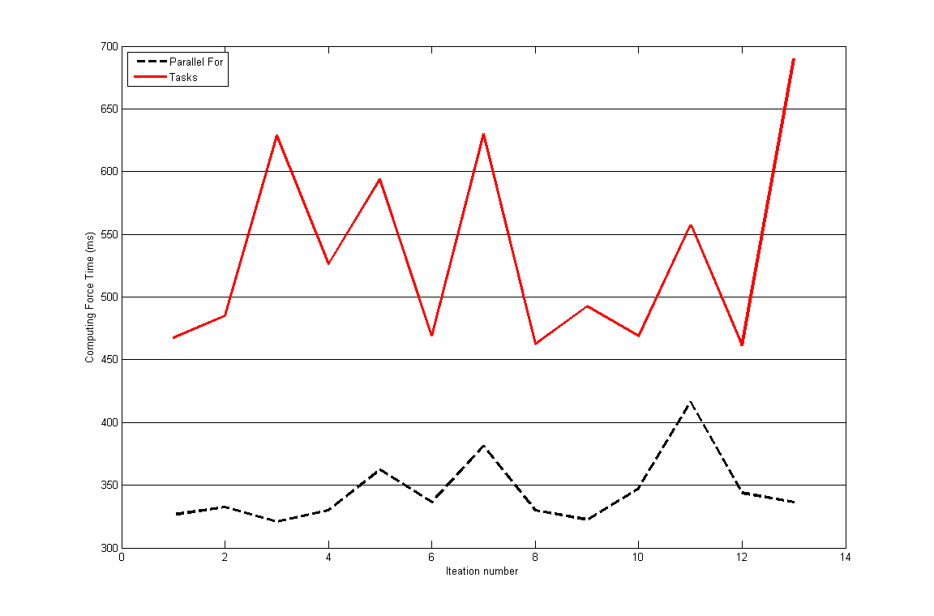
Figure 3. Time fluctuation in computing force function from one iteration to another

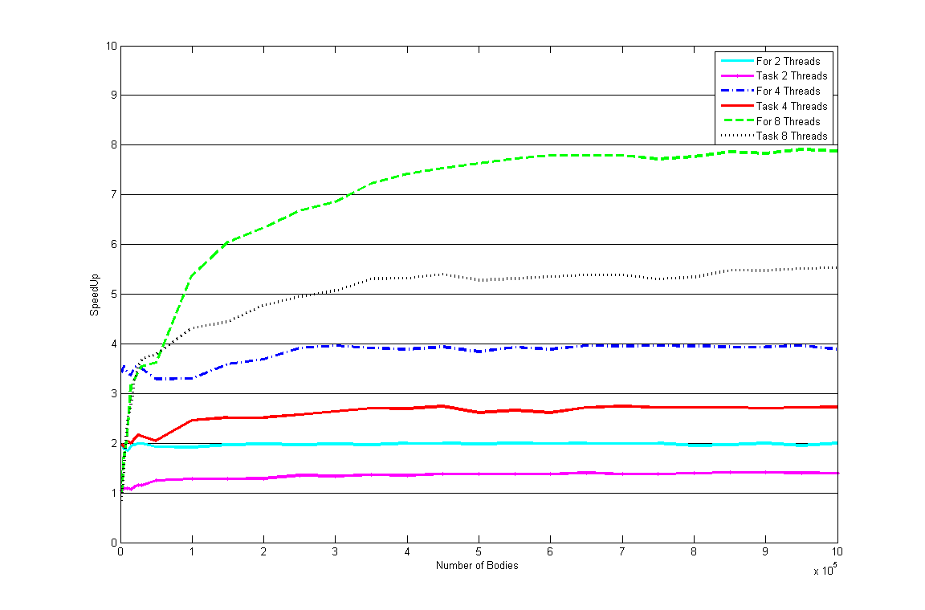
Figure 3. Speedup achieved for computing force function

The results shows that for all simulation instances that parallel for outperforms the tasks technique because of the dynamic nature of problem which makes the tree is imbalanced in almost all the simulation instances. The simulation results also shows that using 2 and 4 threads reaches at the ideal speedup faster than using 8 threads also 2 threads reaches the ideal speedup faster than 4 threads as a result of the effects of the overhead associated with creating more threads. However, this overhead becomes negligible when the problem size becomes larger since you are comparing overhead that can take few micro seconds of the simulation time with the calculations that takes many seconds.
6. Conclusion

In this paper, we discussed the problem of gravitational N-Body simulation and the different algorithms developed to speedup this simulation. We selected among all the algorithms, Barnes-Hut algorithm and we implemented that in C programming language and compared its execution time and correctness to that achieved by brute force algorithm. Barnes-Hut show a very high speedup while preserving the simulation accuracy to a satisfactory error bound. Then we used OpenMP to parallelize the algorithm and we obtained a very high speedup closer to the ideal speedup that can be achieved using the same number of processors. A comparison of the effectiveness of using different techniques of parallelization available with OpenMP is carried out and we concluded that for such algorithms that have a dynamic nature of assignments to processors, it will be of higher value to convert the recursive nature of the problem into loops. This can not be done for all kinds of recursive problems. In such situation using OpenMP tasks will still a good choice.
7. References

[SIN93] Singh, J.P. , “Parallel Hierarchical N-Body Methods and their Implications for Multiprocessors”, PhD. Thesis, Stanford University, USA, 1993.
[APP85] Appel, A., “An Efficient Program for Many-Body Simulation,” SIAM J. Scientific and Statistical Computing, vol. 6, 1985.
[BAR86] Barnes, J., Hut, P., “A Hierarchical O(N logN) Force-Calculation Algorithm,” Nature, vol. 324, 1986.
[GRE87] Greengard, L., Rokhlin, V., “A Fast Algorithm for Particle Simulations,” J. Computational Physics, vol. 73, 1987.
[ZHAO91] Zhao, F., Johnsson, S., “The Parallel Multipole Method on the Connection Machine,” SIAM J. Scientific and Statistical Computing, 1991.
[SAL00] Salmon, J., “Parallel Hierarchical N-Body Methods,” PhD thesis, Caltech, 1990.
[MIL92] Mills, P., Nyland, L., Prins, J., Reif, J., “Prototyping N-Body Simulation in Proteus,” Proc. Sixth Int'l Parallel Processing Symp., 1992.
[NYL93] Nyland, L., Prins, J., Reif, J., “A Data-Parallel Implementation of the Adaptive Fast Multipole Algorithm,” DAGS/PC Symp., 1993.

[DEM96] Demmel, J., Lecture Notes in Computer Sciences, “Fast Hierarchical Methods for the N-body Problem, Part 1” http://www.eecs.berkeley.edu/~demmel/cs267/lecture26/lecture26.html
[LIU00] Liu, P., Bhatt, S. N., “Experiences with Parallel N-Body Simulation,” IEEE Transactions on Parallel and Distributed Systems, VOL. 11, No. 12, Dec. 2000

[WAR92] Warren, M., Salmon, J., “Astrophysical n-body simulations using hierarchical tree data structures,” In Proceedings of Supercomputing Conference, 1992.
[RAV09] Ravindra, M., Chaithanya, V., “Barnes-Hut Algorithm Implementation in parallel Programming World,” Peoples Education Society Institute of Technology, 2009
[LEA92] Leathrum, J. F., “Parallelization of the Fast Multi-pole Algorithm; algorithm and architecture design,” Ph.D. thesis Duke University, USA, 1992.

[KFUPM-HPC] High Performance Computing Machine at King Fahd University for Petroleum and Minerals. KSA.

