Name: Id#

ISE 307, Term 173

ENGINEERING ECONOMIC ANALYSIS

Quiz# 5 Solution

Date: Wednesday, August 8, 2018

Q1. An investor bought 100 shares of stock at a cost of $10 per share. He held the stock for 15 years and wants to sell it now. For the first three years, he received no dividends. For each of the next seven years, he received total dividends of $100 per year. For each of the remaining five years, no dividends were paid. In the last 15 years, the investor's marginal tax rate and capital gain tax rate were averaging about 30% and 20%, respectively. What would be the break-even selling price for the 100 shares to earn a 15% return on investment after tax?

(a) $7,374
(b) $7,574
(c) $7,774
(d) $7,974

PW(15%) = -$1,000 + $100(1 - 0.30)(P/A, 15%, 7)(P/F, 15%, 3) + [X - (X -1,000)0.2](P/F, 15%, 15) = -$1,000 + $191.488 + 0.09983X + $24.5789 = 0
0.0983X = $783.93
X = $7,973.64

Q2. Given the following sensitivity graph, which of the following statements are incorrect:

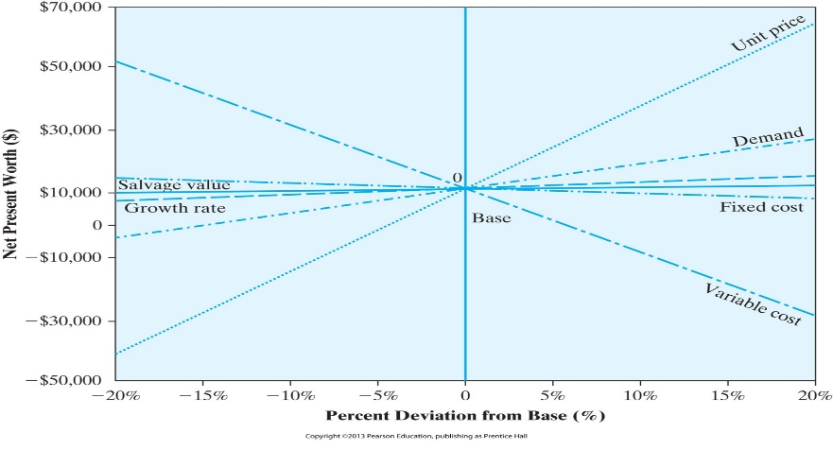
(a) The project is very sensitive to changes in unit price
(b) The project is very sensitive to changes in variable cost
(c) The project is fairly sensitive to changes in demand
(d) The project is at high risk for changes only in unit price

Q3. A Computerized Machining Center (CMC) has been proposed for small tool manufacturing company. If the new system, which costs $250,000, is installed, it will generate annual revenues of $185,000 and will require $20,000 in annual labor, $12,000 in annual material expenses and another $8,000 in annual overhead (power and utility) expenses. The CMC would be classified as a 7-year MACRS property. The company expects to dispose out the facility at the end of year 3 and will be sold for $100,000. Assume a tax rate of 35%. The net cash flow at year 3 is:

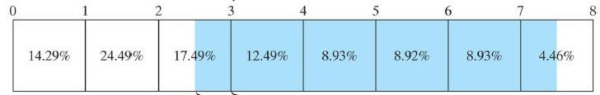
(a) $210,818
(b) $212,818
(c) $214,818
(d) $216,818

INCOME | Year 3
STATEMENT
Revenues: | 185000
Expenses:
Labor | 20000
Material | 12000
Overhead | 8000
Depreciation | (0.1749/2)*250000=21852.5
Taxable Income | 185000-2000-12000-8000-21852.5=123137.5
Net Income | 123137.5*(1-0.35) =80039
CASH FLOW STATEMENT
Net Income | 80039
Depreciation | 21852.5
Investment
Salvage Val. | 100000
Gain (loss) tax | 10915.5
NET CASH FLOW | 80039+21852.5+100000+10915.5=212818

Total depreciation: 35725+61225+21852.5=118812.5
Book Value: 250000-118812.5 = 131187.5
Gain (or loss): 100000-131187.5 = -31187.5
Gain tax (or credit): -31187.5*0.35 = -10915.5

Q4. Higgins Machine Tools, Inc. is currently manufacturing one of its products on a hydraulic stamping press machine. The machine has an operating and maintenance cost of $50,000 in the first year, and this cost is expected to increase by $5,000 each year. The machine has a remaining useful life of five years and could be sold on the open market now for $100,000. Its market value declines at a rate of 17%. A new machine would cost $200,000, and its operating and maintenance cost is expected to be $33,000 each year. The new machine has an expected service life of five years and its market values reduces at a rate of 20%.
The required MARR is 15%. The firm does not expect a significant improvement in the machine's technology to occur, and it needs the service of either machine for an indefinite period of time. The economic service life for the defender is:

(a) N=1
(b) N=2
(c) N=3
(d) N=5

Defender
n | Market Value | O&M Cost
0 | $100,000
1 | $83,000 | $50,000
2 | $68,890 | $55,000
3 | $57,179 | $60,000
4 | $47,458 | $65,000
5 | $39,390 | $70,000

CR = (I-S)(A/P, 15%, N) + 0.15*S
AEC_{O&M} = 50,000 + 5000 (A/G, 15%, N)
AEC = CR + AEC_{O&M}

N=1:
CR = (100,000-83,000)*1.15 + 0.15*83,000 = 32,000
AEC_{O&M} = 50,000 + 5000*0 = 50,000
AEC = CR + AEC_{O&M} = 32,000 + 50,000 = 82,000
N=2:
CR = (100,000-68,890)*0.6151 + 0.15*68,890 = 29,469
AEC_{O&M} = 50,000 + 5000*0.4651 = 52,326
AEC = CR + AEC_{O&M} = 29,469 + 52,326= 81,795
N=3:
CR = (100,000-57,179)*0.4380 + 0.15*57,179 = 27,332
AEC_{O&M} = 50,000 + 5000*0.9071 = 54,536
AEC = CR + AEC_{O&M} = 27,332+ 54,536= 81,868
Since AEC(N=3) > AEC(N=2), the economic service life of the defender is N_{d}*=2

Q5. The following data for a defender and a challenger in the tables given below show the market value, operation and maintenance cost (O&M Cost), capital recovery cost (CR), annual operation cost (AOC) and annual equivalent cost (AEC). Assuming 15% MARR and that the service of either machine is needed for an indefinite period of time:

Defender
n | Market Value | O&M Cost | CR(15%) | AOC(15%) | AEC(15%)
0 | $200,000
1 | $160,000 | $100,000 | $70,000 | 100000 | $170,000
2 | $128,000 | $111,000 | $63,488 | 105116.3 | $168,605
3 | $102,400 | $122,000 | $58,107 | 109978.4 | $168,085
4 | $81,920 | $133,000 | $53,647 | 114588.8 | $168,236
5 | $65,536 | $144,000 | $49,943 | 118951 | $168,894
6 | $52,429 | $155,000 | $46,858 | 123069.1 | $169,927

Challenger
n | Market Value | O&M Cost | CR(15%) | AOC(15%) | AEC(15%)
0 | $450,000
1 | $337,500 | $60,000 | $180,000 | $60,000 | $240,000
2 | $253,125 | $60,000 | $159,070 | $60,000 | $219,070
3 | $189,844 | $60,000 | $142,419 | $60,000 | $202,419
4 | $142,383 | $60,000 | $129,105 | $60,000 | $189,105
5 | $106,787 | $60,000 | $118,404 | $60,000 | $178,404
6 | $80,090 | $60,000 | $109,757 | $60,000 | $169,757

Determine when the defender should be replaced by the challenger.

(a) Immediately.
(b) At the end of the third year.
(c) At the end of the fourth year.
(d) At the end of the fifth year.

Economic service life of defender, N_{d}*=3, and AECd* = $168,992.
Economic service life of challenger, N_{c}*=6, and AEC_{c*} = $169,757.

Since AEC_{d*}=$168,992< AEC_{c*} = 169,757, then we need to keep the defender for its economic service life i.e., 3 years.

Next, we need to find the cost of using the defender for the fourth year.

I = 102,400, S = 81,920, OMC = 133,000
Cost = 102,400 (F/P,15%,1)+ 133,000-81,920
=102,400*1.15+133,000-81,920=168,840

Since 168,840< AEC_{c*} = 169,757, this means that we should keep the defender for the fourth year.

Next, we need to find the cost of using the defender for the fifth year.
I = 81,920, S = 65,536, OMC = 144,000
Cost = 81,920 (F/P,15%,1)+144,000-65,536
= 81,920*1.15+144,000-65,536 = 172,672

Since 172,672 > AEC_{c*} = 169,757, this means that we should replace the defender by the challenger at the end of the fourth year.

