Name: Id#

ISE 307, Term 153

ENGINEERING ECONOMIC ANALYSIS

Quiz# 4

Date: Wednesday, August 24, 2016

Q1. A manufacturing company has purchased three assets:

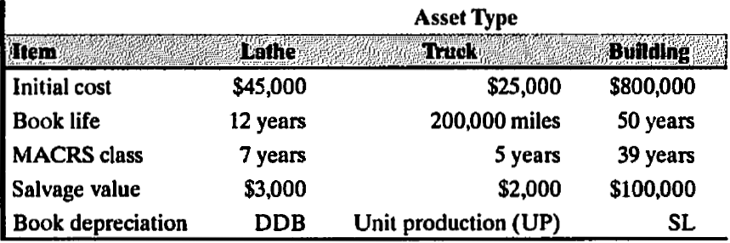

The truck was depreciated by the units-of-production method. Usage of the truck was 22,000 miles and 25,000 miles during the first two years, respectively.
- Calculate the book depreciation for each asset for the first two years.
- If the lathe is to be depreciated over the early portion of its life by the DDB method and then by a switch to the SL method for the remainder of its life, when should the switch occur?

Q2. To automate one of its production processes, Milwaukee Corporation bought three flexible manufacturing cells at a price of $400,000 each. When they were delivered, Milwaukee paid freight charges of $30,000 and handling fees of $15,000. Site preparation for these cells cost $50,000. Six employees, each earning $15 an hour, worked five 40-hour weeks to set up and test the manufacturing cells. Special wiring and other materials applicable to the new manufacturing
cells cost $2,000.
- Determine the cost basis (the amount to be capitalized) for these cells.
- Suppose that these cells were sold after 3 years for $50,000 each and they were depreciated using the 5-year MACRS Table given below. Determine the book value and tax gains or losses assuming 35% tax rate.
