Name: Id#

ISE 307, Term 153

ENGINEERING ECONOMIC ANALYSIS

Quiz# 2

Date: Monday, August 8, 2016

Q1. The accompanying table shows a cash flow for a company along with CPI:

Year | Cash | CPI | Inflation Rate
0 | 100,000 | 180
1 | 115,000 | 184
2 | 128,000 | 189
3 | 145,000 | 196

Assuming that year 0 is the base period, determine the inflation rate for each period, and calculate the average inflation rate over the three years.

What will be the equivalent cash of year 3 stated in terms of year 1 cash?

Q2. The average starting salary for engineers was $8,000 a year in 1985. John, a mechanical engineer, got an offer for $48,000 a year in 2012. Knowing that the CPIs for 1985 and 2012 are 36.87 and 205.43, respectively, what is John's real salary in terms of constant 1985 dollars?

Q3. Consider the following two mutually exclusive investment projects:

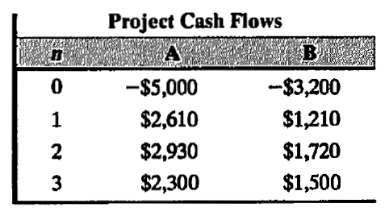

At an interest rate of 12%, which project would you recommend choosing?

