Name: KEY Id#

ISE 307, Term 153

ENGINEERING ECONOMIC ANALYSIS

Quiz# 1

Date: Wednesday, July 20, 2016

Q1. List the Fundamental Principles in Engineering Economics.

- An earlier dollar is worth more than a later dollar.
- All that counts is the difference among alternatives.
- Marginal revenue must exceed marginal cost.
- Additional risk is not taken without additional return.

Q2. Compute the value of P for the accompanying cash flow diagram. Assume i=6% per year.

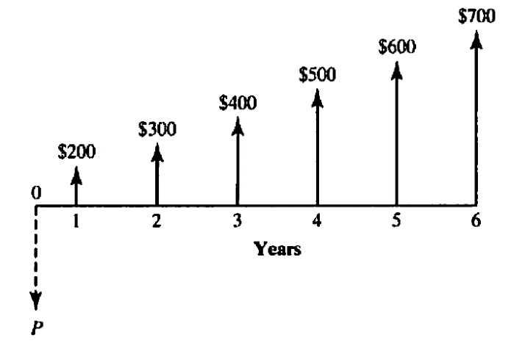

P = A (P/A, I, N) + G (P/G, i, N) = 200*4.9173 + 100*11.4594
= 983.46 + 1145.94 = $2129.4

Q3. From the following cash flow diagram, find the value of C that will establish economic equivalence between the deposit series and the withdrawal series at an interest rate of 8% compounded annually.

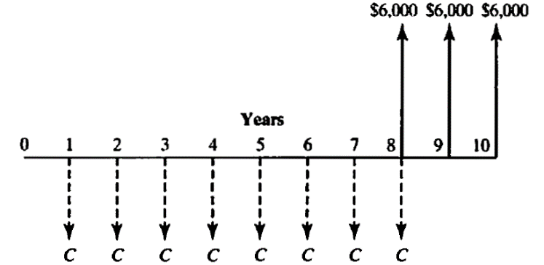

C (F/A, 8%, 8) = 6000 (P/A, 8%, 2) + 6000
C*10.6366 = 6000*1.7833 + 6000
C*10.6366 = 16699.8
C = 16699.8/10.6366 = $1570.03

Another solution:

𝑃8 = 6000 + 6000(1.08)⁻¹ + 6000(1.08)⁻² = $16699.59
𝑃8 = 𝐹 → 𝐶 = 𝐴 = (𝐴⁄ , 𝑖, 𝑁) = 16699.59(𝐴⁄𝐹 , 8%, 8) = 16699.59(0.0940) = $1569.76

