Name: Id#

ISE 307, Term 173

ENGINEERING ECONOMIC ANALYSIS

Quiz# 1

Date: Sunday, July 1, 2018

Q1. If you borrow $25,000 at an interest rate of 6%, compounded annually, with the repayment schedule as shown. what is the amount A? (Note that there is a missing payment in year 5.)

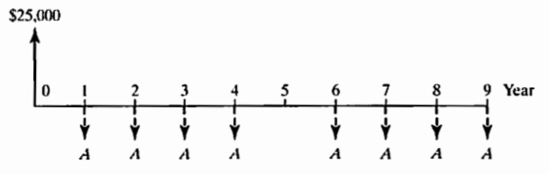

(a) A = $4.129
(b) A = $4,793
(c) A = $3,193
(d) A = $3,593

Q2. The maintenance expense on a machine is expected to be $5,000 during the first year and to increase $500 each year for the following ten years. What present sum of money should be set aside now to pay for the required maintenance expenses over the ten-year period? (Assume 8% compound interest per year.).

