KING FAHD UNIVERSITY OF PETROLEUM & MINERALS
Department of Systems Engineering
Major Exam 1
Summer 2017-2018 (173)
ISE 307: Engineering Economic Analysis

Time: 2 hours
Name: _______________________________

ID: ______________ Section ______
- Dr. Syed Mujahid (Sect 1, 2)
- Dr. Aiman El-Melh (Sect 3, 5)
- Dr. Samir Al-Amer (Sect 6, 7)

Question | 1 | 2 | 3 | 4 | 5 | 6 | Total
Points | 7 | 8 | 8 | 9 | 9 | 9 | 50
Score

Instructions:
- Mobiles are not allowed.
- Do not start before you are told to do so.
- Answer all questions and show all details including Cash Flow Diagrams.
- You are not allowed to share anything with other students.
- Check that you have 6 questions and a total of 8 pages.

[Question 1] (7 points)
Consider the following cash flow diagram.

0 1 2 3 1 2 13 14 15
200 200 200 …. 200 200 300
….
….

….

120

Determine the following assuming an interest rate of 10% compounded annually.

- The present worth of the above cash flow. (5 points)

- The equivalent worth of the cash flow at the end of year 4. (2 points)

NOTE: Show all your work in details.

[Question 2] (8 points):

A company is considering replacing an old piece of industrial equipment to reduce operating and maintenance cost. The price of the new equipment is $200,000. It would save as much as $25,000 in annual operating and maintenance cost. After 12 years, the machine can be sold at a value of $40,000. Assume the firm’s interest rate is 9% compounded annually.

- Draw the cash flow diagram. (2 points)
- Determine the present worth of the cash flow. (5 points)
- Is it a good idea to buy the new equipment? Justify. (1 point)
NOTE: Show all your work in details.

[Question 3] (8 points):

Consider the cash flow diagram given below where the nominal interest rate is 8%.

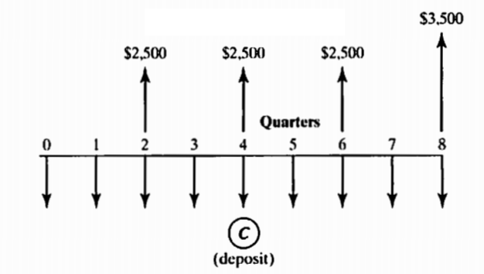
- What is the effective annual interest rate given that interest is compounded quarterly? (1 point)
- What is the effective interest rate per quarter given that interest is compounded monthly? (2 points)
- What is the amount C of quarterly deposits such that you will be able to withdraw the amounts shown in the above cash flow diagram for an interest rate of 8% compounded monthly? (5 points)
NOTE: Show all your work in details.

[Question 4] (9 points):
Suppose you borrowed $100,000 at an interest rate of 12% compounded monthly and to be paid every year over 10 years.
- How much you will pay to the bank every year? (2 points)
- Suppose that at the end of the fourth year, the bank gave an offer to pay off the remainder of the loan in 3 equal payments to be paid on the years 6, 8 and 10. The bank has changed the interest rate to be 16% compounded quarterly. What is the amount that you will pay every two years from year 6 to year 10? (6 points)
- What is the total amount of interest you will pay over the life of the loan? (1 point)

NOTE: Show all your work in details.

[Question 5] (9 points):
If the following two cash flow options are equivalent, then find the values for the missing terms (X & Y) given that the present worth of Cash Flow A is $100,000. Assume the interest rate for the 11 years is 10% compounded annually.

NOTE: Show all your work in details.

0 1 2 3 4 5 6 7 8 9 10 11
0 1 2 3 4 5 6 7 8 9 10
X
X
X
X
2X
2X
2X
2X
$50,000
$500,000
Y
2Y
3Y
4Y
3Y
2Y
Y
Cash Flow A
Cash Flow B
11

[Question 6] (9 points):
You are the chief engineer of a company and you are asked to investigate the introduction of a new product. The company will be initially spending money in manufacturing and marketing the product. Overall, the company will be investing $10,000 at the end of the first year. In the next year, the amount to be invested will drop by 7% from the previous year. The company will be investing in a similar pattern up to the end of seventh year. After year 7, no more investment is required.
On the other hand, the product will be ready by the end of the fifth year, and will be sold in the market right away. The income from the product will be generated starting from the end of the sixth year. The expected income at the end of the sixth year is $15,000. The income for the next year will increase by a factor of 8%, and the income will keep on increasing by the same factor up to the end of the eighth year. From the ninth year, the income will start to decrease from the previous year income by a factor of 3%, and the pattern continues for the rest of the future years. The product will be available for sale in the market up to the end of the 12th year. Assume that the interest rate for the next 12 years will be fixed to 5% compounded annually.

- Draw the cash flow diagram of the new product. (2 points)
- Calculate the expected future worth of the project at the end of year 12. (7 points)

NOTE: Show all your work in details.

