KING FAHD UNIVERSITY OF PETROLEUM & MINERALS

Department of Systems Engineering

MAJOR EXAM II

Summer 2015-2016 (153)

ISE 307 Engineering Economic Analysis

Name: _______________________________

ID: ______________

Section ______SN: ___

15thAugust2016

Question | Points | Marks
Q1 | 7
Q2 | 6
Q3 | 9
Q4 | 8
TOTAL | 30

Q1. (7 Marks)
Consider the following investment project’s cash flow (in actual dollars) and the corresponding yearly inflation rates (based on the CPI). Assume that the annual inflation-free interest rate is 5%. Answer the following questions:
End of year ($i$) | 0 | 1 | 2 | 3
Expected cash flow in actual dollars | -45,000 | 26,000 | 26,000 | 26,000
$$f_{i}$$ |  | 4%for the interval from 0 to1 | 6%for the interval from 1to 2 | 8%for the interval from 2 to 3

- Determine the average annual general inflation rate over the project period?
- Convert the cash flow into an equivalent constant-dollars cash flow with year 2 (shaded) as a base year?
- Find the market interest rate of year 1?
- What is the net present value of the given cash flow?
- Solution:
a) (1+f-bar)^3=(1+f1)*(1+f2)*(1+f3)
1+fbar=( 1.04X1.06X1.08)^(1/3)
f-bar=5.987% |  |  |  |  |  |  |  | 1 mark
b) yr0: -45000*(1+f1)*(1+f2)= -45000*1.04*1.06=-49,608
yr1: 26000*(1+f2)=26000*1.06 = 27,560
yr2: = 26000 |  |  |  |  |  |  |  | 2 marks
yr3: 26000/(1+f3) = 26000/1.08 = 24074
c)i-market @ year 1 = = (1+f1)*(1+i')-1= (1+0.04)(1+0.05)-1= 9.2% |  |  |  |  |  |  |  | 1 mark
OR =0.04+0.05+0.04*0.05 = 9.2%
d) NPV = -45000+26000/(1.04*1.05)+26000/(1.04*1.05*1.06*1.05)+26000/(1.04*1.05*1.06*1.05*1.08*1.05)
19066.11 |  |  |  |  |  |  |  | 3 marks

Q2.(6 Marks)
A firm with 15% MARR is considering the following two investment alternatives:
Projects cash flows
n | Project A | Project B
0 | -15,000 | -25,000
1 | 9,000 | 0
2 | 12,000 | X
3 | 7,000 | X
NPW (15%) | ? | 9,000

- Compute the NPW for project A.
- Compute the unknown X in years two and three for project B.
- If A and B are two mutually exclusive projects, which one would you select?
- Compute the discount payback period for project A.
Solution:

a) | pw(15%) = -15000+9000*(P|F, 15%, 1)+12000*(P|F,15%,2)+7000*(P|F,15%,3)
 |  | -15000+9000/1.15^1+12000/1.15^2+7000/1.15^3 = 6502.4 (1.5 mark)
b) | pw(15%)= 9000=-25000+0*(P|F, 15%, 1)+X*(P|F,15%,2)+X*(P|F,15%,3)
 |  | X=(9000+25000)/(1/1.15^2+1/1.15^3)
 |  | 24051.05 | (1.5 marks)
c) since, NPV of project B> NPV of A, we select project B (1 mark)
d) (2 marks)

n | Cash Flow | Cost of funds | Project Balance
0 | -15,000 | 0 | -15,000
1 | 9,000 | -2250 | -8,250
2 | 12,000 | 1012.5 | 2,513
3 | 7,000 | 1951.875 | 9,889

Discounted payback period is between year 1 and year 2.
Q3(9 points)
You are considering a luxury apartment building project that requires an investment of SR12,000,000. The building has 50 units. You expect the maintenance cost for the apartment building to be SR250,000 for each of the first two years (i.e., SR250,000 in the first year and SR250,000 in the second year), and increasing by SR25,000 in subsequent years (i.e., SR275,000 in year 3, SR300,000 in year 4, etc.). The cost to hire a manager for the building is estimated to be SR80,000 each year. After 15 years of operation, the apartment building can be sold for SR20,000,000.
- What is the minimum annual rent per apartment unit to make this investment appealing at 15% MARR, assuming that 100% of the apartments will be occupied each year over the 15 years? In your solution, show the capital recovery cost, the annual equivalent cost due to maintenance and the overall annual equivalent cost.
- What is the minimum annual rent per apartment unit to make this investment appealing at 15% MARR, assuming that 100% of the apartments will be occupied each year for the first 5 years, 90% of the apartments will be occupied each year for the subsequent 5 years (i.e., years 6 to 10) and 80% of the apartments will be occupied each year for the subsequent 5 years (i.e., years 11 to 15)?
NOTE: If a problem can be solved by a series, you are required to solve it as a series, otherwise you will be penalized.
The following table could be helpful in your calculations:
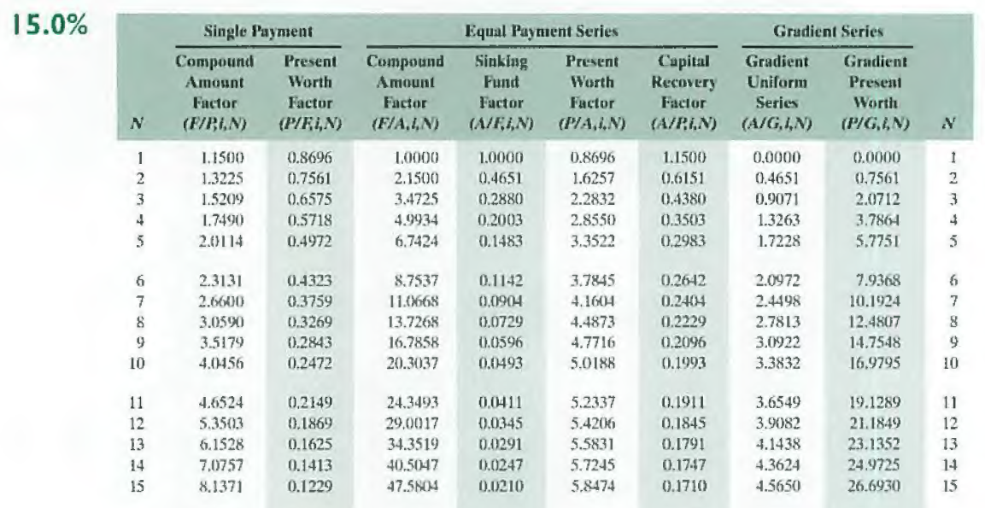

Solution

CR(15%) = (12,000,000 – 20,000,000) (A/P, 15%, 15) + 0.15* 20,000,000
= -8,000,000 * 0.1710 + 3,000,000
= -1,368,000 + 3,000,000 = SR1,632,000 [1.5 marks]

AEC (maintenance) = 250,000 + 25,000 (P/G, 15%, 14)(P/F, 15%, 1)(A/P, 15%, 15)
= 250,000 + 25,000*24.9725*0.8696*0.1710
= 250,000 + 92,836.27 = SR342,836.27 [2.5 marks]

AEC(15%) = 1,632,000 + 342,836.27+ 80,000 = SR2,054,836.27 [1 mark]

Annual rent per apartment = 2,054,836.27 / 50 = SR41,096.73 [1 mark]

ii.

Let us assume that the rent per apartment = R

Then, the annual rent per department = [50R (P/A, 15%, 5) + 0.9*50R (P/A,15%,5)(P/F,15%,5) + 0.8*50R (P/A,15%,5)(P/F,15%,10)] (A/P, 15%, 15)

= [50R*3.3522 + 0.9*50R*3.3522*0.4972 + 0.8*50R*3.3522*0.2472] * 0.1710
= 275.76R * 0.1710 = 47.155R [2 marks]

Annual rent per apartment = 2,054,836.27 / 47.155 = SR43,576.21 [1 mark]

Q4.(8 Marks)
A manufacturing firm is considering three projects with following cash flows:
n | Project A | Project B | Project C
0 | -2,000 | -3,000 | -4,000
1 | 1,500 | 2,500 | X
2 | 1,500 | 2,000 | 3,500
IRR | ? | 33.33% | 6.87%

Assume that MARR is 10%.
- Given that for project A, PW(32.0%)=-2.755 and PW(31.85%)=0.498 , find IRR for project A using a single step linear interpolation.
- Compute the value of X missing in project C rounded to zero decimal places.
- Using incremental analysis, find out which project is a better candidate.

Solution
- IRR = 31.85% + (32%-31.85%)*(0.498/(0.498+2.755))= 31.87 [1 mark]

b)
[2 marks]

c) Since project C has IRR less then MARR, we will reject Project C. [1 mark]
Then we perform incremental analysis IRR_{B-A} as follows: [1 mark]
n | B -A
0 | ($1,000)
1 | $1,000
2 | $500
IRR | 36.60%
[2 marks]
We take the positive value of y. Then
Therefore, we pick Project B over Project A since IRR > MARR. [1 point]

