ICS 103: Computer Programming in C
Handout-13 Topic: 1-D Array (How to use array with function).

Objective:

- Learn how to use one-dimensional arrays with function.
- To know how to pass individual 1-D array elements to function.
- To know how to pass whole 1-D array to the function.

Using Arrays with Functions:

How to use individual array elements as parameters in function? :

- This is similar to passing simple arguments
- The formal parameter should be a simple variable
- The actual parameter should be the array name followed by the particular index in [ ].

Solved Problem# 1:

/***************************************************************
Write a program to find the sum of first three elements in the array, by passing individual array elements to the function.

****************************************************************/
#include<stdio.h>
int sum_elements(int a , int b, int c); // Function Prototype
int main()
{
int x[10], total;

x[0]=10;
x[1]=20;
x[2]=30;

total = sum_elements( x[0], x[1], x[2] ); //Function call to compute sum

printf("For the array values: %d %d %d\n", x[0], x[1], x[2] ); // Output results
printf("\nThe sum of first three array elements is : %d", total);
return 0;
} // end of main

int sum_elements( int a, int b, int c ) // Function header
{
int sum;
sum=a+b+c;
return (sum);
}

Sample Output :

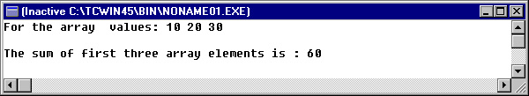

/***************************************************************

Another Solution of Problem#1
***************************************************************/

#include<stdio.h>
int sum_elements(int a , int b, int c); // Function Prototype

int main()
{
int x[10], total=0, i;

printf("Please Input 5 element in array : ");
for(i=0;i<5;i++)
{
scanf("%d", &x[i]);
}

total = sum_elements( x[0], x[1], x[2] ); //Function call to compute sum

printf("\nThe first three array elements are : %d %d %d", x[0], x[1], x[2] ); // Output results

printf("\nThe sum of first three array elements is = %d", total);
return 0;
} // end of main

int sum_elements(int a, int b, int c) // Function header
{
int sum;
sum=a+b+c;
return (sum);
}

Sample Output:
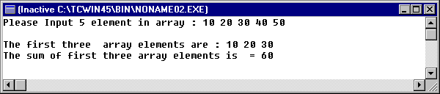

Solved Problem# 2:

// Reads a 1-D array and prints the sum of even and odd numbers

#include <stdio.h>
#define SIZE 4

/* Determines if an element is odd */
int odd(int num)
{
int isodd;

isodd = (num%2==1);
return isodd;
} //end of odd function

int main()
{
int x[SIZE], i, oddsum=0, evensum=0;

printf("Enter %d integer values :", SIZE);

for (i=0; i<SIZE; i++)
{
scanf("%d", &x[i]);
}

for (i=0; i<SIZE; i++)
{
if ( odd(x[i]) ) // function call is within if
oddsum=oddsum+x[i];
else
evensum=evensum+x[i];
}

printf("The sum of odd elements is : %d\n", oddsum);
printf("The sum of even elements is : %d\n", evensum);

return 0;
} // end of main

Sample Output:
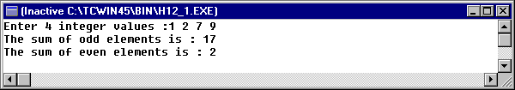

How to pass whole array as a parameter in Function? :

- Unlike simple variables, array is not passed into a function, but rather its address is passed.

- This is done by specifying the array name followed by brackets [] (size is not necessary).

- This makes processing more efficient.

- The actual parameter is the array name (no brackets).

Solved Problem#3:

/* reads the grades of students and prints the average grade.*/

#include <stdio.h>
#define SIZE 30

/* computes the average of elements in an array */
float average(float list[], int n)
{
int i;
float sum=0.0;

for (i=0; i<n; i++)
sum+=list[i];
return sum/n;
} // end of function average

int main()
{
int i,n;
float grades[SIZE]; // array declaration

printf("Enter number of students: ");
scanf("%d",&n);
printf("Enter grades for %d students :", n);

for (i=0; i<n; i++)
{
scanf("%f", &grades[i]);
} // end of for

printf("The Average of grade is %.2f\n", average(grades, n));// function call
return 0;
} // emd of main

Sample Output:
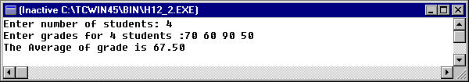

Solved Problem#4:

To pass the array to a function we write the name of the array. To declare the function that accepts an array as its parameter we write the name of the array followed by the [ ] without the size of the array in its parameter declaration part. Consider the following problem of finding the maximum of 4 integer numbers.

#include <stdio.h>
#define SIZE 4 // defining the size of the array as 4 .
int max (int arr[ ] ) ; // declaring the function max which returns integer value and accepts an
// integer array called arr

int main (void)
{
int arr [SIZE] , j , big ; //declaring the array arr along with other variables

for ( j = 0 ; j < SIZE ; ++j ) //using for loop to read the array
{
printf ("Enter the %dth element of array : ", j ) ;
scanf ( "%d", &arr[j] ) ;
} // end of for

big = max ( arr ) ; //calling the function max by passing the array with only name
printf ("\nThe maximum value is : %d\n", big ) ;
return 0;
} // end of main

int max ( int arr[ ] ) //function declaring that it accepts integer array arr as its input
{
int j , big = arr[0] ;

for ( j = 1; j < SIZE ; ++j ) //using for loop to find the maximum number of array arr
{
if ( arr[j] > big )
big = arr[j] ;

} // end of for loop
return (big) ; //returning the maximum value

} //end of max function

Sample Output:

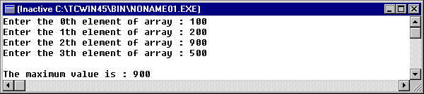

Solved Problem#5:
write a function that receives a 1-D array of real values and reverses it.

#include <stdio.h>
#define SIZE 40
void reverse (double array[], int n) {
int i;
double temp;
for (i=0;i<n/2;i++) {
temp=array[i];
array[i]=array[n-1-i];
array[n-1-i]=temp;
}
}
int main() {
double x[SIZE];
int n,i;
printf ("enter number of values to read\n");
scanf("%d",&n);
printf("enter %d values separated by space\n",n);
for (i=0;i<n;i++)
scanf("%lf",&x[i]);
printf("elements of the array before reversal\n");
for (i=0;i<n;i++)
printf("x[%d]=%f\n",i,x[i]);
reverse(x,n);
printf("elements of the array after reversal\n");
for (i=0;i<n;i++)
printf("x[%d]=%f\n",i,x[i]);
return 0;
}

Solved Problem#6:
Write a function that receives a 1-D array of integer values. It then returns the maximum and the minimum through the output parameter.

#include <stdio.h>
#define SIZE 40
void maxmin (int array[], int n, int *min, int *max) {
int i;
*max=*min=array[0]; // initialize max and *min with first element of the array
for (i=1;i<n;i++) {
if(*max<array[i])
*max=array[i];
else if (*min > array[i])
*min=array[i];
}
}
int main() {
int x[SIZE];
int n,i,min,max;
printf ("enter number of values to read\n");
scanf("%d",&n);
printf("enter %d values separated by space\n",n);
for (i=0;i<n;i++)
scanf("%d",&x[i]);
maxmin(x,n,&min,&max);
printf("maximum=%d\nminimum=%d\n",max,min);
return 0;
}

