ICS 103, Term 132

Computer Programming in C

HW# 5
Due date: Sunday, April 27, 2014

Write a program to grade an n-question multiple-choice exam (for n between 5 and 50) and provide feedback about the most frequently missed questions. Your program will take data from the file examdat.txt. The first line of the file contains the number of questions on the exam followed by a space and then an n-character string of the correct answers. Write a function fgetAnswers that inputs the answers from an open input file. Each of the lines that follow contain an integer student ID followed by a space and then that student’s answers. Function fgetAnswers can also be called to input a student's answers. Your program is to produce an output file, report.txt, containing the answer key, each student’s ID and each student’s score as a percentage, and then information about how many students missed each question. Here are short sample input and output files.

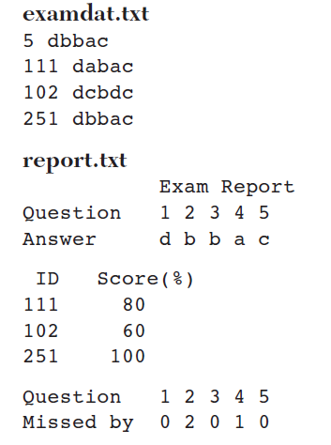

The solution should be well organized and your program should be well documented. Submit a soft copy of your solution in a zip file. Your solution should be submitted in a word file that contains the following items:

Your name and ID

Homework number

Problem statement

Your solution along with the code

Discussion of what worked and what did not work in your program. Include snapshots that demonstrate the working parts of your program. If things did not work and you attempted to solve them, mention that and write about the difficulty that you have faced.

The soft copy should also contain the source code file (i.e. .c) and the executable (i.e. .exe).

