ICS 103, Term 132

Computer Programming in C

HW# 3
Due date: Tuesday, March 18, 2014

You would like to find the area under the curve y = f(x) between the lines x = a and x = b. One way to approximate this area is to use line segments as approximations of small pieces of the curve and then to sum the areas of trapezoids created by drawing perpendiculars from the line segment endpoints to the x -axis, as shown in the figure below:

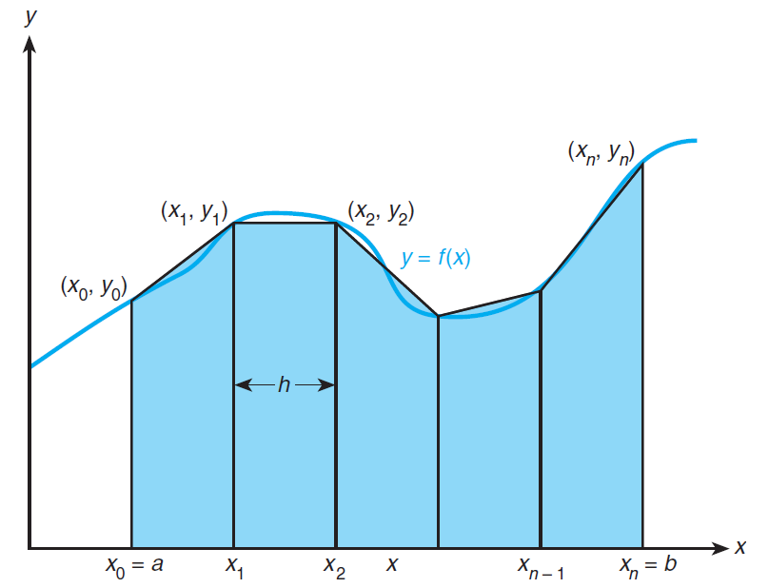

We will assume that f (x) is nonnegative over the interval [a , b]. The trapezoidal rule approximates this area T as:

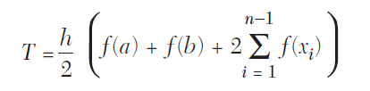

for n subintervals of length h:

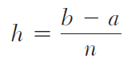

Write a function trap with input parameters a, b, n, and f that implements the trapezoidal rule.

Call trap with values for n of 2, 4, 8, 16, 32, 64, and 128 on the following functions:
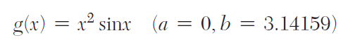

Function h defines a half-circle of radius 2. Compare your approximation to the actual
area of this half-circle.

It should be noted that the trapezoidal rule is approximating:

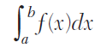

The solution should be well organized and your program should be well documented. Submit a soft copy of your solution in a zip file. Your solution should be submitted in a word file that contains the following items:

Your name and ID

Homework number

Problem statement

Your solution along with the code

Discussion of what worked and what did not work in your program. Include snapshots that demonstrate the working parts of your program. If things did not work and you attempted to solve them, mention that and write about the difficulty that you have faced.

The soft copy should also contain the source code file (i.e. .c) and the executable (i.e. .exe).

